Elderbrook Unveils Music Video for ‘Broken Mirror’

The affecting video was directed by Jordan Rossi and stars multidisciplinary artist Darkwah

Taken from Elderbrook’s newly released Innerlight EP

Watch the ‘Broken Mirror’ Video Here
Listen to Innerlight Here

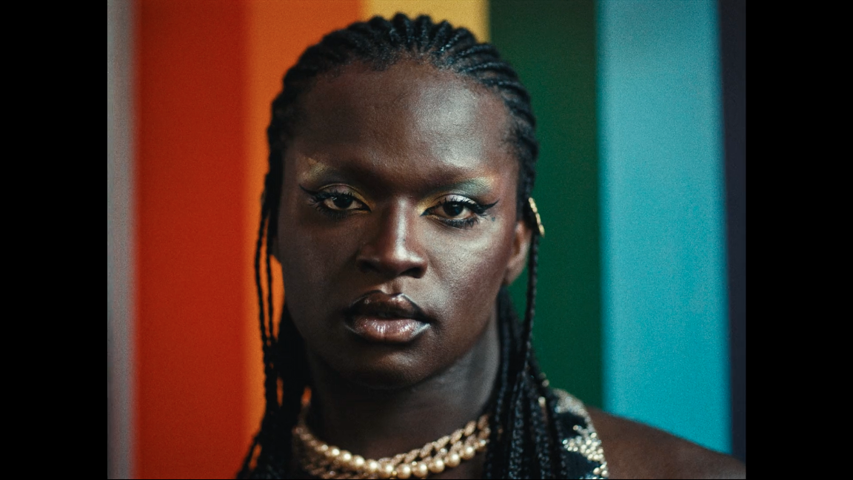

Elderbrook (he/him), has unveiled the official video for his new single ‘Broken Mirror’, the focus track from his new EP Innerlight.

Helmed by photographer and Director Jordan Rossi (he/him), in collaboration with multidisciplinary artist and creator Darkwah (they/them), this narrative showcases the issues that Queer people face moving through the world but aren’t often acknowledged or spoken about.

Following a day in the life of a Queer performer (played by Darkwah), the audience witnesses with unflinching realism, the aggressions and micro-aggressions that impact personal safety and their mental health, through a range of scenes from in the local community to their place of work and what should be deemed as a ‘safe space’.

Rossi, a fearless, rule-breaking creative who is lauded for his work that often centers around the LGBTQ+ community, has previously collaborated with the likes of Little Mix, The Vamps, Years & Years, Griff, Becky Hill and MNEK.

Rossi comments, “With Queer culture moving into the mainstream, you’d think this would be a great time for Queer liberation but actually it’s far from it. More than ever before, we’re put into a box and forced to try and make our Queerness palatable for so many audiences.

As a LGBTQ+ working director and photographer, I’m still excluded from so many conversations and projects which is why it’s a privilege to have the opportunity to craft this narrative and film. A big expression of gratitude goes to Elderbrook, his team and the record label who have let us tell this story freely and authentically whilst supporting us at every step of the process.”

On the project Darkwah notes, “As soon as I saw the treatment, I knew I wanted to be a part of this project. It’s all of the things I’ve experienced many times over. It’s so important that aggressions and microaggressions are spoken about outside of the LGBTQIA+ community. We know these things. We experience them - sometimes at the hands of those in our community but more so by those outside of it.

Having these occurrences shown at this level in conjunction with an artist like Elderbrook, I hope will not only generate more conversation but result in change for the better as people check the ways in which they interact with performers, queer performers and queer people.

I’m incredibly grateful to have been part of this project. I’m super excited for the change it will start to incite.”

The ‘Broken Mirror’ video follows the release of Elderbrook’s Innerlight EP on October 8th, a four-track release featuring ‘Dominoes’ with Louis The Child, ‘Inner Light’ with Bob Moses, ‘I’ll Find My Way To You’ with Emmit Fenn and focus single ‘Broken Mirror,’ produced with Kölsch. Known for using his music and videos as an opportunity to drive forward conversations (his Why Do We Shake I The Cold? album and video for ‘Something About You’ both focused heavily on mental health), Elderbrook was keen to extend this to the ‘Broken Mirror’ video due to its personal lyricism and meaning.

Elderbrook explains, “‘Broken Mirror’ is about wanting to change yourself. Not knowing what version of you is the right one. Wanting to be all different kinds of people all at the same time and a journey of discovery.’

I loved the treatment and felt it was important to use my platform as a stage to tell this amazing story from Jordan. I really loved how intimately Jordan connected with the meaning of the song and how he really made it his own. Though his experiences are different to mine it shows that the message of this song transcends the experiences of various different stories, in different ways.”

The support from Elderbrook and his record label marks the start of a number of LGBTQIA+ activations to support the community. These range from live sessions with Elderbrook again sharing his platform with the likes of Rossi and Darkwah, to curated Spotify playlists highlighting emerging Queer musicians, to an eventual event at a leading LGBTQIA+ venue with proceeds going towards Mermaids - a charity chosen by Rossi and Darkwah.

Elderbrook is currently in the midst of his North American headline tour, having kicked off the run of dates with performances at Lollapalooza and 2 sold-out nights at Red Rocks. The majority of the dates on the tour have sold out, with second nights added in Vancouver, Denver, and Santa Barbara. The run includes stops at The Novo in LA, as well as a sold-out album release show held last weekend at New York’s iconic Irving Plaza (full dates below).

A live phenomenon, self-taught multi-instrumentalist, producer and singer-songwriter, Elderbrook arrived on the global stage in 2017, lending his vocals and co-writing the platinum-selling smash ‘Cola’ with Camelphat which received both Grammy and Ivor Novello nominations. He then dropped his debut album Why Do We Shake In The Cold? last year, an acclaimed release that was lauded by critics including NPR and Billboard. With over 1 billion streams to date, and tours alongside the likes of Bonobo, Friendly Fires and Jungle, he is a global sensation who continues to grow as an artist.

A stunning collection of tracks, Innerlight is Elderbrook’s finest body of work to date.

Innerlight EP Tracklist
- Elderbrook & Bob Moses – ‘Inner Light’
- Elderbrook & Emmit Fenn – ‘I Will Find My Way To You ‘
- Elderbrook – ‘Broken Mirror’ (produced by Kölsch)
- Elderbrook & Louis The Child – ‘Dominoes’

Elderbrook North American Tour Dates
October 15 – Philadelphia, PA – The Foundry *sold out*
October 16 – Denver, CO – Bluebird Theater *sold out*
October 17 – Denver, CO – Bluebird Theater *sold out*
October 20 – Santa Barbara, CA – Soho Music Club
October 21 – Santa Barbara, CA – Soho Music Club *sold out*
October 22 – Los Angeles, CA – The Novo
October 23 – San Francisco, CA – Regency Ballroom
October 26 – Santa Cruz, CA – The Atrium @ The Catalyst
October 28 – Austin, TX – The Concourse Project (w/ Diplo & Amtrac)
December 1 – Vancouver, BC – Celebrities Nightclub
December 2 – Vancouver, BC – Celebrities Nightclub
December 3 – Toronto, ON – Danforth Music Hall *sold out*
December 4 – Montreal, QC – L’Astral *sold out*
December 5 – Trois-Rivieres, QC – Cabaret Notre Dame
December 11 – Boulder, CO – Powabunga Vail

# # #

For more information on Jordan Rossi, please visit:
Instagram | Twitter | Facebook | Website

For more information on Darkwah, please visit:
Instagram | Twitter | Facebook

For more information on Elderbrook, please visit:
Instagram | Twitter | Facebook | Spotify

