100 gecs Shares New Holiday Song
Listen To "Sympathy 4 The Grinch" Now

track art by Mikey Joyce

LISTEN: "sympathy 4 the grinch"
https://100gecs.lnk.to/sym4thy4th3gr1nchPR
Just in time for the holidays, 100 gecs are sharing a new song for the occasion. Aptly titled "sympathy 4 the grinch," the new song injects the quintessential gecs electronica along with some Ska flavor, jolly sleigh bells, and sugar encrusted lyrics that make the perfect case for the beloved villain. The song continues the duo's holiday spirit from last year when they put on Gec The Halls, a sold-out, hometown holiday show in St. Louis.
"sympathy 4 the grinch" closes out one of 100 gecs most industrious years yet. They released their much-lauded remix album 1000 gecs & The Tree of Clues, graced the covers of PAPER Pride and OFFICE Magazine, appeared on The Pitchfork Review and Song Exploder podcasts, and held a virtual Minecraft festival experience, Square Garden, which drew in 178,000 total viewers between Minecraft, Twitch and YouTube, and raised over $50,000 for Feeding America. Late last year the duo also embarked on a North American run with BROCKHAMPTON and slowthai, and a "Secret Tour" which saw the duo headline seven sold-out one-off shows.
Like it's predecessor, 1000 gecs, which was praised by Pitchfork as "one of the year's most fascinating, exhilarating experimental pop albums," 1000 gecs & The Tree of Clues pushes the boundaries of what music can sound like and breathes new life into one of the most exciting debuts in recent memory, with the standout single "money machine" taking over TikTok and YouTube again. The album is the first on new label Big Beat/Atlantic Records and took shape as the result of crowd-sourcing, garnering official remixes from friends and familiar names, as well as fans who received stems for the album via the band's Twitter.
Listen to "sympathy 4 the grinch" above, see details for 1000 gecs & The Tree of Clues, out now on all streaming platforms, below and stay tuned for more from 100 gecs coming soon.

What the press is saying about 100 gecs:

“utterly unhinged in the best way possible”
GQ
"[1000 gecs] was one of the most exciting things that happened in the whole decade. I really mean that"
Skrillex, in conversation with 100 gecs for PAPER Magazine
"It's fascinating and disorienting, and also some of the savviest pop music of the year"
The New York Times
“the truest, most authentic representations of the modern condition”
NPR
"a compelling case for the joys of having your brain permanently mangled by the internet"
Vulture

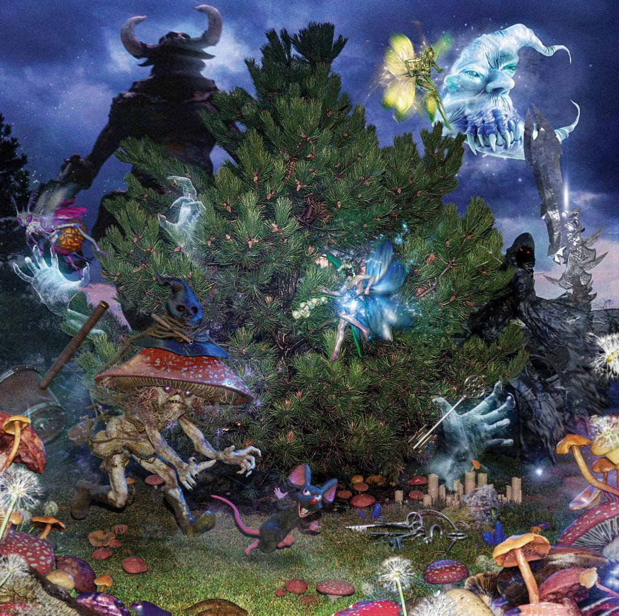

ALBUM COVER ART

100 gecs
1000 gecs & The Tree of Clues
Big Beat / Atlantic Records
July 10, 2020

1. money machine (A. G. Cook Remix)
2. ringtone (Remix) feat. Charli XCX, Rico Nasty, Kero Kero Bonito
3. 745 sticky (Injury Reserve Remix)
4. gec 2 Ü (Danny L Harle Harlecore Remix)
5. hand crushed by a mallet (Remix) feat. Fallout Boy, Craig Owens, Nicole Dollanganger
6. 800db cloud (Ricco Harver Remix)
7. stupid horse (GFOTY and Count Baldor Remix)
8. ringtone (umru Remix)
9. xXXi_wud_nvrstøp_ÜXXx (Remix) feat. Tommy Cash & Hannah Diamond
10. 745 sticky (Black Dresses Remix)
11. gecgecgec (Remix) feat. Lil West and Tony Velour
12. xXXi_wud_nvrstøp_ÜXXx (99jakes Remix)
13. gec 2 Ü (Remix) feat. Dorian Electra
14. hand crushed by a mallet (nothankyou Remix)
15. came to my show (intro)
16. came to my show
17. toothless
18. small pipe (live at fishcenter)
19. 800db cloud (live at fishcenter)

100 gecs:
Twitter | Instagram | SoundCloud

Dylan Brady:
Twitter | Instagram | SoundCloud | YouTube

Laura Les:
Twitter | Instagram | SoundCloud

Dog Show Records:
Twitter | Instagram | Website

﻿(Download hi-res assets HERE)

For more information please contact: Paige.Rosoff@atlanticrecords.com

