DWILLY RINGS IN FRIDAY THE 13TH IN STYLE BY RECRUITING FRND AND JELEEL!
FOR NEW COLLABORATIVE SINGLE, “ASSASSIN”

LISTEN HERE: https://BigBeat.lnk.to/assassinDw

OUT TODAY VIA BIG BEAT RECORDS!

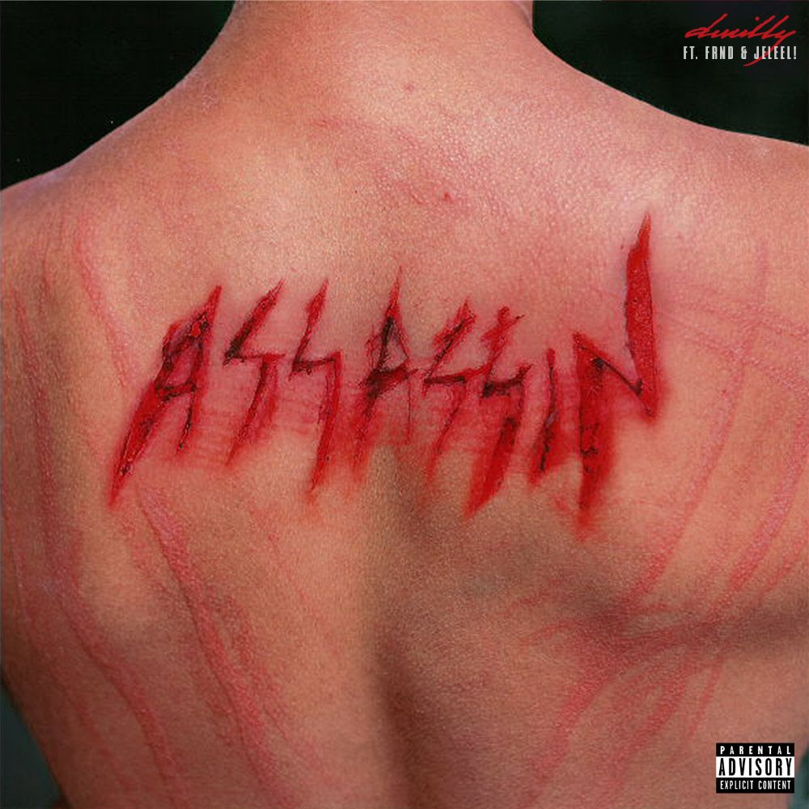
DOWNLOAD ARTWORK HERE

The producer, songwriter and multi-instrumentalist dwilly is fresh off supporting Zedd at an epic show at Red Rocks in June, and now the prolific artist is ringing in Friday the 13th in spooky style by releasing his debut single for Big Beat Records, called “ASSASSIN.” dwilly recruited FRND and JELEEL! for the genre-smashing track, which incorporates elements of trap, hip-hop, and emo with dwilly’s signature electronic touch. FRND’s hook and JELEEL!’s verse only add to the already hook-laden track, making it the perfect soundtrack to your Friday the 13th... LISTEN HERE!

dwilly is the brainchild of the South Carolina-born/LA-based artist David Wilson, who’s taken the music industry by storm after his tenure at the prestigious Berklee School of Music by releasing smash remixes for NOTD, Felix Jaehn, GREY, KIIARA, and producing tracks for Mike Posner, Ty Dolla $ign and Wiz Khalifa. His 2019 Crayola EP already boasts over 5 million streams thanks to his ability to seamlessly fuse genres and create enthralling hooks. dwilly was also an opener for GriZ’s US tour this year and he
produced rapper Witt Lowry’s “DEBT” (feat. Dia Frampton), from Witt’s album Nevers Road that came out last week.

FRND is the solo effort from Andrew Goldstein, a singer-songwriter and producer who’s coined releases for 5 Seconds of Summer, Quin XCII, Fifth Harmony, Andrew McMahon, Demi Lovato and others, garnering praise from Entertainment Weekly, YourEDM, Nylon and Indie Shuffle, among others.

This is dwilly’s debut for Big Beat Records, but if the early praise is any indication, we’ll be hearing much more from him sooner than you might think!

CONNECT WITH DWILLY:
Instagram | Facebook | Twitter | Spotify

DWILLY PRESS ASSETS: https://press.wearebigbeat.com

FOR MORE INFORMATION:
Paige Rosoff – Big Beat Records
Paige.Rosoff@atlanticrecords.com

