CHILLPILL RETURNS WITH “HATE U” FT RIAA GOLD-CERTIFIED SINGER/PRODCUER SUECO & INDIE PHENOMENON LONELY GOD

“HATE U” COMPANION VIDEO GAME ALSO OUT NOW

FOLLOWS “MOONWALK” (FEAT. YBN NAHMIR, COUSIN STIZZ & TEEJAYX6)
& “LIL BITCH” (FEAT. RICO NASTY AND SOLEIMA)

LISTEN/WATCH THE LYRIC VIDEO HERE: https://chillpill.lnk.to/HateU
PLAY THE OFFICIAL “HATE U” VIDEO GAME HERE: https://hateugame.com/

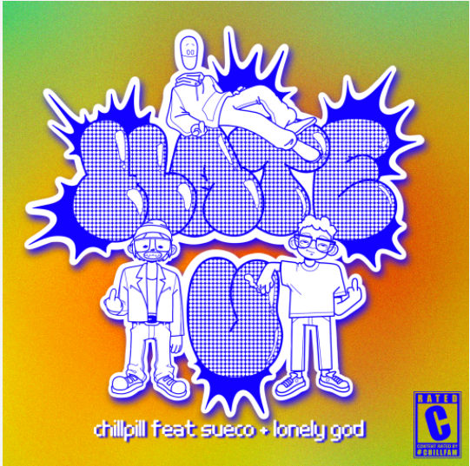
DL art
Virtual producer chillpill is back with yet another hit, “Hate U” featuring RIAA gold-certified singer/producer Sueco and underground indie phenomenon Lonely God, out today via Big Beat Records. Listen HERE. The single also comes with an official video game, where players can act as chillpill, Sueco or Lonely God to dodge all the haters & collect the lyrics before the song finishes. Get a high score for your chance to win exclusive augmented reality merchandise & discounts! Play the game HERE.
“Hate U” follows chillpill’s “LiL BitCH” (feat. Rico Nasty and Soleima), which was accompanied by the world’s first ever music video game, and “Moonwalk,” which features rappers Coustin Stizz, Teejayx6 and multi-Platinum, 2018 XXL Freshman Class member YBN Nahmir.
On “Hate U” Lonely God says, "This song was cool because we made the whole thing over the internet during quarantine. my verse is also super good and about a girl, so you should really give it a listen.”
Already having written and produced records for artists like Panic! At The Disco, Chloe X Halle and more, chillpill made an introduction of his own artist project (and the virtual being that is chillpill) with single “FUCK THE CLUB” feat. GOLDN, which also received a chillpill remix featuring PC pop artist Ravenna Golden. He followed up with “LiL BitCH” (feat. Rico Nasty and Soleima), which was accompanied by the world’s first ever music video game and received praise from Complex, Consequence, Hot New Hip Hop and more, and most recently released “Moonwalk” with star-studded features Coustin Stizz, Teejayx6 and YBN Nahmir.

The story of chillpill the artist begins in an alternate 2-D cartooniverse. chillpill grew up feeling like he had no purpose and struggled to find his place, until he found music. "On the surface level, it's a fun genre-blending idea, almost a tongue in cheek flip on pop culture. On a deeper level, it's really a dark comedy and commentary on the state of the music industry" says chillpill on his inspiration behind the project.

Sueco (fka Sueco The Child) first unveiled his electrifying new sound late last year with his single, “PRIMADONA.” The genre-bending single followed a series of acclaimed releases from Sueco, including the hypnotic “Smackdown (Feat. TOKYO’S REVENGE),” “Juice,” and 2019’s full-length debut project, MISCREANT, highlighted by the global streaming smash, “fast.”

Last year, Sueco joined forces with global superstars Ty Dolla $ign, Wiz Khalifa, and Lil Yachty for “Speed Me Up,” produced by Take A Daytrip (Lil Nas X, Big Sean, YBN Cordae) and featured in Paramount Pictures’ blockbuster action-adventure, Sonic The Hedgehog. “Speed Me Up” was accompanied by a star-studded official video which premiered during MTV’s GRAMMY® Awards special. In addition, Sueco made his high profile network television debut with a spectacular performance of the track on Jimmy Kimmel Live!

Immediately recognizable for his long blue hair, gleaming grill, and headbanging beats, Sueco proved an online sensation with 2019’s RIAA gold certified breakthrough hit single, “fast.” Hailed by Rolling Stone as “a low-slung, battering ram of a record made up of little more than ‘a clap, a hi-hat and an 808,’” the track lit up TikTok with over 2.5 million videos en route to more than 200 million worldwide streams, catapulting it to the top spot at TikTok and #1 on Spotify’s “Viral 50 - Global” and “Viral 50 – US” charts. Furthermore, “fast” was followed by an official remix featuring Offset and A Boogie Wit Da Hoodie, which premiered on Apple Music’s Beats 1 as Zane Lowe’s #WorldFirst.

Fast growing Baltimore artist Lonely God released his breakthrough single “Marlboro Nights” last year, alongside a video that also served as the directorial debut from Kylie Jenner’s in-demand personal photographer Amber Asaly. Writing, recording and releasing “Marlboro Nights” from his Baltimore bedroom, the 22-year-old multi-instrumentalist, producer and songwriter’s break came as the catchy indie pop anthem began circulating on the popular short-form video-sharing app TikTok, catapulting “Marlboro Nights” to one of the platforms biggest hits, landing in the top 10 in Spotify Viral 50 charts with over 33 million streams and counting, and transforming Lonely God from unknown bedroom artist to underground indie phenomenon. “Marlboro Nights” marks Lonely God’s first release in Australia and New Zealand with indie stalwart label Dew Process. In all other markets, the single is the first release by Pizzaslime Records – the new outside the box record label by left-of-centre creative agency and apparel creators PIZZASLIME and Diplo’s Mad Decent label.

DL press photo here

CONNECT WITH CHILLPILL
Instagram | Website | Facebook | Twitter

FOR MORE INFORMATION
Paige Rosoff – Big Beat / Atlantic Records
Paige.Rosoff@atlanticrecords.com

Gabby Reese – Big Beat / Atlantic Records
Gabrielle.reese@atlanticrecords.com

