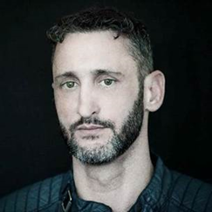

ZENBI is a house DJ and Producer from Philadelphia and based in Washington DC. ZENBI started in music as a DJ in the mid 90’s, spinning vinyl in the Philadelphia club scene. Since, he has developed his own unique artist, mixing elements of tech house, latin, and tribal grooves to create his signature sound, which he has dubbed “Good and Beautiful”, a direct English translation of the Japanese word, “Zenbi”. ZENBI has played to crowds and major EDM festivals, including BPM, Miami Music Week, Groove Cruise, SodaPop Milano, and ADE. ZENBI also holds residencies at Lima in Washington DC and Rumor in Philadelphia, where he shares a rotation with the likes of Chus & Ceballos, Morgan Page, Saeed Younan, and Oscar G. ZENBI’s releases have received support and acclaim from Moby, Mark Knight, Marco Carola, and Stefano Noferini, to name a few.

SOCIALS
SPOTIFY – 1.3K MONTHLY LISTENERS
SOUNDCLOUD – 2.7K SUBSCRIBERS
FACEBOOK – 88.7K FOLLOWERS

###

Big Beat Records, 2018

