WHETHAN DELIVERS NEW MUSIC VIDEO
FOR “TOP SHELF” (FT. BIPOLAR SUNSHINE)!
FROM ‘LIFE OF A WALLFLOWER VOL1’ EP OUT NOW

WATCH/SHARE “TOP SHELF” FT. BIPOLAR SUNSHINE: https://BigBeat.lnk.to/topshelfWh
BUY/STREAM LIFE OF A WALLFLOWER: https://whethan.lnk.to/V1PR

“…dazzling video, and the house-inclined production makes for a visual feast.” – Clash

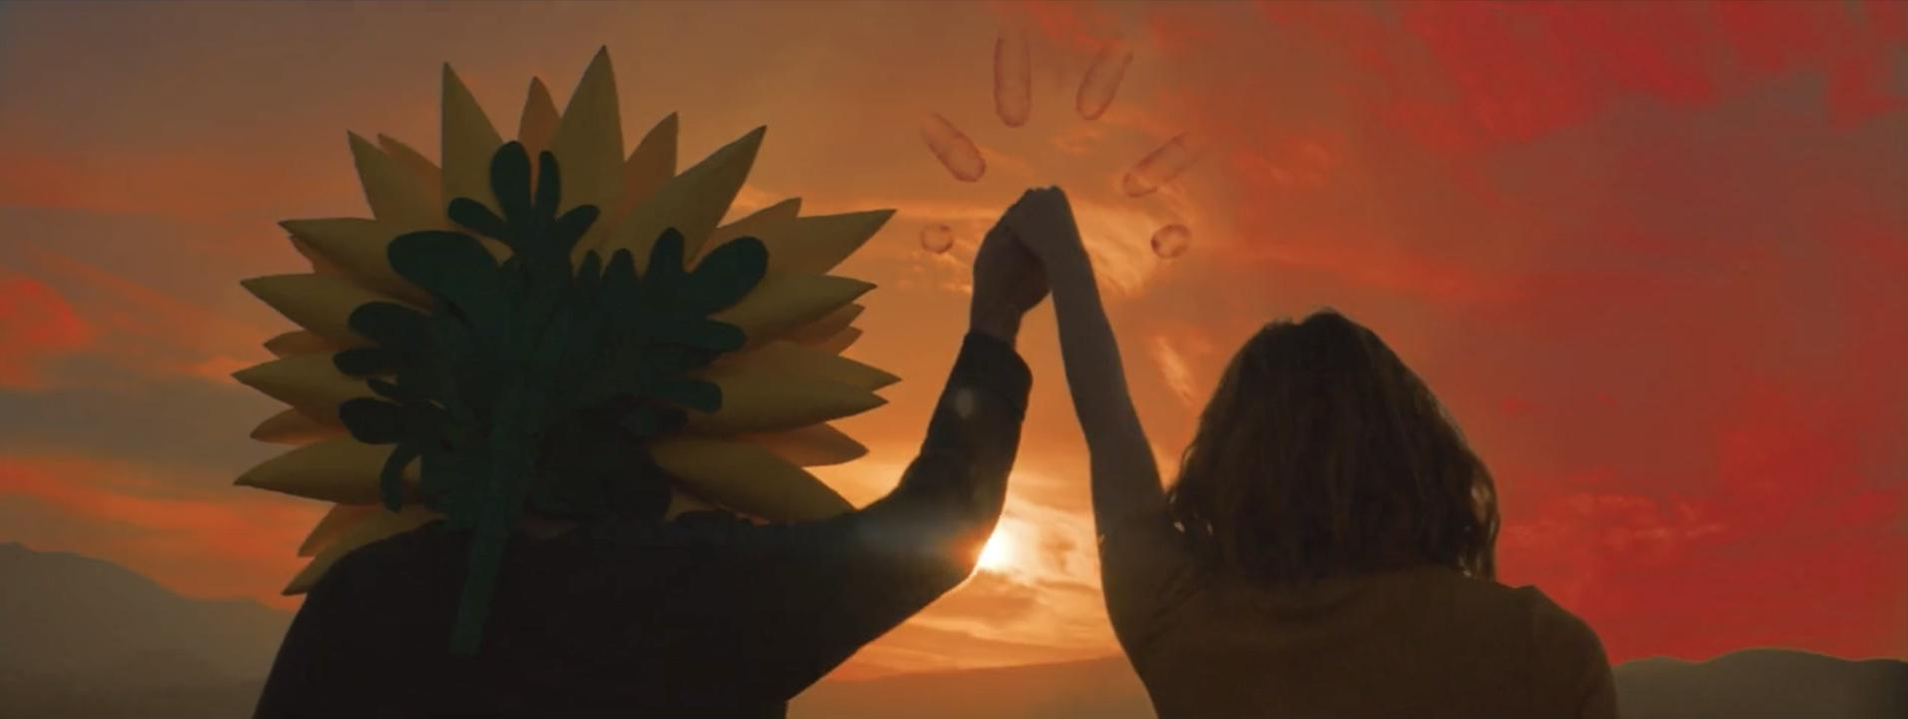

“Whethan is a beat king” – V Magazine
“Funky and unfadeable” – Billboard

DJ/producer Whethan prodigious’ debut Life of a Wallflower Vol.1 EP gave rise to several luminary collabs with Broods, Oh Wonder, HONNE and Mascolo. Today, the Los Angeles-based, Chicago-rooted artist rolls out the official music video for his single “Top Shelf” featuring the brilliant British singer Bipolar Sunshine, starring model Alina Lee, and a wallflower– WATCH HERE!

The video builds on Whethan’s wallflower character, this time as a love story, showcasing his signature cheeky humor meets psychedelic hallucination scenes… In Whethan’s words, "This music video is a continuation of the story about Wallflower and his journey through life. It’s one of my favorite songs to play in my sets and it was extremely fun to experiment with house music. Working with Bipolar Sunshine was an absolute honor and he absolutely nailed it."

The wallflower previously made an appearance in the official video for “Radar” ft. HONNE which premiered on The FADER - WATCH HERE! Whethan also claims Billboard’s “21 Under 21” 2018 class, admiring his “sophisticated sound… sizable enough for radio while deviating from standard dance-pop structure.” At 19, Whethan has already accomplished more in his career than those twice his age. He recently collaborated with Tom Morello and Portugal. The Man on “Every Step That I Take” (which they also performed on Jimmy Kimmel Live! - watch HERE!), Dua Lipa on “High”, Charli XCX’s “love gang,” and Flux Pavilion and MAX’s “Savage”.

Whethan’s slayed Lollapalooza, Billboard Hot 100 Music Festival, Outside Lands, Electric Daisy Carnival, Hangout, as well as at Coachella’s DoLab & Heineken House festival performances to name a few. He returned to Coachella in 2018, nearly breaking the internet after bringing Yodel Boy on stage with him. Now signed to Big Beat, Whethan first made a name for himself as a SoundCloud producer with a slew of viral remixes. He continues to put out remixes and bootlegs such as, TRAVIS SCOTT X SKRILLEX – “SICKOMODE” (WHETHAN TURN), Post Malone x Justin Bieber – “Déjà vu” (Whethan Remix), Clairo – “Pretty Girl” (Whethan Bootleg), and Brockhampton – “Stains” (Whethan Bootleg) on top of his Big Beat releases.

WHETHAN - Life of a Wallflower Vol. 1
(Big Beat Records)
1. Wallflower
2. Radar (feat. HONNE)
3. Be Like You (feat. Broods)
4. Together
5. Superlove (feat. Oh Wonder)
6. Top Shelf (feat. Bipolar Sunshine)
7. Good Nights (feat. Mascolo)
8. I Miss You

Connect with @WhethanMusic: Facebook | Twitter | Instagram | SoundCloud | YouTube

For press assets: http://press.wearebigbeat.com/artists/whethan/

For more information: http://lifeofawallflower.whethan.com/

Press Contact:
Jordan Danielle Frazes
Head of Publicity, Big Beat Records
Jordan.Frazes@atlanticrecords.com

