**WHETHAN’S “SUPERLOVE” GETS AN ATTENTION-GRABBING VISUAL TREATMENT FT. OH WONDER -- STREAM TODAY!**

**+ “LIFE OF A WALLFLOWER” NORTH AMERICAN TOUR KICKING OFF THIS FALL**

**WATCH/SHARE:** <https://youtu.be/AEP942evkzg>

**BUY/STREAM “SUPERLOVE:** <https://whethan.lnk.to/SuperlovePR>

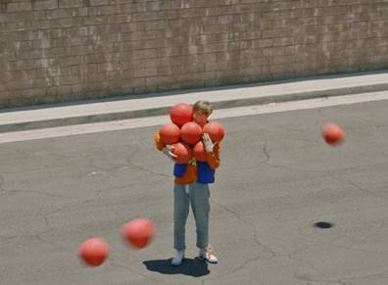

Prodigious young producer **Whethan** delivers a stellar visual for **“Superlove”** today celebrating the single which earned over a half million streams in its first week, #2 on iTunes US Electronic chart placement, #1 love on HypeMachine Popular chart, and was described as *“a wave of bliss”* by [*Billboard*](https://www.billboard.com/articles/news/dance/8461191/whethan-new-song-superlove-oh-wonder-2018-tour). Directed by **Mark Golembeski** (Anderson Paak, Adidas, #Millenials), and starring **Whethan**, alongside song feature, London-based alt-pop duo **Oh Wonder**, a rogue vacuum cleaner, and people breaking out of mundane suburbia, it’s a video not to miss – WATCH [HERE!](https://youtu.be/AEP942evkzg)

**Whethan** is the brainchild of the19-year-old Chicago-born producer **Ethan Snoreck**. On the heels of a string of high-profile, chart-topping collaborations, including one with **Dua Lipa** called [“High”](https://www.youtube.com/watch?v=ABLsSWE06q4)off the **“Fifty Shades Freed”** soundtrack**,** as well as [“](https://bigbeat.lnk.to/lvegngPR)[love gang” (ft. Charli XCX)](https://youtu.be/96Bo8n35LYw), [“Savage” (ft. Flux Pavilion & MAX)](https://www.youtube.com/watch?v=uPLMgp7XmiU), **and** “[Good Nights” (ft. Mascolo)](https://www.hive.co/l/goodnightsyt), Whethan is just getting started. Whethan first made a name for himself as a **SoundCloud** producer, remixing tracks for **Louis The Child** (“It’s Strange”), **ZAYN** (“Pillow Talk”) and **Ty Dolla $ign** (“Blasé feat. **Future** & **Rae** **Sremmurd**”) which all surpassed 2.5 million plays, before releasing a groundbreaking original cut – “Savage” (feat. Flux Pavilion & MAX)” – having amassed over 25 million streams worldwide. “**Love gang” (feat. Charli XCX)** was the next chapter in Whethan’s already ground-breaking discography, kicking off with clanging, discordant synths transposed with Charli XCX’s dazzling vocals, before exploding into an ethereal, hook-laden chorus. Gaining early attention from the likes of **Skrillex** and **Flux Pavilion**, Whethan continued to rise through the ranks building a loyal fanbase that’s led him on the meteoric rise he’s on today. Catch Whethan live on his **headlining “Life of a Wallflower” North American** tour which kicks off in San Marcos, Texas at The Marc on September 13th – see below for full itinerary and log on to purchase tickets here <http://whethan.com/tour/>.

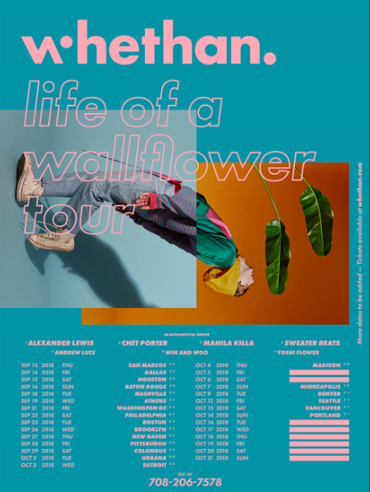

[HI-RES DOWNLOAD](http://press.wearebigbeat.com/wp-content/uploads/2018/06/Whethan-Life-Of-A-Wallflower-Tour-2018.jpg)

**WHETHAN**

**“LIFE OF A WALLFLOWER” TOUR DATES**

Sept 13 – San Marcos, TX @ The Marc

Sept 14 – Dallas, TX @ Stereo Live Dallas

Sept 15 – Houston, TX @ Stereo Live Houston

Sept 16 – Baton Rouge, LA @ Varsity Theatre

Sept 18 – Nashville, TN @ Exit In

Sept 19 – Athens, GA @ Georgia Theatre

Sept 21 – Washington, DC @ 9:30 Club

Sept 22 – Philadelphia, PA @ Union Transfer

Sept 25 – Boston, MA @ Royale

Sept 26 – Brooklyn, NY @ Brooklyn Steel

Sept 27 – New Haven, CT @ Toad's Place

Sept 28 – Pittsburgh, PA @ Spirit Hall

Sept 29 – Columbus, OH @ Skully's

Oct 2 – Urbana, IL @ Canopy Club

Oct 3 – Detroit, MI @ Majestic Theatre

Oct 4 – Madison, WI @ The Sylvee

Oct 5 – Chicago, IL @ Concord Music Hall

Oct 6 – Chicago, IL @ Concord Music Hall

Oct 7 – Minneapolis, MN @ Skyway Theatre

Oct 9 – Denver, CO @ Ogden Theatre

Oct 12 – Seattle, WI @ Showbox SoDo

Oct 13 – Vancouver, BC @ Commodore Ballroom

Oct 14 – Portland, ME @ Wonder Ballroom

Oct 16 – San Luis Obispo, CA @ Fremont Theater

Oct 17 – Santa Cruz, CA @ Catalyst Club

Oct 18 – San Francisco, CA @ Warfield Theatre

Oct 19 – Santa Ana, CA @ The Observatory

Oct 20 – Los Angeles, CA @ The Novo

Oct 21 – San Diego, CA @ The Observatory North Park

[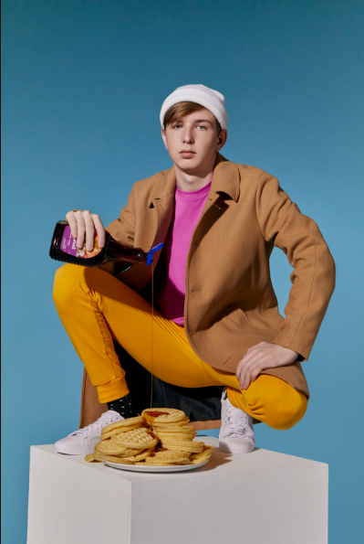](http://press.wearebigbeat.com/wp-content/uploads/2018/02/Whethan-Credit-Jimmy-Fontaine-1.jpg)

*(*[Click for Hi-Res](http://press.wearebigbeat.com/wp-content/uploads/2018/02/Whethan-Credit-Jimmy-Fontaine-1.jpg) *| Photo credit: Jimmy Fontaine)*

**Connect with @WhethanMusic:** [Facebook](https://www.facebook.com/whethanmusic) | [Twitter](https://twitter.com/whethanmusic) | [Instagram](https://www.instagram.com/whethanmusic) | [SoundCloud](https://soundcloud.com/whethan) | [YouTube](https://www.youtube.com/whethan)

For press assets: <http://press.wearebigbeat.com/artists/whethan/>

For more information: <http://belikeyou.whethan.com/>

**Press Contact:**

Jordan Danielle Frazes

Head of Publicity, Big Beat Records

[Jordan.Frazes@atlanticrecords.com](mailto:Jordan.Frazes@atlanticrecords.com)