PRODIGIOUS SUPERSTAR PRODUCER WHETHAN RELEASES
LIFE OF A WALLFLOWER VOL 1 EP TODAY VIA BIG BEAT RECORDS!

LISTEN TO “TOP SHELF” FT. BIPOLAR SUNSHINE: https://youtu.be/0g5320wd4-c
BUY/STREAM LIFE OF A WALLFLOWER VOL 1: https://whethan.lnk.to/V1PR

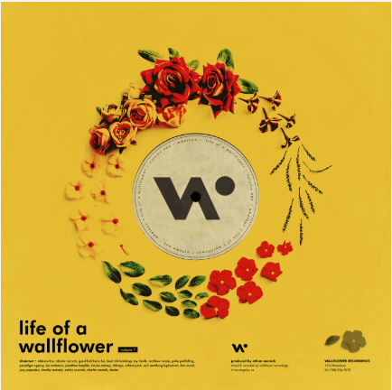

“Whethan is a beat king” – V Magazine

“Funky and unfadeable” – Billboard

The prodigious, chart-topping 19-year-old DJ/producer extraordinaire Whethan is fresh off sharing the hilarious video for “Radar” ft. HONNE) - watch HERE - and today the LA-based artist delivers a much-anticipated eight-track “Life of a Wallflower Vol 1” EP, chock-full of superstar collaborations, including Broods, Oh Wonder, Bipolar Sunshine and Mascolo, out now via Big Beat Records – listen HERE!

Billboard recently named Whethan as having a “sophisticated sound… sizable enough for radio while deviating from standard dance-pop structure,” and ranked him on their esteemed annual 21 Under 21 list. He has already collaborated with a host of high-profile artists, including Tom Morello and Portugal. The Man on “Every Step That I Take”, a track on Tom Morello’s latest album. Check out their live performance of the track on Jimmy Kimmel Live!. Other collaborations include “High” with Dua Lipa, “love gang” (ft. Charli XCX), and “Savage” with Flux Pavilion & MAX.

Whethan first made a name for himself as a SoundCloud producer with tracks alongside Louis The Child, ZAYN, and Ty Dolla $ign (feat. Future & Rae Sremmurd). He recently wrapped his “Life of a Wallflower” 30-city North American headline tour last week ahead of the release of the EP and previously brought his live show to Lollapalooza, Billboard Hot 100 Music Festival, Outside Lands, Electric Daisy Carnival, Hangout, as well as at Coachella’s DoLab & Heineken House to name a few. He returned to Coachella in 2018, nearly breaking the internet after bringing Yodel Boy on stage with him.

WHETHAN - Life of a Wallflower Vol. 1
1. Wallflower
2. Radar (feat. HONNE)
3. Top Shelf (feat. Bipolar Sunshine)
4. Good Nights (feat. Mascolo)
5. Together
6. Superlove (feat. Oh Wonder)
7. Be Like You (feat. Broods)
8. I Miss You

Connect with @WhethanMusic: Facebook | Twitter |Instagram | SoundCloud | YouTube

For press assets: http://press.wearebigbeat.com/artists/whethan/

For more information: http://lifeofawallflower.whethan.com/

Press Contact:
Jordan Danielle Frazes
Head of Publicity, Big Beat Records
Jordan.Frazes@atlanticrecords.com

