WHETHAN RELEASES OFFICIAL VIDEO FOR “HURTING ON PURPOSE (FEAT K.FLAY)”

ACCLAIMED SINGLE GETS FUTURISTIC OFFICIAL ANIMATED VISUAL
STREAMING NOW HERE

WHETHAN’S DEBUT FULL-LENGTH ALBUM FANTASY COMING SOON

WATCH THE MUSIC VIDEO HERE
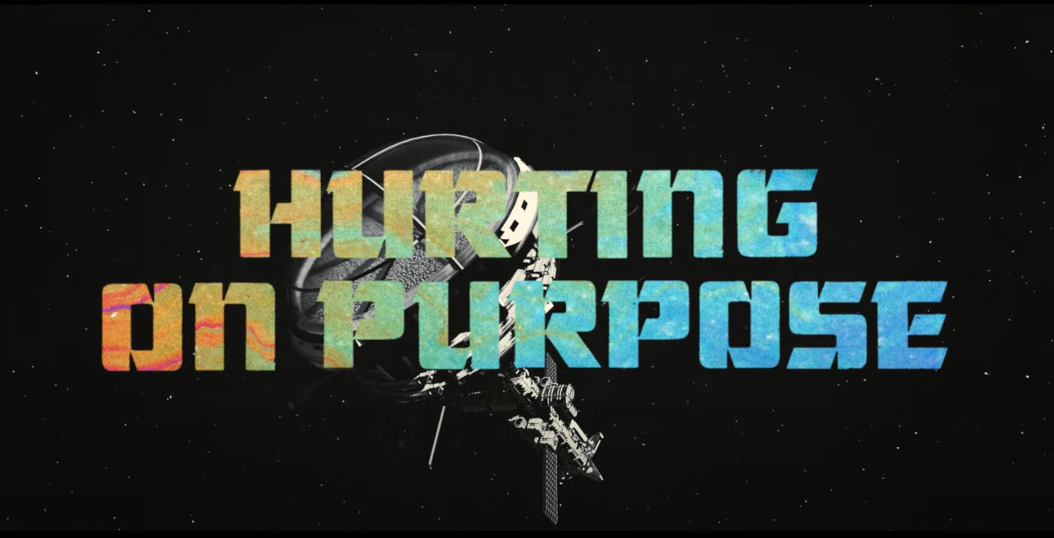

Acclaimed producer Whethan has released his latest stunning visual for his recent single “Hurting on Purpose (feat K.Flay)” – watch it now HERE. The space-age video was directed by Easton West who Whethan previously collaborated with on the incredible “Stay Forever (feat. STRKFR)” visual. The new official video features Whethan’s iconic futuristic helmet as well as stunning colorful and florescent visuals. The rock-influenced track highlights Whethan’s effortlessly cool, alt-electronic production and K.Flay’s floating yet powerful vocals. “Hurting on Purpose (feat. K.Flay)” is latest release from Whethan’s forthcoming debut album, FANTASY.

DOWNLOAD ARTWORK HERE

WHAT PEOPLE ARE SAYING ABOUT “HURTING ON PURPOSE (FEAT.K.FLAY)”:

“[Whethan] is on fire...”
-LADYGUNN

“we’ve just received another immaculate single from the rising superstar…This newest one is called ‘Hurting On Purpose,’ and it might be our favorite track ever released from Whethan...If these recent releases from Whethan don’t have you fired up for his long-awaited debut album, you’re trippin’.”—THIS SONG IS SICK

“K.Flay and producer Whethan team up to create songs featuring heart-hitting lyrics and synth-filled rhythms like their latest track, ‘Hurting On Purpose.’”
-ALT PRESS

“Few producers today have the courage or the skill to combine pop-rock with alternative trap and actually make it work. Whethan is one of them” – DANCING ASTRONAUT

“Whethan has been on absolute fire during 2020 with some incredible releases, and he’s continuing down that trend yet again with the release of his new single ‘Hurting On Purpose’” – ACID STAG

“Whethan continues doing what he does best on ‘Hurting On Purpose’, combining indie and alternative aesthetics with electronic sounds.– CULTR

“The new rock-influenced release taps into Whethan’s effortlessly impressive alt-electronic production as K.Flay’s bold and alluring vocals immediately turn heads.” – EDM.COM

“K.Flay’s familiar voice leads Whethan’s effortlessly cool, alt-electronic production and together they find a unique stride.” – YOUR EDM

“Glossed with Whethan’s effortlessly cool productions and K.Flay’s captivating vocals, this duo has single-handedly formulated the ultimate Summer ‘20 therapeutic anthem we all so desperately needed.” – POPULAR TV

“Overall, ‘Hurting on Purpose’ by Whethan and K.Flay is worth more than just a passing glance. The hooks, lyrics, and melodies are all distinct and memorable. It is a match made in musical heaven, and it garners four out of five stars. Well done.” – DIGITAL JOURNAL

“’Hurting on Purpose’ is a banger!” – B SIDES TV

DOWNLOAD PRESS PHOTOS
# # #

CONNECT WITH WHETHAN
OFFICIAL
FACEBOOK
TWITTER
INSTAGRAM
YOUTUBE
PRESS ASSESTS

PRESS REQUESTS:
Jessica Nall / Jessica.Nall@atlanticrecords.com

