FOR IMMEDIATE RELEASE
MARCH 26, 2021

WHETHAN UNVEILS FANTASY: REMIXED

REMIX COMPILATION OF GROUNDBREAKING DEBUT ALBUM INCLUDES REWORKS FROM
NGHTMRE, FLUX PAVILION, TCHAMI, MIDNIGHT KIDS + MORE

LISTEN TO FANTASY: REMIXED HERE
DOWNLOAD ARTWORK

“Seemingly unable to produce anything that isn’t an immediate crowd favorite” – DANCING ASTRONAUT

“one of the most sought-after names in dance music” – FLAUNT

“Whethan is nothing short of a prodigy” – ATWOOD MAGAZINE

“flawlessly produced” – EDM.COM

Visionary producer Whethan has unveiled the remix compilation of his groundbreaking debut album – Fantasy: Remixed is available now HERE. The project is highlighted by an explosive and hypnotic remix of Whethan’s acclaimed track “So Good (feat bulow)” from trap legend NGHTMRE – listen HERE. The 10-track compilation also includes previously release remixes from electronic heavyweights Flux Pavilion, Tchami, Midnight Kids and more, as well as 4 additional new remixes.

“Fantasy: Remixed was a way for me to put on some of my favorite artists and musical heroes,” Whethan shared. “From established legends like NGHTMRE and Flux Pavilion, to newcomers like delto and kimj and friends like Memba, there is something in this package for everyone. I’m so honored I could tap in to such great talent to expand the Fantasy universe.”

Whethan’s debut album FANTASY was one of the biggest electronic releases of the last year and landed on the best of 2020 lists from Dancing Astronaut, EDM.com, This Song Is Sick, Magnetic Magazine, Atwood Magazine and more. Upon release, critical acclaim poured in from critics across the board with Billboard praising “[Whethan and RL Grime] launch into deep space on walls of synth and airy trap beats that lift you up,” EDM.com stating “Comprised of 15 tracks of pure fun, FANTASY acutely blends Whethan's quirky avant-electronica sound with the perfect punch of retro pop and rock undertones, making it the perfect display of talent and creativity for the young producer,” and Acid Stag hailing “Whethan’s latest album, an imaginative splash of color that’s like getting on a spaceship and blasting off into the land of feel-good vibes. High-energy and hella fun, ‘Fantasy’ is, simply put, a bop and a half”

Fantasy: Remixed Tracklist
- Upside Down (feat. Grouplove) Flux Pavilion Remix
- So Good (feat. bülow) NGHTMRE Remix
- Freefall (feat. Oliver Tree) Tchami Remix
- Stay Forever (feat. STRFKR) Midnight Kids Remix
- Hurting On Purpose (feat. K.Flay) Biicla Remix
- Upside Down (feat. Grouplove) Delto Remix
- Drumdown Mambo (feat. Jasiah) Hekler Remix
- Freefall (feat. Oliver Tree) MEMBA Remix
- All In My Head (feat. grandson) Saint Punk Remix
- In The Summer (feat. Jaymes Young) JINXSPR0 Remix
- Clouds (feat. The Wombats) kimj Remix

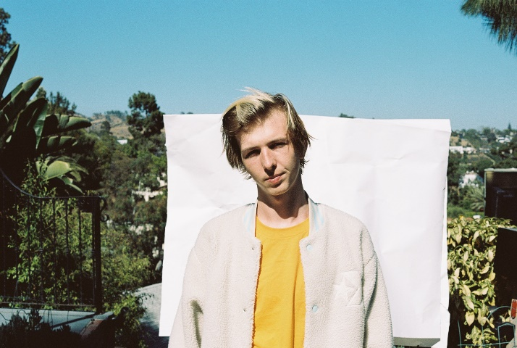
DOWNLOAD WHETHAN PRESS PHOTOS

PRAISE FOR FANTASY: REMIXED SO FAR!
“the partnership further reinforces Whethan's ascent into the world of distinguished electronic music makers.” – EDM.COM

“Whethan‘s debut album, Fantasy, is a genre-bending spectacle that continues to linger through the airwaves here in 2021” – DANCING ASTRONAUT

“As evidenced with his body of work (initially singles), Whethan knows how to entice you into a tightly-crafted world of EDM/pop music” – AMERICAN SONGWRITER

“Tchami transforms Whethan‘s hit collaboration with Oliver Tree, ‘Freefall’ into a soulful house production.” – YOUR EDM

“Any Tchami fan (or any house fan for that matter), will absolutely love this tune.” – THIS SONG IS SICK

“Flux has knocked this one out of the park” – WE RAVE YOU

“Whethan excels at fusing different genres together into unexpected mashups that shouldn’t work on paper. But, he shows that they do” – OFF KILTER

ABOUT WHETHAN
Whethan has quickly become one of electronic dance music’s most in-demand artists, spanning superstar collaborations, blockbuster remixes, and his own extraordinary solo output. Born Ethan Snoreck, the 21-year-old, Chicago-based producer has unleashed a steady stream of viral smashes, making history in 2016 as the youngest ever artist on Australia’s hugely influential Future Classics label while also winning over famous fans including EDM icon Skrillex.

2018 saw the long awaited release of Whethan’s debut EP, LIFE OF A WALLFLOWER VOL. 1, which included collaborations with HONNE, Bipolar Sunshine, Oh Wonder, and Broods, among others, earned widespread critical applause, with Billboard raving, “The whole collection of songs plays perfectly into Whethan’s pastel-colored sonic palette. It’s soft as petals falling in the breeze, but just as bright and intoxicating as cherry blossom perfume. His super-clean production makes even rough-edged noise sound cute. Really, it’s just freakin’ fun.”

This past fall saw the release of Whethan’s highly anticipated debut album FANTASY which featured an array of chart-topping artists such as Oliver Tree, Chrome Sparks, Jaymes Young, Grouplove, The Wombats, The Knocks, Mr Gabriel, The Front Bottoms and RL Grime. The genre-bending album launched Whethan into “one of the most sought-after names in dance music” (FLAUNT), receiving instant praise from outlets such as EDM.com which raved, “FANTASY acutely blends Whethan's quirky avant-electronica sound with the perfect punch of retro pop and rock undertones, making it the perfect display of talent and creativity for the young producer” Dancing Astronaut lauded “Whethan has proven time and time again that talent and uncompromising dedication eclipse all else. Fantasy is both a testament to that unwavering grind, but also an exercise in letting one’s imagination run wild” and This Song is Sick labeled the project “a work of art.”

In addition to his recorded work, Whethan has lit up crowds at countless clubs and top festivals, including Coachella, Lollapalooza, the Billboard Hot 100 Music Festival, Outside Lands, SXSW, and Electric Daisy Carnival, as well as a sold out co-headline show at Morrison, CO’s iconic Red Rocks Amphitheatre and a headline performance at MTV’s Snowglobe Music Festival in South Lake Tahoe, CA.

CONNECT WITH WHETHAN
OFFICIAL | FACEBOOK | TWITTER | INSTAGRAM | YOUTUBE | PRESS ASSETS

For press inquiries, please contact
Jessica Nall // Jessica.Nall@atlanticrecords.com

