FOR IMMEDIATE RELEASE

FEBRUARY 7, 2020

**WHETHAN TEAMS UP WITH GRANDSON FOR ENERGETIC NEW SINGLE, “ALL IN MY HEAD”**

**LIMITED SPRING HEADLINE TOUR DATES TO KICK OFF MARCH 26TH IN LOS ANGELES**

**TICKETS ON SALE NOW** [**HERE**](https://nam04.safelinks.protection.outlook.com/?url=http%3A%2F%2Fwww.whethan.com%2Ftour&data=02%7C01%7CMegan.Rasmussen%40atlanticrecords.com%7C9c4ff282504a48b6822208d7a38729eb%7C8367939002ec4ba1ad3d69da3fdd637e%7C0%7C0%7C637157673220525328&sdata=5ST0rvcvFMQ%2FO9Jb32lCLjcB7W7Bn7MQo1s4sXTMUWY%3D&reserved=0)

**DEBUT FULL-LENGTH ALBUM *FANTASY* COMING SOON**

**LISTEN TO “ALL IN MY HEAD (feat. grandson)”** [**HERE**](https://whethan.lnk.to/AllinMyHead)

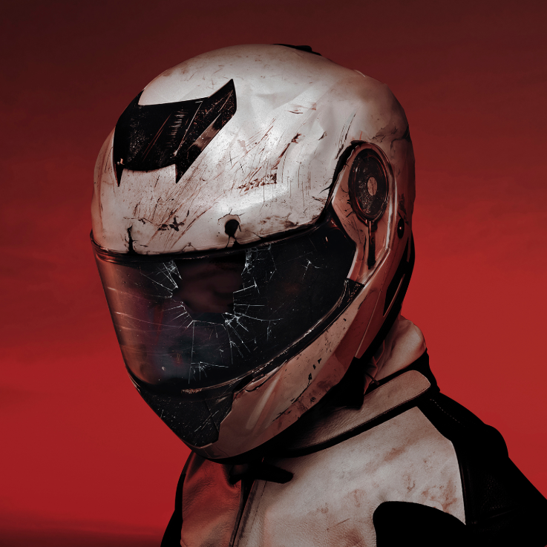

[DOWNLOAD ARTWORK HERE](https://warnermusicgroup.app.box.com/s/ycaoxogphdc6z25qyr0lvykw4qenij12)

Today, acclaimed producer **Whethan** has released “All In My Head” featuring alternative artists and activist [**grandson**](https://nam04.safelinks.protection.outlook.com/?url=http%3A%2F%2Fwww.grandsonmusic.com%2F&data=02%7C01%7CMegan.Rasmussen%40atlanticrecords.com%7C66b09501dd1c40c9460508d7aa8a6173%7C8367939002ec4ba1ad3d69da3fdd637e%7C0%7C0%7C637165383628234500&sdata=Ab3G2kN4IUeERHl9Hc99Q9n66XzL73kA42TO1d5o1qY%3D&reserved=0). “All In My Head” showcases the energy and melody of grandson’s rock compositions alongside **Whethan’s** signature synthesized production. “All In My Head (feat. grandson)” is available now on all streaming platforms and DSPs – listen [HERE](https://nam04.safelinks.protection.outlook.com/?url=https%3A%2F%2Fwhethan.lnk.to%2FAllinMyHead&data=02%7C01%7CMegan.Rasmussen%40atlanticrecords.com%7C66b09501dd1c40c9460508d7aa8a6173%7C8367939002ec4ba1ad3d69da3fdd637e%7C0%7C0%7C637165383628234500&sdata=EVq5728yhKORgp0x2Yd2mZroF62Qk2wo3sdAcXvDcuw%3D&reserved=0).

“All In My Head (feat. grandson)” is the latest single Whethan has unveiled from his forthcoming debut album ***FANTASY****.*  Last month, Whethan released “**Stay Forever (feat. STRFKR)”** available [HERE](https://nam04.safelinks.protection.outlook.com/?url=https%3A%2F%2Fwhethan.lnk.to%2FStayForeverPR&data=02%7C01%7CMegan.Rasmussen%40atlanticrecords.com%7C9c4ff282504a48b6822208d7a38729eb%7C8367939002ec4ba1ad3d69da3fdd637e%7C0%7C0%7C637157673220535326&sdata=xzcejn8D94RzLTFoCnUU2bcfu3MCW8uIMvHaOovu4lY%3D&reserved=0); alongside a  futuristic, TRON-inspired companion video streaming now at Whethan’s official YouTube channel [HERE](https://nam04.safelinks.protection.outlook.com/?url=https%3A%2F%2Fwhethan.lnk.to%2FStayForeverVideoPR&data=02%7C01%7CMegan.Rasmussen%40atlanticrecords.com%7C9c4ff282504a48b6822208d7a38729eb%7C8367939002ec4ba1ad3d69da3fdd637e%7C0%7C0%7C637157673220535326&sdata=m5wrA7TSYeN%2BKI3X2S39U9Uf03Sc9rW77b7iOUFFMIk%3D&reserved=0).

The prodigious producer will kick off his North American headline ‘*Fantasy’* tour March 26th at Los Angeles, CA’s The Novo with additional stops in San Francisco, Chicago, and Brooklyn (see details below). Each date will operate as a pop-up show, providing a sneak peek for what’s to come in addition to special surprises for fans at each stop. **Chrome Sparks** (DJ set) and **Ramzoid** will join **Whethan** as support for the announced dates. In addition to his tour, Whethan will also take the stage at Ultra Music Festival in March. Tickets for all live dates on sale now. For complete details, please visit [www.whethan.com/tour](https://nam04.safelinks.protection.outlook.com/?url=http%3A%2F%2Fwww.whethan.com%2Ftour&data=02%7C01%7CMegan.Rasmussen%40atlanticrecords.com%7C9c4ff282504a48b6822208d7a38729eb%7C8367939002ec4ba1ad3d69da3fdd637e%7C0%7C0%7C637157673220545325&sdata=DzOZfPHVs3FaYjmxx7%2BFoMsg%2BjDDwenr%2B9hXrCMIjKk%3D&reserved=0).

Hailed by Atwood Magazine as “a continuously-developing musical identity that shines by elevating the very best traits of his collaborators,” **Whethan** has quickly become one of electronic dance music’s most in-demand artists, spanning superstar collaborations, blockbuster remixes, and his own extraordinary solo output. The 20-year-old has unleashed a steady stream of viral smashes, making history as the youngest ever artist on Australia’s hugely influential Future Classics label while also over famous fans including EDM icon Skrillex.

Recently, Whethan collaborated with Oliver Tree on “[Cash Machine](http://olivertree.lnk.to/CashMachine)” off the genre-defying sensation’s upcoming album *Ugly is Beautiful.* The long awaited release of **Whethan’s** debut EP, [Life of a Wallflower Vol. 1](https://nam04.safelinks.protection.outlook.com/?url=https%3A%2F%2Fwhethan.lnk.to%2FV1&data=02%7C01%7CMegan.Rasmussen%40atlanticrecords.com%7C9c4ff282504a48b6822208d7a38729eb%7C8367939002ec4ba1ad3d69da3fdd637e%7C0%7C0%7C637157673220545325&sdata=xxgCD0Bi%2BvblqDo84KJ2RV0aLx4R4yAyZl4%2B0oSvbOY%3D&reserved=0), includes collaborations with **HONNE, Bipolar Sunshine, Oh Wonder**, and **Broods**, among others. The EP earned widespread critical applause, with [Billboard](https://nam04.safelinks.protection.outlook.com/?url=https%3A%2F%2Fwww.billboard.com%2Farticles%2Fnews%2Fdance%2F8484146%2Fwhethan-life-of-a-wallflower-vol-1-album-breakdown&data=02%7C01%7CMegan.Rasmussen%40atlanticrecords.com%7C9c4ff282504a48b6822208d7a38729eb%7C8367939002ec4ba1ad3d69da3fdd637e%7C0%7C0%7C637157673220555311&sdata=PRt%2FbTlCJ37k4mYNBOew96UsppvQsN%2FlwQ%2FCPoOZyZ4%3D&reserved=0) raving, “The whole collection of songs plays perfectly into **Whethan’s** pastel-colored sonic palette. It’s soft as petals falling in the breeze, but just as bright and intoxicating as cherry blossom perfume. His super-clean production makes even rough-edged noise sound cute. Really, it’s just freakin’ fun.”

As if that weren’t enough, **Whethan** has released a range of remixes – including his most recent rework of **Foster the People’s “**[Pumped Up Kicks](https://nam04.safelinks.protection.outlook.com/?url=https%3A%2F%2Fwww.youtube.com%2Fwatch%3Fv%3D4SKG-nbWb9k&data=02%7C01%7CMegan.Rasmussen%40atlanticrecords.com%7C9c4ff282504a48b6822208d7a38729eb%7C8367939002ec4ba1ad3d69da3fdd637e%7C0%7C0%7C637157673220555311&sdata=4WXFPCmjLuYiMYDbAxj%2FXL8H3j5J%2Fb9qSI1fckDsyxM%3D&reserved=0),” as well as **Travis Scott X Skrillex’s** “[SICKO MODE](https://nam04.safelinks.protection.outlook.com/?url=https%3A%2F%2Fsoundcloud.com%2Fwhethan%2Fsickomode&data=02%7C01%7CMegan.Rasmussen%40atlanticrecords.com%7C9c4ff282504a48b6822208d7a38729eb%7C8367939002ec4ba1ad3d69da3fdd637e%7C0%7C0%7C637157673220565304&sdata=m6NGbg0PqIG%2BGSyBe3mGYIj%2F768zT8xMpMuVLDPDpQM%3D&reserved=0)” and  **Post Malone x Justin Bieber’s** “[Deja Vu](https://nam04.safelinks.protection.outlook.com/?url=https%3A%2F%2Fsoundcloud.com%2Fwhethan%2Fpost-malone-x-justin-bieber-deja-vu-whethan-remix&data=02%7C01%7CMegan.Rasmussen%40atlanticrecords.com%7C9c4ff282504a48b6822208d7a38729eb%7C8367939002ec4ba1ad3d69da3fdd637e%7C0%7C0%7C637157673220565304&sdata=dEppRlZe1MQCAxoHp4PlRE3Lzh4hB2dRhERDd8fsK%2Fc%3D&reserved=0)” – along with such major league partnerships as frequent collaborator **Oliver Tree’s** “[Movement](https://nam04.safelinks.protection.outlook.com/?url=https%3A%2F%2Folivertree.lnk.to%2FMovement&data=02%7C01%7CMegan.Rasmussen%40atlanticrecords.com%7C9c4ff282504a48b6822208d7a38729eb%7C8367939002ec4ba1ad3d69da3fdd637e%7C0%7C0%7C637157673220575301&sdata=3nMR%2BZaysQYFGAPsRZ12Fy%2BVQy3ynUfexu%2BTqebXCIE%3D&reserved=0)“ (featured in Apple’s iPhone X commercial campaign and weekly on Monday Night Football) and **Wafia’s** acclaimed “[Hurts (Feat. Louis the Child + Whethan)](https://nam04.safelinks.protection.outlook.com/?url=https%3A%2F%2Fatlantic.lnk.to%2FhurtsID&data=02%7C01%7CMegan.Rasmussen%40atlanticrecords.com%7C9c4ff282504a48b6822208d7a38729eb%7C8367939002ec4ba1ad3d69da3fdd637e%7C0%7C0%7C637157673220575301&sdata=KKap03Kl7QhWYCVyk9pjlbQ0szAH6cUc7F1QLAjSvLE%3D&reserved=0).”

In addition to his recorded work, **Whethan** has lit up crowds at countless clubs and top festivals, including **Coachella, Lollapalooza, Billboard Hot 100 Music Festival, Outside Lands, SXSW**, and **Electric Daisy Carnival**, to name but a few. Recent highlights include a sold-out co-headline show at Morrison, CO’s iconic Red Rocks Amphitheatre and a headline performance at MTV’s year-ending Snowglobe Music Festival in South Lake Tahoe, CA as well as a massive New Years Eve performance at Decadence Festival in Colorado.

# # #

CONNECT WITH WETHAN

[OFFICIAL](https://nam04.safelinks.protection.outlook.com/?url=https%3A%2F%2Fwww.whethan.com%2F&data=02%7C01%7CJessica.Nall%40atlanticrecords.com%7C2c85efd94cdc40f5ae4108d795eea2cc%7C8367939002ec4ba1ad3d69da3fdd637e%7C0%7C0%7C637142725578082206&sdata=EWi%2FITedPK3mNmJuPbyZjNfYD5sZ4eHqZEP%2Bb2hKrv0%3D&reserved=0)

[FACEBOOK](https://nam04.safelinks.protection.outlook.com/?url=https%3A%2F%2Fwww.facebook.com%2Fwhethanmusic&data=02%7C01%7CJessica.Nall%40atlanticrecords.com%7C2c85efd94cdc40f5ae4108d795eea2cc%7C8367939002ec4ba1ad3d69da3fdd637e%7C0%7C0%7C637142725578092196&sdata=%2BniDhZmrx6wZLHo19UMb4vvbS%2Fu87uguW%2FnZaxeWtJM%3D&reserved=0)

[TWITTER](https://nam04.safelinks.protection.outlook.com/?url=https%3A%2F%2Ftwitter.com%2Fwhethanmusic&data=02%7C01%7CJessica.Nall%40atlanticrecords.com%7C2c85efd94cdc40f5ae4108d795eea2cc%7C8367939002ec4ba1ad3d69da3fdd637e%7C0%7C0%7C637142725578092196&sdata=NjSL%2FDgB5j%2FCHSZEaeK00b7tZJFywLJIbq8hq1mPCvo%3D&reserved=0)

[INSTAGRAM](https://nam04.safelinks.protection.outlook.com/?url=https%3A%2F%2Fwww.instagram.com%2Fwhethan%2F&data=02%7C01%7CJessica.Nall%40atlanticrecords.com%7C2c85efd94cdc40f5ae4108d795eea2cc%7C8367939002ec4ba1ad3d69da3fdd637e%7C0%7C0%7C637142725578102197&sdata=3sNSn6NgzPkNzI8RnpsYw2tlE5CnGQkTwh66cw2R8QU%3D&reserved=0)

[YOUTUBE](https://nam04.safelinks.protection.outlook.com/?url=https%3A%2F%2Fwww.youtube.com%2Fwhethan&data=02%7C01%7CJessica.Nall%40atlanticrecords.com%7C2c85efd94cdc40f5ae4108d795eea2cc%7C8367939002ec4ba1ad3d69da3fdd637e%7C0%7C0%7C637142725578112194&sdata=RDXX0QOphibhc%2ByEan1FKd%2FbyXYky4qOFmQHORpDdwA%3D&reserved=0)

[PRESS ASSESTS](https://nam04.safelinks.protection.outlook.com/?url=http%3A%2F%2Fpress.wearebigbeat.com%2Fartists%2Fwhethan&data=02%7C01%7CJessica.Nall%40atlanticrecords.com%7C2c85efd94cdc40f5ae4108d795eea2cc%7C8367939002ec4ba1ad3d69da3fdd637e%7C0%7C0%7C637142725578112194&sdata=eJigOKZ9K4bj5McnzyZE5se%2Bsa%2BKTKDpCRlAqQr9drY%3D&reserved=0)

Press requests:

Jessica Nall / [Jessica.nall@atlanticrecords.com](mailto:Jessica.nall@atlanticrecords.com)

**WHETHAN**

**FANTASY TOUR – NORTH AMERICA 2020**

MARCH

26 – Los Angeles, CA – The Novo

27 – San Francisco, CA – The Warfield

APRIL

2 – Chicago, IL – The Riviera Theatre

4 – Brooklyn, NY – Brooklyn Steel

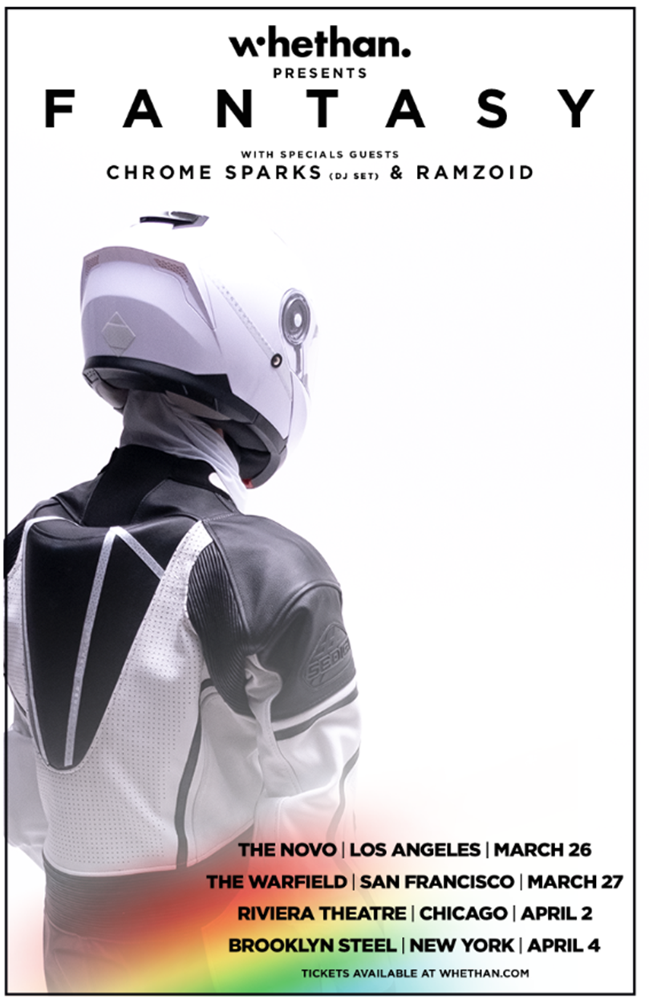

[*DOWNLOAD OFFICIAL ART*](https://www.dropbox.com/s/zxymuprf5jfj0dr/Whethan_Fantasy_MainAdmat.jpg?dl=0)