WHIPPED CREAM CAPS OFF MASSIVE 2020 WITH RELEASE OF
“TOLD YA” REMIX PACKAGE

LISTEN HERE: https://bigbeat.lnk.to/ToldYaRemixesPR

“WHO IS WHIPPED CREAM?” EPISODE 2 OUT NOW
WATCH HERE

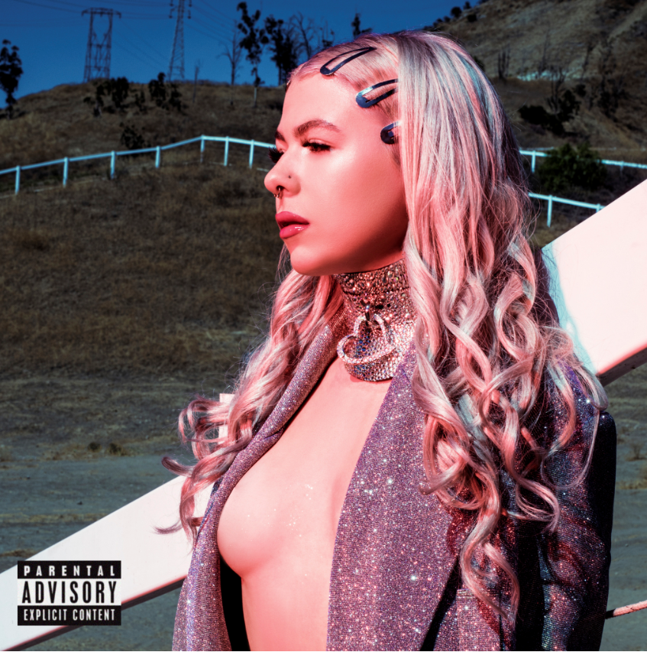

2020 has been a whirlwind year for the genre-defying artist WHIPPED CREAM. After dropping her massive debut WHO IS WHIPPED CREAM EP to critical acclaim across the globe, the rising star has been steadily dropping remixes for its stand-out singles, “I Won’t Let You Fall,” “Dumb Sh!t” (ft. Jasiah) and now, the EP’s hip-hop infused trap banger “Told Ya” (ft. Lil Xan) gets its own remix package. LISTEN HERE.

Out now through Big Beat Records, WHIPPED CREAM wanted to treat her fans to one last surprise as she wraps up her dizzying year. The dubstep-leaning remix come courtesy of BOM, whose throbbing, bass-heavy rework is sure to be a 2021 dance floor staple, while the British grime producer MONXX infuses his remix with bass house, complete with a wobbly drop.

“Was so pumped to throw this remix together for my girl Whipped Cream. The original track was already fire so I just took the best elements and gave them some oomph. Blast this thru ya speakers heavy for me 😈” said BOM.

“I enjoyed the original, it was a pleasure to put a wonky twist on it” says MONXX.

From being featured as one of Billboard Dance’s “Ones to Watch” and Mixmag hailing WHIPPED CREAM as one of the “most exciting new names in bass music”, it’s clear that the genre-defying producer has already made her mark on the music industry, and has no signs of slowing down anytime soon. With boundless style, a frenzied work ethic, and a year for the history books capped, there’s no telling what WHIPPED CREAM will bring to 2021, but one thing is for sure… we’re ready for it.

CONNECT WITH WHIPPED CREAM:
Instagram | Facebook | Twitter | Spotify

PRESS ASSETS: https://press.wearebigbeat.com/artists/whipped-cream/

FOR MORE INFORMATION:
Paige Rosoff – Big Beat Records
Paige.Rosoff@atlanticrecords.com

