VASCO CHANNELS LOVE AND NOSTALGIA IN SOPHOMORE SINGLE
“N NOW I FEEL LIKE”
ARRIVING IN TIME FOR VALENTINE’S DAY
OUT NOW VIA BIG BEAT RECORDS

LISTEN/SHARE: https://youtu.be/ggqxxErVkeA
BUY/STREAM: https://BigBeat.lnk.to/VNNFLPR
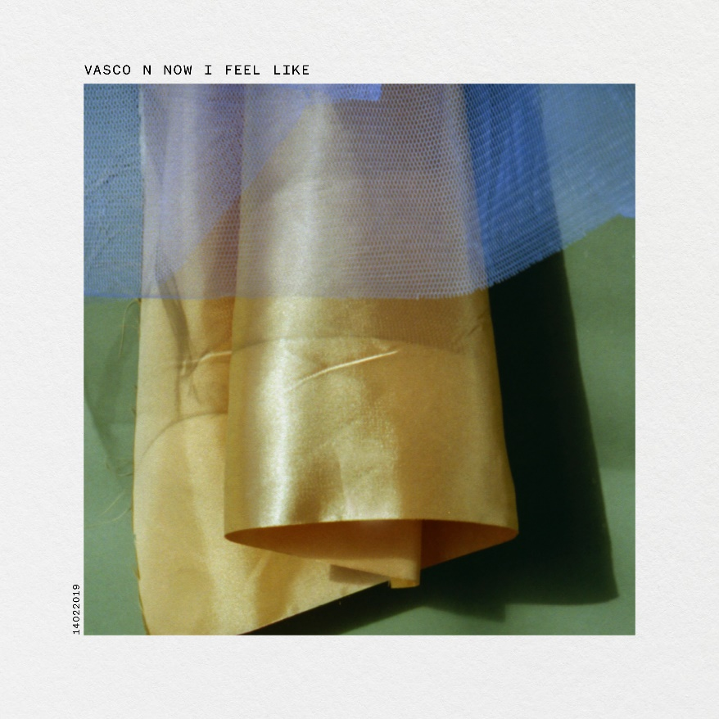
(DOWNLOAD TRACK ARTWORK + OTHER ASSETS HERE)

““Leave it to Danish producer Nick Labajewska Madsen, aka Vasco, to nail that hazy, lost loving feeling with “N’ Now I Feel Like”” – BlackBook

“…with his minimal, intriguing, yet utterly captivating way of threading sound, there’s much to look forward to upon its March 8th release.” – BlackBook

“…ethereal, electronic... and minimal, abstract instrumental sounds with a pop twist...” – V Magazine

“…left-leaning pop production…” –as-told-to NYLON by Terror Jr.

Danish producer Vasco puts heart in sophomore track “N Now I Feel Like” out today as a Valentine to fans awaiting his forthcoming debut “Tender Luv” EP arriving on March 8th via Big Beat Records – WATCH HERE! The visualizer follows the Jonas Bang-directed “Diamond Rings” music video (WATCH HERE) which saw Nick Labajewska Madsen, aka Vasco, step out from behind the studio console where he’s worked behind the scenes in production with the likes of MØ, Terror Jr, Soleima and Baauer to name a few. The vocal performances on Vasco’s music (including the ‘Tender Luv’ EP track list included below) showcase some of the producer’s close circle of music collaborators. Fans may recognize the distinct vocals of these artists, though their names remain uncredited to display Nick’s uncompromising intention to stand on his own feet from the start of his solo career as Vasco.

“N Now I Feel Like is a song about nostalgia and past time,” Vasco remembers and recalls the heartfelt inspiration and emotion behind the track: “It’s about growing up and still longing for the innocent feeling of youth, while adjusting to the feeling, that life is a progress and no feeling is static. Written with my very good friends of the band Scarlet Pleasure and sung by lead singer Emil. I think his voice and the lyrics speaks to a memory in everybody, and the video made by Jonas Bang is associating the thin curtain blowing in the wind with how life just happens and disappears. The release on Valentine’s Day was important because it is often through childhood lovers that the memories are strongest; that is important to remember and stand by instead of regretting lost love.”

Vasco ‘Tender Luv’ EP track list
(Arrives March 8th via Big Beat Records)
1. Running Wild
2. N’ Now I Feel Like
3. Diamond Rings
4. Everybody Needs Someone
5. I Don’t Wanna Waste Love
6. I Guess I Should Have Loved You

Connect with Vasco:
Twitter | Instagram | Facebook
For press assets, visit: http://press.wearebigbeat.com/artists/vasco/

Press Contacts:
Jordan Danielle Frazes - Jordan.Frazes@atlanticrecords.com
Paige Rosoff – Paige.Rosoff@atlanticrecords.com

