SWEDISH/NORWEGIAN DUO TUNGEVAAG & RAABAN

DELIVER A FRESH NEW RELEASE, “BAD BOY,” ALONGSIDE ACCOMPANYING MUSIC VIDEO

OUT TODAY VIA BIG BEAT RECORDS

WATCH / POST: https://youtu.be/WCTjFHyvEaM
BUY/STREAM: https://BigBeat.lnk.to/TNRBB

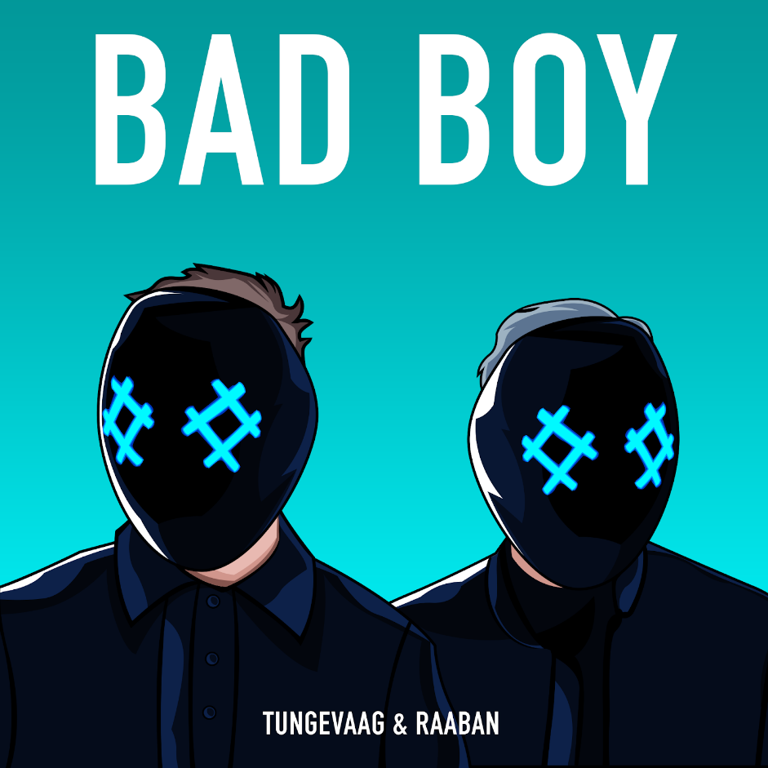
Download album art HERE

After successful, pop-flavored EDM anthems such as “All For Love”, “Russian Roulette” and “Wolf”, the Swedish/Norwegian duo Tungevaag & Raaban have come through once again with their latest dancehall-tinged single, "Bad Boy," out today via Big Beat Records. Listen HERE!

“Bad Boy” delivers some serious danceability. The song is infused with inspiration from a variety of genres like electro, dancehall, soca and trap, all of which make the production both inspired and exciting. The track is taken over the top with powerful vocals that are packed with some serious swagger. All of the elements perfectly intertwine to create an addictive vibe. The visual stays true to “Bad Boy’s” name, and appropriately features Tungevaag & Raaban causing absolute mayhem all over the streets of Las Vegas.

Tungevaag & Raaban, who have been creating music together since they joined forces in 2015, believe that the single marks an important creative moment for the collective. “‘Bad Boy’ became a milestone for us. We have been wanting to develop our sound and find new interesting ways to create dance music for a long time now,” says Tungevaag & Raaban. “During the creation of ‘Bad Boy,’ we had several new ideas and it created a snowball effect. We started working on it over a year ago, and we are really looking forward to the release! Here comes the updated/upgraded Tungevaag & Raaban,” declares the group.

Tungevaag & Raaban released the single "All For Love" earlier this year. The song, which became a summer hit, achieved great success on the Swedish, Norwegian and Finnish charts. The duo had several shows during this summer, including Summerburst's biggest stage in both Gothenburg and Stockholm in Sweden.
***
Connect with Tungevaag & Raaban:
SOUNDCLOUD I FACEBOOK I TWITTER | INSTAGRAM |PRESS ASSETS

For more information:
For “Tungevaag & Raaban” press inquiries:
Lindsay Herr: Publicity, The Wanderlvst
Lindsay@thewanderlvst.com

For Big Beat Records inquiries:
Jordan Frazes: Head of Publicity, Big Beat Records
Jordan.Frazes@atlanticrecords.com

