TOBTOK & MAHALO TEAM UP FOR THIS TOWN (FEAT. TIMPO)
Listen here: https://youtu.be/gqha0a7dtPM
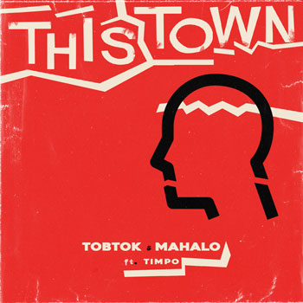
DL art

“Mahalo, Tobtok, and Timpo have woven their explorative personas together to compose one of the most inviting and flavorsome tunes of the summer thus far.” -The Nocturnal Times

Standout DJ/producers Tobtok and Mahalo jointly deliver their brand new single ‘This Town’ featuring vocals from UK singer-songwriter Timpo today. Listen HERE.
27-year-old Tobtok aka Tobias Karlsson, is one of the most talented artists leading the new wave of Swedish electronic music DJ / producers. He has generated over 300+ million streams across his music globally with a double platinum record to his name in Australia with ‘Fast Car’ and enjoyed consistent regular DJ and radio support from the likes of BBC Radio 1, KISS FM, Capital Xtra and more and is in high demand as a remixer and producer for other artists such as Joel Corry, L Devine, HRVY, Alex Ross, Karen Harding, Kesha and more.
With the success of his productions and remixes, Tobtok has had the opportunity to showcase his skills as a DJ with hugely respected house label, Toolroom, who invited him to provide a mix for their ‘Miami Poolside’ album series, he has graced the decks at a number of venues around the world including Ushuaia in Ibiza 6 times to date, and played The Warehouse Project, Village Underground and multiple Kitsuné parties. He’s appeared at festivals such as Creamfields, Sziget and Summerfade, as well as toured across the USA three times with his own headline dates. Tobtok has also enjoyed releases on labels such as Ministry of Sound, Astralwerks, Toolroom., Hexagon, Kitsune and Good Soldier. With more massive tracks, collaborations and DJ sets lined up, Tobtok is ready to break through in a big way.
Hailing from the shores of Hawai’i and setting up shop in Southern California, Mahalo has quickly made a name for himself as one of the newest rising stars of the global dance music machine. By blurring the lines sonically and creating cutting edge material branded as his signature sound "liquid house", this young producer has managed to gain the support of an impressive amount of many of the world’s biggest DJs, producers and tastemakers while also performing at some of the most coveted festivals in North America such as Electric Daisy Carnival, Groove Cruise, Nocturnal Wonderland and Countdown.
Mahalo's 2019 breakout single 'So Cold' (released on Perfect Havoc / Armada) set a benchmark for future success journeying 15 weeks on the Billboard Dance/Mix Show Airplay chart eventually rising to #1, while also taking the top spot on the Mediabase US Dance Radio chart and achieving over 20 million streams globally. With releases on labels like Tiesto’s AFTR:HRS Records, Mark Knight’s Toolroom Records, Armin van Buuren’s Armada Music and various other taste making labels such as Enormous Tunes, Bunny Tiger, and Insomniac Records - it’s no wonder why the world is starting to take notice of this promising talent whose future looks more than bright.
Follow Tobtok  https://www.instagram.com/tobtokmusic  https://twitter.com/tobtok  http://www.facebook.com/tobtok | Follow Mahalo  http://www.instagram.com/mahalo_dj  http://www.facebook.com/mahalo.muisc  http://www.twitter.com/mahalo_dj
Press assets: https://press.wearebigbeat.com/singles/tobtok-mahalo/
Press contact: gabrielle.reese@atlanticrecords.com

