DANISH BREAKOUT SINGER/SONGWRITER SOLEIMA
RELEASES TRANSCENDENT NEW SINGLE, “FORCE OF NATURE”

LISTEN HERE: https://bigbeat.lnk.to/SoleimaFONID

OUT TODAY VIA BIG BEAT RECORDS

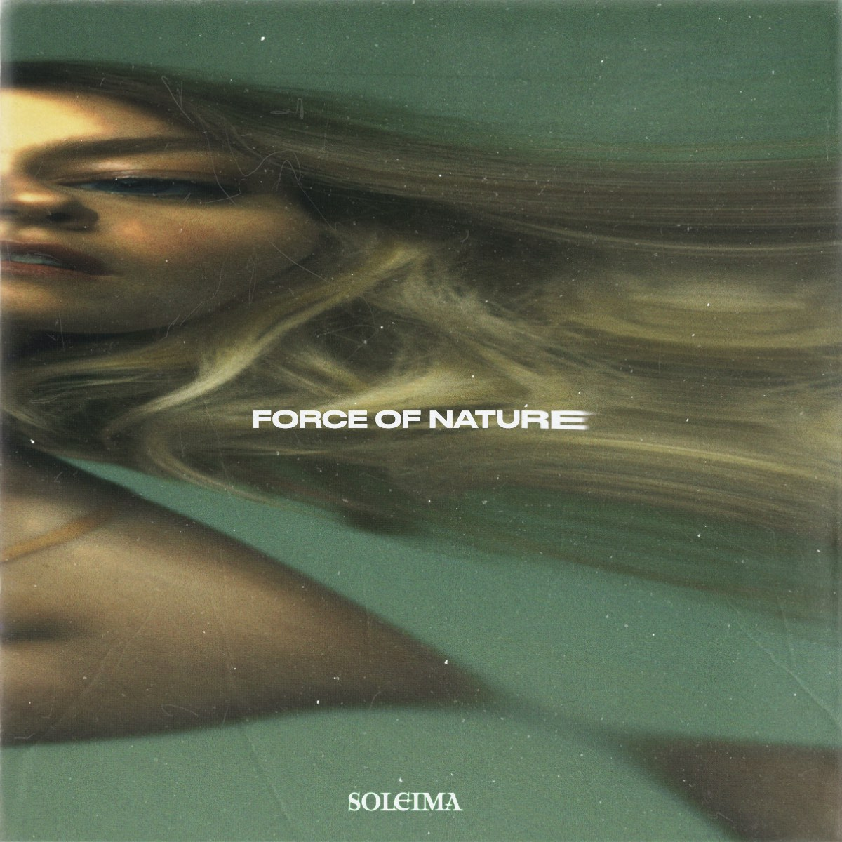

Scandinavia has long been synonymous with cultivating icy-cool pop artists, but none stands out more in recent memory than the versatile Danish singer/songwriter and political pop artist Soleima, who has devised an otherworldly sound all her own. Boasting an inimitable voice that’s simultaneously placid and powerful, Soleima is now releasing a transcendent new single called “Force of Nature” today through Big Beat Records. Her first new release since her album Powerslide came out in March, “Force of Nature” is perfectly exemplary of Soleima’s deftly unique songwriting and style; opening with only a sparse acoustic guitar backing her up, the emotionally powerful track steadily unfurls with richly layered instrumental accompaniment, resulting in an epic new single - LISTEN HERE.

Tallying over 32 million streams to her name and counting and known for her cutting-edge productions with immediate pop songwriting at its core, Soleima’s songs also navigate relatable lyrical themes that explore societal issues, and the very meaning of what it is to be human. A highbrow press darling, Soleima has received praise from PAPER, Refinery29, Pop Crush, C-Heads, Red Bull, Bellus, Ones To Watch, LADYGUNN, L’Officiel, and more. She even received high praise from BBC Radio 1’s Annie Mac, who selected Soleima as one her coveted New Names (ones to watch) on her show!

The effortlessly talented singer/songwriter was born and raised in Denmark, drawing inspiration and honing her style from many genres and life experiences, including time spent at an African dance camp and pursuing a degree in Anthropology. Her breakout 2018 single “Low Life” was selected as one of Billboard’s “20 Great Pop Songs from 2018” along with being featured on the Spotify US Viral Chart following its release. Soleima continued her streak of critical acclaim in 2019, thanks to Refinery29 nominating her single “STFU” for their Song of the Year, along with a massively successful first official North American tour in support of Electric Guest.

With her debut album Powerslide in contention for one of the best pop albums of the year, and its brand-new follow-up single “Force of Nature” officially out today and destined for high praise, Soleima already has her sights set on 2021.

CONNECT WITH SOLEIMA:
Instagram | Facebook | Twitter | Spotify

PRESS ASSETS: https://press.wearebigbeat.com/artists/soleima/

FOR MORE INFORMATION:
Paige Rosoff – Big Beat Records
Paige.Rosoff@atlanticrecords.com

