Danish songwriter/producer Soleima demands creative experimentation on new mini album “Bulldog” out today!

LISTEN/POST: https://bit.ly/2uPNgEK
BUY/STREAM: https://BigBeat.lnk.to/BulldogPR

“Modernist pop perfection.” – PAPER

“Music that's moody, dancy and garnering quite a few MØ comparisons.” – Noisey

“We’re absolutely mesmerized by Soleima’s vocals and are convinced that she’s what’s next in the pop world.” – Milk

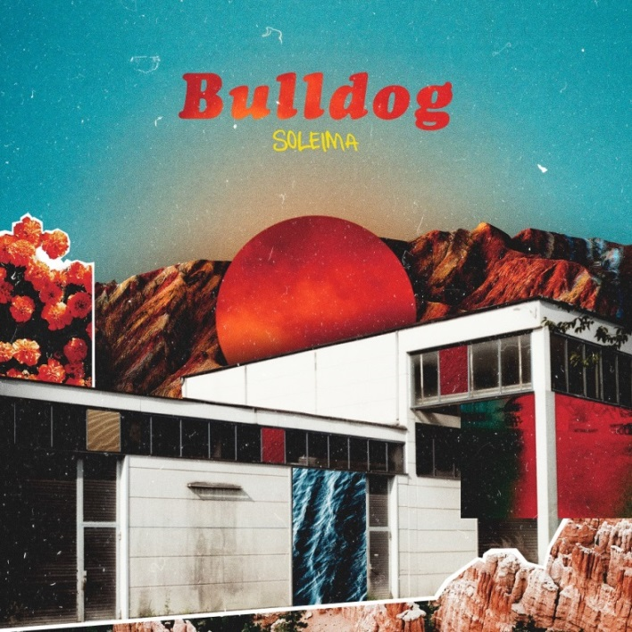

(Soleima photo by Morten Rygaard)

Copenhagen-based singer, songwriter and producer Soleima’s recent EP ‘No. 14’ resulted in widespread critical acclaim and recognition – including Talent of the Year at the major Danish award ceremony P3 Guld and Best Newcomer at the Danish Music Awards. Meanwhile, Radio 1’s Annie Mac highlighted Soleima as a New Name.

Now, Soleima returns with the release of her sophomore mini album, “Bulldog,” out today via Big Beat Records – listen here!

Soleima’s quirkiness, closeness, and unconventional pop sensibilities shape this new release inspired by the space of ultimate creative freedom: “These new tracks are some of the most experimental tracks I’ve ever done. I think it’s important to continuously release songs like this, both personally, but also so that our music doesn’t get too homogenized and generic. That’s always a challenge when you’re trying to fit into a certain box, and then we, as artists, tend to create very similar stuff,” Soleima reveals in her Gaffa cover story (the largest music magazine in Scandinavia) which is on stands now.

“Bulldog” challenges the dominant perception of “pop music” and comes as a result of “focusing on the songwriting process and staying creative, instead of trying to make the music fit into a time or sound,” Soleima explains. She continues, “Actually that’s how it should always be, but sometimes you just need to remind yourself.” Through the years ‘left of center’ songs have shaped what will later become popular music. Soleima believes the ability to challenge music rules, is what changes our idea of what’s allowed and how music should sound. It is exactly that kind of freedom the musical playground that Soleima requires of herself when writing and producing music. It’s her driving force and inspiration as an artist.

Soleima describes the tracks from Bulldog:

“The single, ‘Low Life’ is a song written for my brother. It’s a celebration of people who fight for a better life, in spite of what life might throw at you. ‘Pacify Me’ is a song that touches upon that moment in a relationship where everything seems safe. It touches upon the ambivalence of being ecstatic and safe, but still scared of the ordinary. ‘Bulldog’ is about being obsessed with someone for a period of time. In the same way that things can be ‘trendy’ in life, so can people. ‘Waterloo’ is actually a smaller part of a full song that might be released some other time – about being each other’s downfall. ‘Friend’ describes that special type of love you can feel for your friend when you’re really drunk! I wrote it in a bar, when my friend was on the phone forever. We grew up together and I was feeling extremely nostalgic about our time together.”

CONNECT: Facebook | Twitter | Instagram | SoundCloud | YouTube | Press Site

##

For more information please contact:

Jordan Danielle Frazes
Head of Publicity, Big Beat Records
Jordan.Frazes@atlanticrecords.com

