SNAVS AND UNKWN COMBINE FORCES FOR MASSIVE BASS SINGLE, “I CAN FEEL”

LISTEN HERE: https://BigBeat.lnk.to/ICFPR

OUT TODAY VIA BIG BEAT RECORDS!

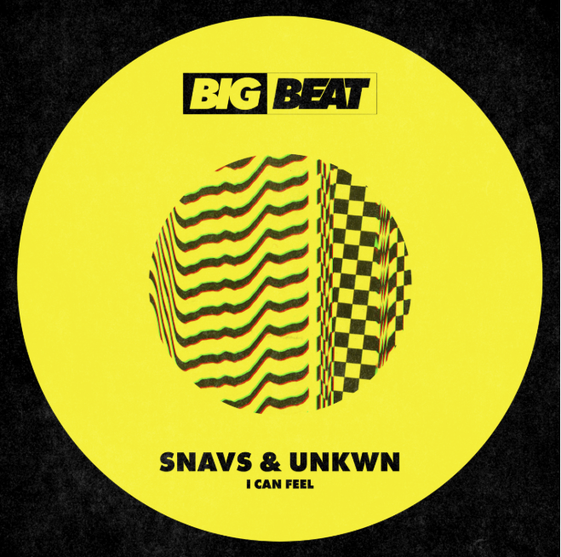
DL art here

Copenhagen-based DJ/producer Snavs has teamed up with the enigmatic UNKWN for their latest heavy hitter, “I Can Feel”, out today through Big Beat Records. LISTEN HERE! “I Can Feel” is perfectly representative of Snavs and UNKWN’s utterly unique production styles, combining elements of bass, house and trap for a diverse sound design that any dance music fan can appreciate.

Snavs has been active within the scene since 2013, when he released his debut 808% EP. Since then, his music has been supported by Diplo, Skrillex, DJ Snake, Martin Garrix, Major Lazer, The Chainsmokers, Tiesto and more. He has worked with influential electronic labels including Barong Family, Monstercat, STMPD RCRDS, Mad Decent, Kannibalen Records, Musical Freedom and Spinnin’ Records. In 2018, he released his first full-length album via his own label Riotville Records. Snavs has also hit the road, playing sold-out shows across the world, including Australia, Asia, Europe and the US.

With the artist name UNKWN, it’s no surprise there is little to discover about the identity of this mysterious artist. Curiously experimental, UNKWN can be identified by his brooding yet incredibly powerful trap cuts. Discovered on SoundCloud by Quality Goods Records boss UZ in 2016, his remix of UZ & ATLien’s ‘Cavern’ went on to be released on the label. The next year saw collaborations with Fabian Mazur, Maliboux and WIDE AWAKE, whilst UNKWN produced an official remix for UZ’s ‘Layers’ LP. In 2018, UNKWN produced official remakes for both Diplo and Zedd, counting continued support from artists including Troyboi, Diplo, Zedd, Tiesto and Alison Wonderland. The profile of the covert UNKWN is on the rise –

CONNECT WITH SNAVS:
Instagram | Facebook | Twitter | Spotify | Apple Music

CONNECT WITH UNKWN:
Instagram | Facebook | Twitter | Spotify | Apple Music

Press assets: http://press.wearebigbeat.com/singles/snavsunkwn/
Press contact: Gabrielle.reese@atlanticrecords.com

