SLATIN DROPS MODULAR NEW SINGLE “APPLE JUICE” FEATURING CARLA MONROE OUT NOW ON BIG BEAT RECORDS
LISTEN/SHARE: https://youtu.be/rqMYe5SlAqU
STREAM/BUY: https://BigBeat.lnk.to/AJPR

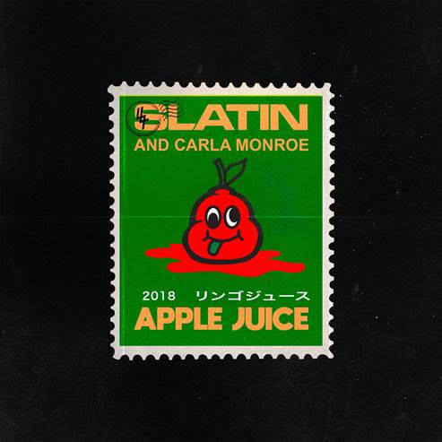
Album artwork available for download HERE

Ruslan Slatin, who performs under the name SLATIN, is a Russian-Spanish multiple genre producer and DJ. Today he unleashes his latest record “Apple Juice” Featuring UK based artist and songwriter Carla Monroe via Big Beat Records - LISTEN HERE. Dynamic bassline, funky vocals, and a bounce from the get-go, “Apple Juice” is a guaranteed get your feet moving on dance floors grooving worldwide. Carla shares, “The song “Apple Juice” is about a sweet feeling of happiness in the haze of a drunken hour. Spending the night dancing and celebrating with the friends you came with and making new friends as the night goes on. The song takes you on a journey from the moment you step into the club to feeling the after-effects of the “Apple Juice” the following morning.”
“Apple Juice” is the first “Modular House” series developed by SLATIN. His main idea is to integrate modular synthesis in a way no one did before. SLATIN gets all his underground influences from techno and house music and combines them into hybrid analog-digital tracks that everyone could listen to. Blending together the best from the past and the future, SLATIN aims to deliver the weirdest sounds to the broadest audience making them dance all around the globe.

###

MORE ABOUT SLATIN
His sets are famous for the variety of uplifted house music and a big hip-hop influence that make them dance at all the clubs around the world. Starting his music career at a young age he won his first turntablism contests in Moscow being only 14 years old.
At the age of 21, after being s part of the Spanish nightlife organizing underground parties, he started his residency at Pacha (La Pineda) the biggest Pacha club in the world, playing every day with the most famous DJ’s and Pop Stars of the moment.
His first track was signed by Spinnin’ Records, in which he released on Ultra Records and consolidated two videos on Spinnin’ TV, all while winning an award for the best dance music track of the year in Spain.
SLATIN officially remixed iconic artists such as Giorgio Moroder, Krewella, A-trak, Laidback Luke, Redman, Tommie Sunshine and Angelz among others.
His genuine sound is currently attracting a ton of buzz and notoriety.
###
Soundcloud | Facebook | Spotify I Instagram I Twitter

For more press tools: http://press.wearebigbeat.com/singles/apple-juice-slatin-ft-carla-monroe/

For more information:
For Big Beat Records inquiries:
Paige Rosoff: Publicity Manager, Big Beat Records
Jordan.Frazes@atlanticrecords.com

SLATIN press inquiries:
Lindsay Herr: Publicity, The Wanderlvst
Lindsay@thewanderlvst.com

