**SHIP WREK RELEASE DEBUT EP “MIRROR MIRROR”**

**LISTEN HERE:** [https://BigBeat.lnk.to/epMirrorMirrorPR](https://nam04.safelinks.protection.outlook.com/?url=https%3A%2F%2Fbigbeat.lnk.to%2FepMirrorMirrorPR&data=02%7C01%7CPaige.Rosoff%40atlanticrecords.com%7Cdec1b7c5001c47d4488708d7c7575517%7C8367939002ec4ba1ad3d69da3fdd637e%7C0%7C0%7C637197050215979382&sdata=7bR1cgB7jCx7AjeC7AcbRbyUzKMYWHD%2BXQy3S11V9Zs%3D&reserved=0)

**OUT TODAY VIA BIG BEAT RECORDS!**

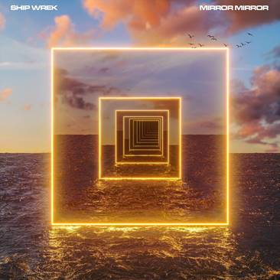

The fast-rising DJ/production duo, **Ship Wrek**, has been on a prolific tear, releasing house banger after house banger, and today sees the long-awaited release of their debut EP for **Big Beat Records**, “Mirror Mirror”.The EP is officially out today, alongside an official music video for their collaborative track with **Dillon Francis** called “**It’s My House**”. “It’s My House” features Ship Wrek’s anthemic, throbbing house production, complete with elastic basslines and glitchy, manipulated vocals. Between “It’s My House” and previously released massive singles “**Danger**” and “**Bloodstream**” that have been tearing up the dancefloors, Ship Wrek has established themselves as a sonic force to be reckoned with on “Mirror Mirror”- **LISTEN** [**HERE**](https://BigBeat.lnk.to/epMirrorMirrorPR)**!**

Ship Wrek is comprised of Tripp Churchill and Collin Maguire who have had massive success after getting their start remixing their favorite dance records; heavyweight DJs and producers like **Skrillex** have been playing Ship Wrek’s edits for the past year. Their bootleg of Skrillex & **Boys Noize** “Turn Off The Lights” was also recently included in **Dog Blood**’s [“Clap Back Vol 1” mix](https://nam04.safelinks.protection.outlook.com/?url=https%3A%2F%2Fsoundcloud.com%2Fdogblood%2Fclap-back-vol-1&data=02%7C01%7CPaige.Rosoff%40atlanticrecords.com%7C5c908459e41c461506bd08d7c6de3324%7C8367939002ec4ba1ad3d69da3fdd637e%7C0%7C0%7C637196529952319706&sdata=6jN0aJqE3HAD7A%2Bk6i9XZM%2FnqvBg5fmR%2BMWqLbp%2FcNA%3D&reserved=0), marking one of the duo’s first big breaks. Ship Wrek has been one of the most prolific production teams in the electronic scene as of late, having been commissioned for recent official remixes for **DJ Snake** and **A R I Z O N A**. After only three years of releasing music, their discography now boasts **over 10 million streams**, while still very much on the rise.

Dillon Francis has taken Ship Wrek under his wing in a big way, taking them out as support for a handful of shows and even booking them to perform at Francis’ latest EP release party in LA back to back with **Alison Wonderland** and **Valentino Khan**. With support already rooted firmly in place from massive EDM artists like **Diplo**, **Jauz**, **The Chainsmokers**, **Zedd**, and **Tiesto**, the sky’s the limit for Ship Wrek, and the future keeps looking brighter and brighter.

**“MIRROR MIRROR”EP TRACKLIST**

1. Danger

2. It’s My House (with Dillon Francis)

3. Bloodstream

4. Mirror Mirror

5. Fell for You

**CONNECT WITH SHIP WREK:**

[Instagram](https://www.instagram.com/shipwrekdj) | [Facebook](https://www.facebook.com/ShipWrekDJ) | [Twitter](https://twitter.com/ShipWrekDJ) | [Spotify](https://open.spotify.com/artist/1ic0FHNGIjXZAWH6O6Reif)

**PRESS ASSETS:** <https://press.wearebigbeat.com/singles/ship-wrek/>

**FOR MORE INFORMATION:**

Paige Rosoff – Big Beat Records

[Paige.Rosoff@atlanticrecords.com](mailto:Paige.Rosoff@atlanticrecords.com)