SHIP WREK RELEASE ANTHEMIC NEW SINGLE “DANGER”

OUT TODAY VIA BIG BEAT RECORDS

LISTEN HERE

‘MIRROR MIRROR’ EP OUT 3/13

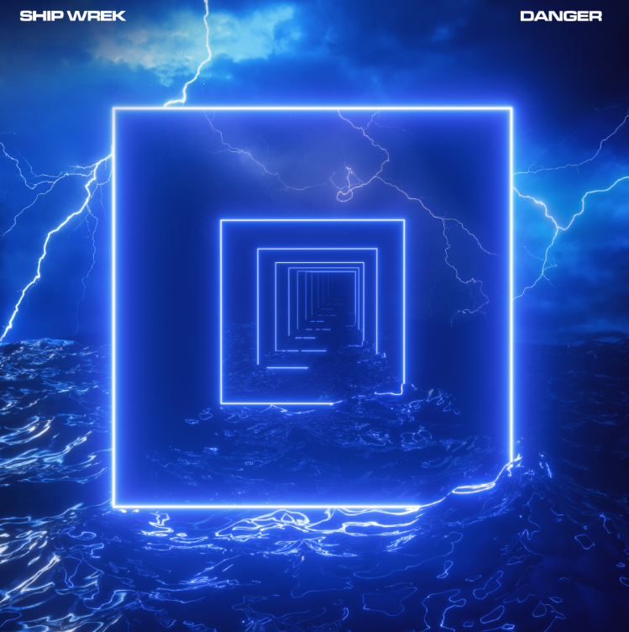

LA’s fast-rising, party-starting DJ/production duo Ship Wrek is set to drop their new Mirror Mirror EP on March 13th through Big Beat Records, but to build anticipation in the lead-up, they’re releasing one final single from the EP today called “Danger”. Driven by a propulsive, wobbly bassline, the anthemic track combines elements of EDM and classic house with a head-spinning drop that will keep dance floors going wild all summer long - LISTEN HERE!

The duo is composed of Tripp Churchill and Collin Maguire who have had massive success with bootlegging their favorite dance records; in fact, artists like Skrillex have been playing Ship Wrek’s bootleg in recent DJ sets! Their bootleg of Skrillex & Boys Noize “Turn Off The Lights” was also recently included in Dog Blood’s “Clap Back Vol 1” mix. The duo has been one of the most prolific production teams in the electronic realm as of late, having been commissioned for recent official remixes for DJ Snake and A R I Z O N A.

Ship Wrek also recently befriended the dance titan Dillon Francis, who’s taken them out as support on the road for a handful of shows. They even performed at Dillon Francis’ latest EP release party in LA back to back with Alison Wonderland and Valentino Khan. Fans of Ship Wrek and Dillon Francis will be excited to know that the two are currently hard at work putting finishing touches on an animated music video for Mirror Mirror’s focus track “It’s My House,” which features production and vocals from Francis.

Having only been releasing music for three years, Ship Wrek’s discography already boasts over 10 million streams and counting; between that and their ever-growing social media numbers and prolific output, it’s safe to say that Ship Wrek is here to stay. Before inking a deal with Big Beat Records, Ship Wrek previously released music on iconic dance labels like Spinnin’, Aramada, and Bite This! With their momentum on the rise and Mirror Mirror’s release on the near horizon, Ship Wrek is an artist to watch in 2020!

CONNECT WITH SHIP WREK:
Instagram | Facebook | Twitter | Spotify

PRESS ASSETS: https://press.wearebigbeat.com/singles/ship-wrek/

FOR MORE INFORMATION:
Paige Rosoff – Big Beat Records
Paige.Rosoff@atlanticrecords.com

