SAMARAN UNLEASHES FUNKY FRENCH HOUSE JAM

“A NEW BEGINNING”

OUT NOW ON BIG BEAT RECORDS

LISTEN/SHARE: https://youtu.be/fl1TWFUW-p0
BUY/STREAM: https://BigBeat.lnk.to/NBPR

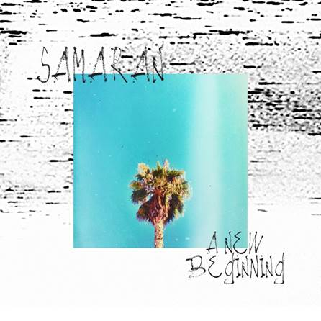
Download Artwork HERE

French producer Samaran has been working steadily behind the scenes garnering support from some of the biggest names around like the Tchami’s entire Confessions label, Kasakde and Point Point. Now Samaran emerges as the brand-new project from (real name) Etienne, a UK-based producer who's now ready to deliver his first tracks under his alias today via Big Beat Records. Listen HERE!

Speaking on the new single Samaran shares, “A New Beginning says it all, it's my first official release as Samaran, it's a brand-new project with a simple but personal direction. A mix of old school sampling techniques to get this lo-fi /vintage color mixed with actual drums, to keep some freshness and get the best of those 2 worlds. The origins of filtered house facing the strength of modern sounds. Modern Old School!”

With a deep love for French filtered sampling techniques and Chicago house drums and grooves, Samaran combines his own interests with one mission, to make people dance and smile.

“A New Beginning” is just that, the beginning for his own music by Samaran.

For press assets: http://press.wearebigbeat.com/singles/a-new-beginning-samaran/

For more information:
For “Samaran” press inquiries:
Lindsay Herr: Publicity, The Wanderlvst
Lindsay@thewanderlvst.com

For Big Beat Records inquiries:
Jordan Frazes: Head of Publicity, Big Beat Records
Jordan.Frazes@atlanticrecords.com

