DANISH MUSICIAN SOLEIMA RELEASES NEW ELECTRO-POP SINGLE “STFU”

LISTEN HERE: https://BigBeat.lnk.to/STFUPR

OUT TODAY VIA BIG BEAT RECORDS!

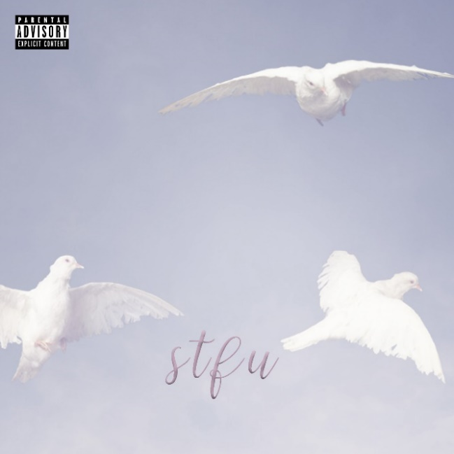

Danish singer/songwriter, Soleima, is making waves in the music industry with her fascinatingly off-kilter style and infectiously unique take on pop music…and this is only just the beginning. After her recent transfer from Warner Denmark to Big Beat/Atlantic Records in the US, she is ready to release her brand new track “STFU”. Listen HERE!
Soleima’s innocently playful vocals paired with soft violins, melodic bells and a fuzzy bassline is the recipe for the summer jam we all need. As Soleima describes it, “STFU” is a song about embracing each other’s differences amid the negativity we face in the world. “We live in a time where people have multiple platforms in which they can always express themselves freely. This is so beautiful, but the dark side of this is that in our attempts to speak our minds, we tend to spread a lot of hate. Some things are better left unsaid; we should all educate each other in showing more love. If we are bitter and hateful…maybe we should just ‘shut the fuck up’”. After hearing this new track, it’s safe to say the phrase “shut the fuck up” has never sounded so sweet.
The Danish musician’s heady cocktail of pitch-shifted synths, R&B, future bass and an undercurrent of world music is already something quite apart from the pack, but her vocals – simultaneously otherworldly, childlike in its innocence and sweetly sensual – are what elevate her beyond the average popstar. Soleima crafts “political pop”– cutting-edge productions with an immediate pop core, and relatable lyrical themes, which simultaneously explore societal issues and the very meaning of what it is to be human. Soleima’s mother took her to an African dance camp where the singer grew to appreciate different cultures, eventually leading her to pursue a degree in Anthropology. The open-mindedness that accompanied her studies and travels subsequently landed her in the political pop subgenre of pop music.

2018 was a big year for Soleima with the release of her breakout single “Low Life” off of her ‘Bulldog’ EP, which was selected as one of Billboard’s “20 Great Pop Songs From 2018's First Half You Might Have Missed” with over seven million streams. 2018 also saw BBC Radio 1’s Annie Mac highlight Soleima as one of her “New Names to Watch”, while Soleima also took home awards such as “Best Newcomer” at Danish Music Awards and “Talent of the Year” at P3 Guld. The songstress is preparing for an even bigger 2019 with more releases and appearances at European festivals and shows this summer, including performances with MØ at Roskilde Festival on July 4th. She is an artist to keep a close eye on as she continues to release new music, building up to her debut album in 2020.

CONNECT WITH SOLEIMA:
Instagram | Facebook | Twitter | Spotify

PRESS ASSETS:
https://press.wearebigbeat.com/artists/soleima/

