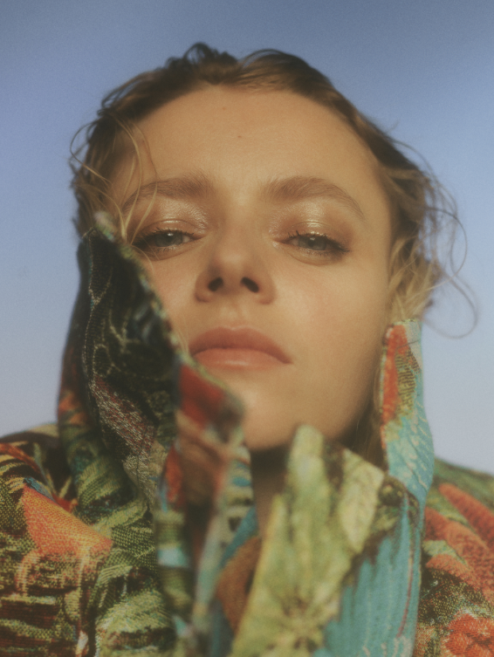

Soleima has cast an enigmatic spell with the music she’s introduced over the past few years. From the beloved track ‘Breathe’, off her debut mini-album “NO.14” receiving over 2 million streams on Spotify alone, to “Low Life” off of her ‘Bulldog’ EP being selected as one of Billboard’s “20 Great Pop Songs From 2018's First Half You Might Have Missed” (and over seven million streams…), to her most recent releases STFU and Cheers for the Tears (heralding her forthcoming album in 2020), the songstress has presented herself as a fascinatingly off-kilter alternative artist with pop sensibilities, who has no plan on slowing down any time soon.
The Danish musician’s cocktail of pitch-shifted synths, R&B, future bass and an undercurrent of world music is already something quite apart from the pack, but her vocal – simultaneously otherworldly, childlike in its innocence and sweetly sensual – elevates her individualistic style to another level. As this star on the rise continues to share her unique talent with the world, she’s building a cult following alongside support from notable publications such as DuJour, Refinery29, NYLON, PAPER, L’Officiel and many more.
While her tracks are skewered heavily towards the kind of alternative pop in which easy genre classifications lie just out of reach, Soleima’s own story is similarly unconventional. Raised in Aarhus, a city on the Jutland peninsula, Soleima grew up in a family home soundtracked by classic soul and R&B, notably Aretha Franklin, Stevie Wonder and Otis Redding.
So far, so normal? Pretty much. Yet that’s only a snippet of the tale. Soleima’s mother took her to an African dance camp which operated as a cultural exchange between Denmark and Sukumaland in Tanzania, and she soon became enamoured with their music – especially with their collection of traditional African drums such as the sikulu. As a young adult, she moved out to Sukumaland for two extended spells, and even organized a grant to allow some of their members to live and teach in Denmark. She subsequently earned a bachelor’s degree in Anthropology, did field work in Nepal and started to make a documentary about migration in Senegal.
With an all new album on the horizon, Soleima continues to spread her wings and craft her unique sound with avant-garde productions, relatable lyrical themes, and the exploration of societal issues and the meaning of what it is to be human.
CONNECT WITH SOLEIMA
TWITTER | INSTAGRAM | FACEBOOK | SOUNDCLOUD | PRESS SITE

