**SCAREDY CAT**

**SHARES BRAND NEW SUMMER TRACK**

**‘FOLLOW ME’**

**OUT TODAY ON BIG BEAT RECORDS!**

**LISTEN/POST:** <https://www.hive.co/l/scvisyt>

**STREAM/BUY:** [https://BigBeat.lnk.to/scfmPR](https://bigbeat.lnk.to/scfmPR)

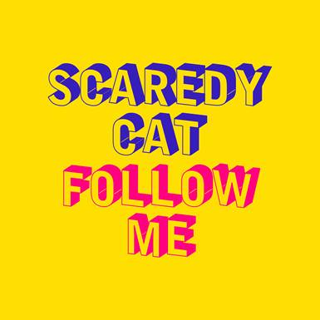

**Scaredy Cat** delivers his debut single **‘Follow Me’** to **Big Beat Records/Parlophone** out today via all digital service providers; a contemporary interpretation of Uncle Kracker’s song which became a worldwide smash when it was released in February 2001. The track’s infectious hook, uplifting soulful vocal and a tropical flourish– [LISTEN HERE](https://bigbeat.lnk.to/scfmPR) – is poised as a bright and breezy anthem for the summer months ahead. The original hit reached the **Top 5** in the **US** and the **UK**, and also topped the charts in several countries across the globe.

**##**

**Connect with SCAREDY CAT:**

<https://www.facebook.com/Scaredy-Cat-Music-1391918694188228/>

<https://twitter.com/scaredycatmusic/>

<https://www.instagram.com/scaredycatmusic/>

<https://soundcloud.com/scaredycatofficial>

**Connect with BIG BEAT:**

<http://www.wearebigbeat.com>

<https://www.facebook.com/wearebigbeat>

<https://soundcloud.com/wearebigbeat>

**For more information please contact:**

Jordan Frazes (Head of PR): [jordan.frazes@atlanticrecords.com](mailto:jordan.frazes@atlanticrecords.com)

Catherine Corkery (Online): [catherine.corkery@atlanticrecords.com](mailto:catherine.corkery@atlanticrecords.com)