RUDIMENTAL & PREDITAH JOIN FORCES ON NEW SINGLE
“MEAN THAT MUCH” FT. MORGAN

https://www.youtube.com/watch?v=HKDC9g2xDPc
STREAM/DOWNLOAD: https://bigbeat.lnk.to/TMBPR

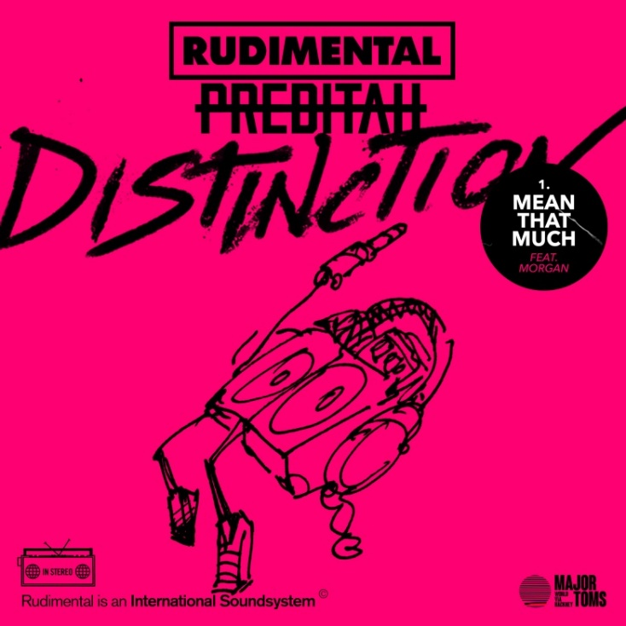

Rudimental have joined forces with Preditah on new UKG (UK garage house) track, “Mean That Much,” out today via Major Tom’s / Big Beat Records and available across all DSPs (listen here).

Lifted from Rudimental’s forthcoming ‘Distinction’ EP and premiered by DJ Target on BBC 1Xtra, “Mean That Much” follows lead EP track “Sitigawana,” which was produced with The Martinez Brothers and also features Malawian vocalist, Faith Mussa.

The track sees the band collaborate with Preditah for the first time since he remixed Rudimental’s “Scared Of Love” (ft. Ray BLK & Stefflon Don) earlier this year, and taps into a bright, bubbling UKG sound, melding together elements of soulful, peak-time house and lo-slung garage swing. Featuring rising Major Tom’s star MORGAN – signed to Rudimental’s label earlier this year – on vocals, the track forms an exciting primer as to what fans can expect from the full ‘Distinction’ EP, which drops on August 16th.

‘Mean That Much’ ft. MORGAN is out now: https://bigbeat.lnk.to/TMBPR

CONNECT WITH RUDIMENTAL
rudimental.co.uk
FB : rudimental
Twitter : rudimental
Instagram : rudimental
Soundcloud : rudimental

US PRESS CONTACT:
Libby Kober | Libby.Kober@AtlanticRecords.com

