RUDIMENTAL UNVEIL THEIR OFFICIAL VIDEO FOR
‘THESE DAYS’ FEATURING
JESS GLYNNE, MACKLEMORE & DAN CAPLEN

WATCH/POST: https://www.youtube.com/watch?v=pjTj-_55WZ8
BUY/STREAM: https://atlanti.cr/thesedays

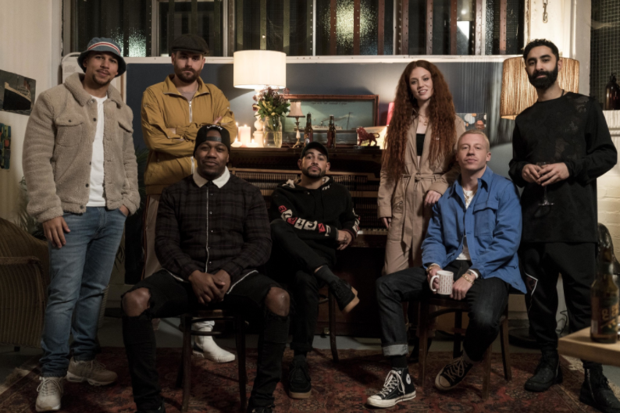

Rudimental have today unveiled their official video for “These Days.” Shot in London and Seattle, and directed by Johnny Valencia, the video follows a relationship and break-up story, portrayed by featured artists Jess Glynne and Macklemore.
The collective’s new single offers vocal duties from the inimitable talent that is Jess Glynne, [Jess is only the second female artist to ever have five #1 singles in the UK], Macklemore [four-time GRAMMY Award winner], and emerging soul/RnB sensation Dan Caplen.

In the space of a week, the single has amassed over 5 million streams worldwide and the official music video released today has already cracked the YouTube Trending charts.

Released via Major Toms in partnership with Big Beat Records in the US, “These Days” is available now on all digital platforms.

Rudimental are currently working on their third studio album.

For more information please visit:
www.rudimental.co.uk
https://twitter.com/Rudimental
https://www.facebook.com/Rudimental
https://www.youtube.com/user/RudimentalUk
Press Tools: http://press.wearebigbeat.com/artists/rudimental

Press Contact:
Jordan Danielle Frazes
Head of Publicity, Big Beat Records
Jordan.Frazes@atlanticrecords.com

