ACCLAIMED MULTI-PLATINUM PRODUCER ROBIN SCHULZ RELEASES
“RATHER BE ALONE”
WITH NICK MARTIN (FT. SAM MARTIN)

https://www.youtube.com/watch?v=lVFVcgQswh4

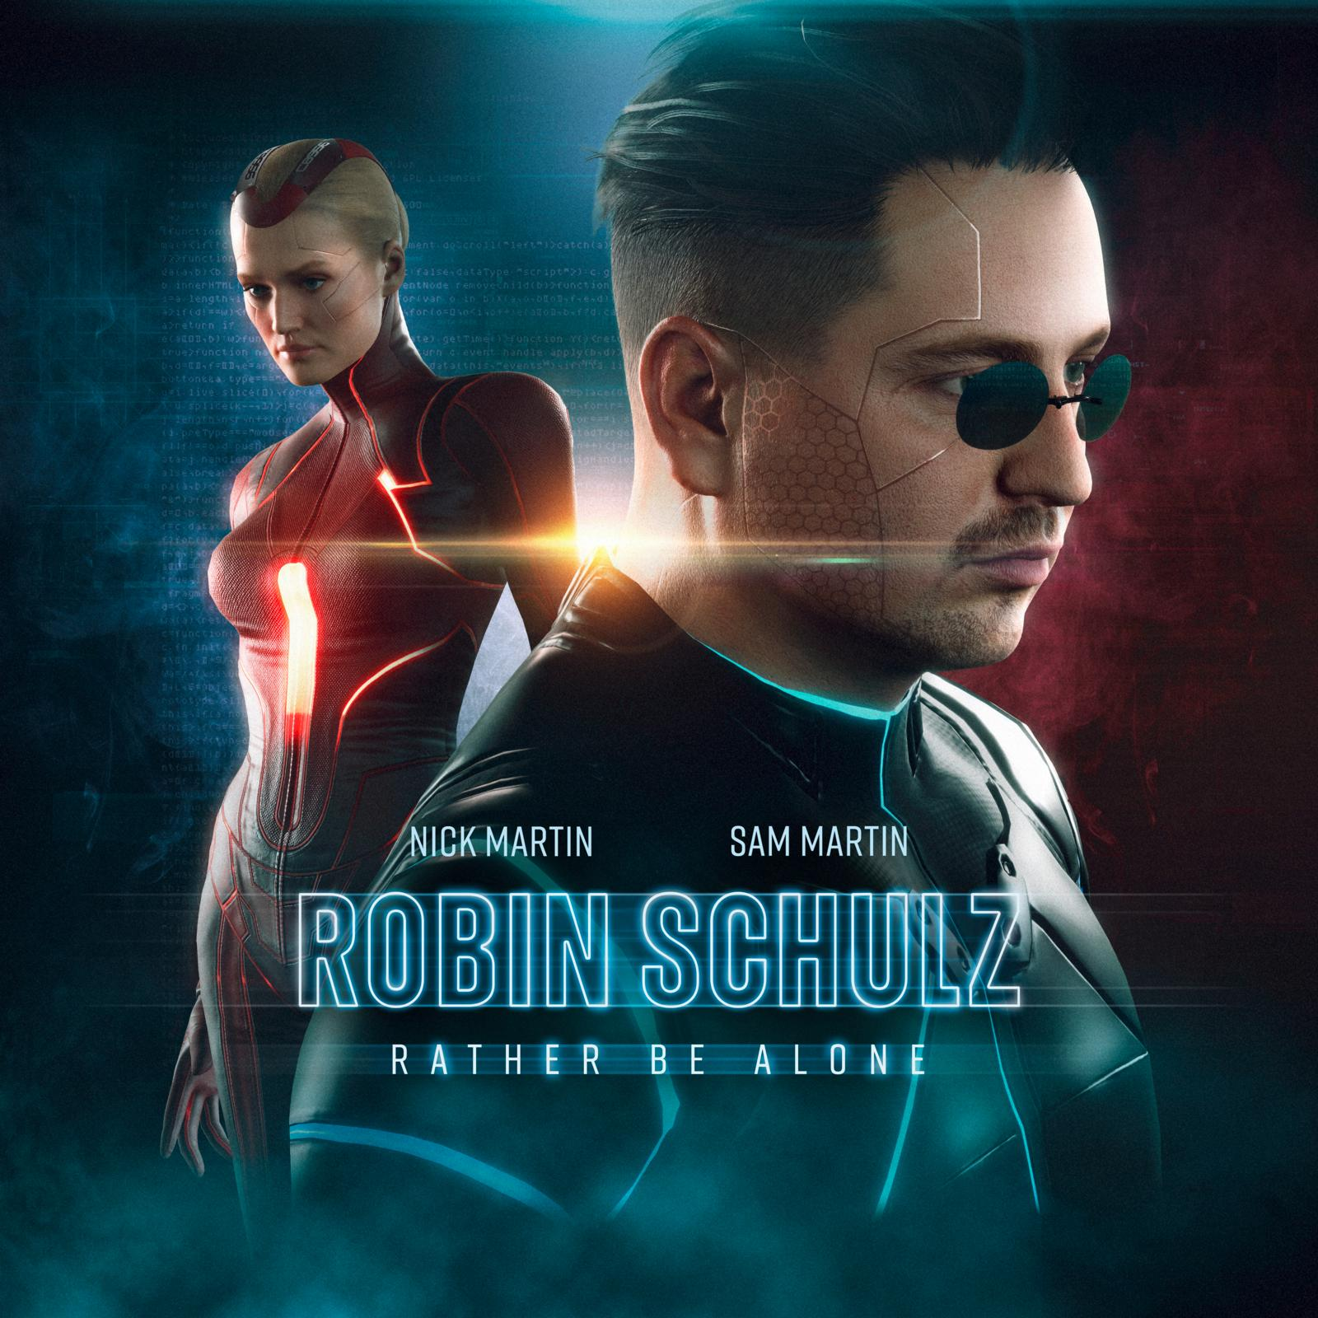

On his new single “Rather Be Alone,” German superstar producer Robin Schulz reveals a surprising and rather brilliant new side. Collaborating with Greek DJ / Producer Nick Martin, he serves a tune brimming with disco enthusiasm. A whipping groove with funky horns, house-heavy piano vibes, and vocals reminiscent of the Bee Gee’s heyday set the tone for this track, with guest singer Sam Martin fighting to overcome the unrequited love affair addressed in the song: “Hey, my guess is that you want what I want and you know what I want,” he croons in his finest falsetto, dying to get through to the woman of his dreams.

“Rather Be Alone” follows Robin’s previous single “All This Love (feat. Harloe)”, released in May. Recently, he crossed 2 billion YouTube views on his own channel, making him the first German artist to ever accomplish that feat. He also holds the record for the most #1 positions in the German radio chart. Following recent certifications for “Speechless (ft. Erika Sirola)” and “Oh Child” (w/ Piso 21), he increased his collection of global gold and platinum awards to an impressive total of 253.

Robin Schulz and Nick Martin already proved great chemistry on Martin’s remix of Schulz’ 2017 hit “I Believe I’m Fine,” followed by Martin’s performance on this year’s Robin & Friends’ Tomorrowland stage. Martin frequently tours with The Chainsmokers, including their 2019 Asian tour and their trek through Europe in 2017.

Featured artist Sam Martin hails from L.A. and is one of today’s most sought-after songwriters. After earning his first Billboard #1 with Maroon 5’s double-platinum hit “Daylight” (2012), the Grammy Award-winner went on to pen tracks for artists like David Guetta, One Direction, The Chainsmokers, and G-Eazy, as well as shatter the record for the biggest Top 40 US radio launch in history with Jason Derulo’s chart-topping “Want to Want Me.” His full-length debut Alpha Omega was released earlier this year.

