ROBIN SCHULZ RELEASES “ALL THIS LOVE” FT. HARLOE

+ GEARS UP FOR UNITED NATIONS ‘PLAY IT OUT’ ON JUNE 1st

LYRIC VIDEO: https://youtu.be/4hUHNFORhUo

BUY/STREAM: https://robinschulz.lnk.to/ATL

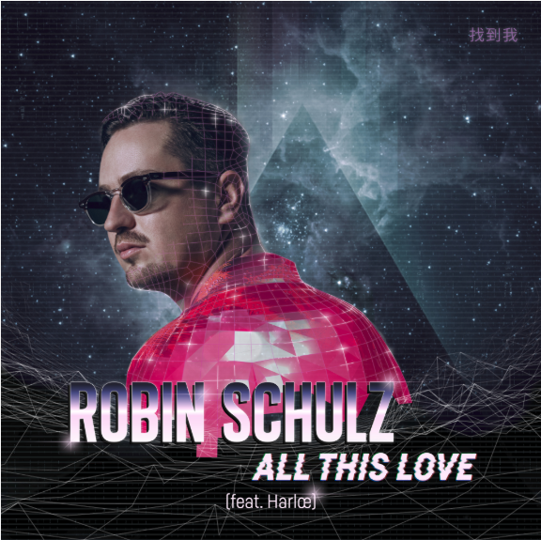

Grammy nominated German DJ and producer Robin Schulz delivers an anthemic new single today “All This Love” featuring Los Angeles-based singer-songwriter Harloe (born Jessica Karpov) known for Britney Spears, Charli XCX and Kelly Clarkson co-writing credits. Sitting in a cheap hotel in the dead of night, she ponders on the trials and tribulations of a great love: “And if we have to say goodbye ‘cause it's for the best / What are we gonna do with all this love?”, while the chart-topping DJ’s signature Deep House vibes make for a beautiful and evocative soundtrack – LISTEN HERE!

“All This Love” ft. Harloe follows Robin Schulz latest release “Speechless” ft. Erika Sirola – LISTEN HERE – which has racked up over 130 million global streams and 25 million Views on YouTube, reached #2 on the German Airplay Charts, #6 in the European Airplay Charts, #18 in the Global Shazam Charts, #110 in the Global Spotify Charts. “Speechless,” which followed Robin’s “Uncovered” album, was also featured in 30 out of 32 NMF Spotify playlists around the globe, reached the Spotify Top 200 in 20 countries (Top 30 in 7 countries), #5 in the US Mediabase Dance Airplay Charts and #14 in the Billboard Dance/Mixshow Airplay Charts.

Robin Schulz, who peaked #49 in this year’s recent Billboard Dance 100 list, will also play at the United Nations “Play it Out – A call to action on Ocean Plastic” festival in the Caribbean island of Antigua on June 1st and will be livestreamed internationally. Led by the President of the UN General Assembly, Maria Fernanda Espinosa, the concert aims to raise awareness for the 15 million tons of plastic litter that are dumped into the ocean each year. Headlined by Ashanti, the event will see performances by international artists such as St. Lucia, Bomba Estéreo, Nico & Vinz, Rocky Dawuni as well as local musicians. Additionally, the concert will feature an array of speakers including dignitaries, policymakers, celebrities, and representatives from the scientific, philanthropic and academic communities. For more information please follow: http://webtv.un.org/

Connect with Robin Schulz:
Website | Twitter | Facebook | YouTube

For press assets, visit: http://press.wearebigbeat.com/artists/robin-schulz/

Press Contacts:

Jordan Danielle Frazes
Head of Publicity, Big Beat Records
Jordan.Frazes@atlanticrecords.com

Libby Kober
Libby.Kober@atlanticrecords.com

