RAVENNA GOLDEN SAYS “YOUR GIRLFRIEND SUCKS” IN NEW SINGLE

LISTEN TO “GIRLFRIEND SUCKS” HERE/WATCH THE MUSIC VIDEO HERE

OUT TODAY VIA BIG BEAT RECORDS

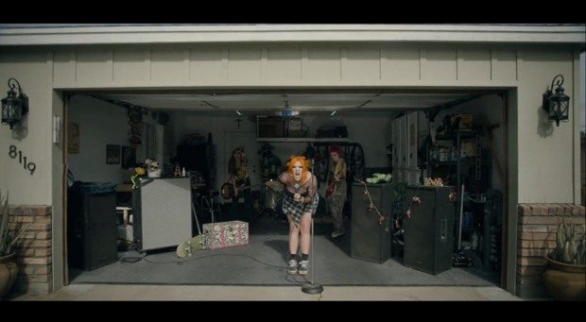
DOWNLOAD PRESS PHOTO HERE

Singer/songwriter Ravenna Golden follows her Big Beat Records debut single “R U Joking” with the punchy “Girlfriend Sucks,” co-written by Ravenna, produced by Cisco Adler, Bardo Novotny, Cole Hutzler, and Dylan Brady of 100 gecs, and featuring fellow Hyper pop artist midwxst, who recently signed to Geffen at the age of 18. Watch the music video HERE and listen HERE.

Ravenna Golden’s story starts in the suburbs of St. Louis, soaking up the sun and diverse sounds of Blink 182, Green Day, MGMT, Bruno Mars, Lil Wayne and Elliot Smith. After taking a poetry class in high school, she set verses to melodies and recorded a demo on a lark. Freshman year of college, she sent the songs to her old friend Dylan Brady who insisted Golden work on a full-length album. Fast forward to now and Ravenna is a founding member of the Hella and Cake Pop crews and a leader in crafting a unique sound and stealing center stage in the minds of kids and critics alike. Weaving fibers of pop-punk, indie rock and electronic mayhem into a vibrant fabric of original noise, she creates a blistering energy that explodes with life and sweat on stage.

In 2015, Ravenna gave birth to Girl Gone Wild, an 11-track trip through toxic relationships, party scenes, introspectiveness, existentialism, glitter and gore. Soft ballads are sandwiched between harsh-hitting electro-pop beats and toy synths. It’s a little bit bubblegum with a whole lot of bite, and the process of its creation proved to Golden that music was her destiny - especially performing on stage. Things bubbled from there into a tight string of singles, each song exploring a different shade of personality. It boiled over with 2018 single “7th Grade,” a guitar-driven sing-along ripped straight from the summer of 2001. Since then, she’s collaborated with WHIPPED CREAM and Perto on “IDFC”, chillpill on his remix of “FUCK THE CLUB," and 6 songs on the Cake Pop 2 album, among others. She made her Big Beat Records debut with “R U Joking” in May 2021.

This is just the beginning for Ravenna Golden, stay tuned for much more to come.

CONNECT WITH RAVENNA GOLDEN
Instagram | Spotify | Twitter | Facebook

FOR MORE INFORMATION:
Paige.Rosoff@atlanticrecords.com
Atlantic Records | Big Beat Records

