EMERGING HOUSE PRODUCER ROSSI. REWORKS 90’S HOUSE GEM ‘PARADISE’

LISTEN HERE: https://BigBeat.lnk.to/paradisePR

Out Today VIA Big Beat Records!

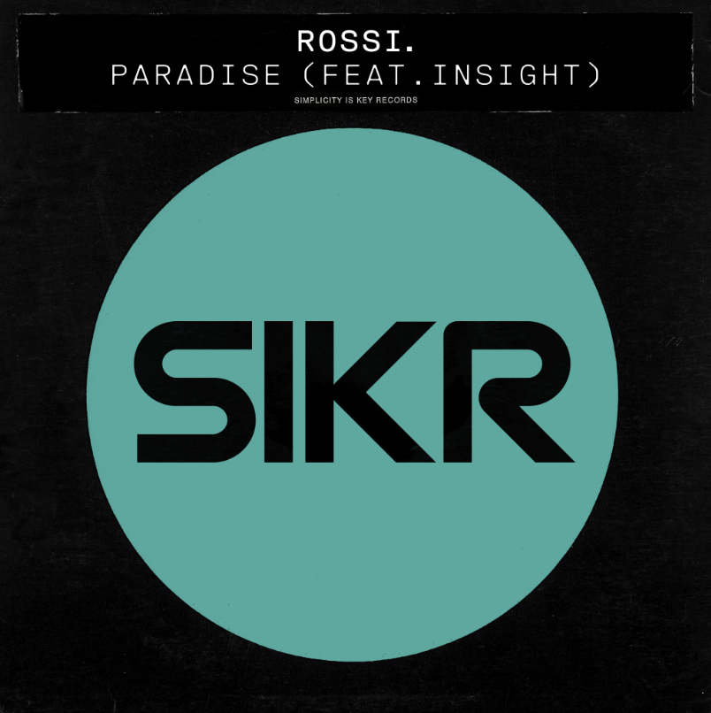
DOWNLOAD PHOTO HERE

Up-and-comer UK House producer Rossi. has teamed up with long-time producer Insight to recreate his classic house track ‘Paradise.’ Following the song’s UK release on new label SIKR, Big Beat Records is teaming up to premiere the track in the US.

Originally released on the formative New York House label Strictly Rhythm back in 1993, House music legend “Little” Louie Vega was an original supporter of the record and featured it on his mix album “Little Louie Vega At The Underground.” Insight also has the accolade of being the first UK artist to ever release on the legendary New York label.

Rossi. brilliantly reworks the original track in a contemporary style. With the vocal acapella no longer present, original vocalist Trevor Ashaye re-sung the vocals so a new generation of House music fans can enjoy the underground anthem all over again.

Rossi. is one of the hottest new DJs in the London club scene, making a name for himself with his own unique spin on the Minimal House sound. With a residency at Fabric, one of London’s acclaimed nightclubs, he has become a popular fixture at events across London over the last few years and now regularly headlines clubs across the UK.

His previous tracks have found success and approval across the UK House scene and ‘Paradise’ is prepared to do the same in the US. Rossi. is definitely a DJ to keep an eye on as he will undoubtedly be one to watch for in the future.

CONNECT WITH ROSSI.:
Instagram | Facebook | Soundcloud

FOR MORE INFORMATION:
Paige Rosoff – Big Beat Records
Paige.Rosoff@atlanticrecords.com

