INTRODUCING RIBB[]N

THE RISING HOMEGROWN UK TALENT RELEASES DEBUT TRACK
‘STUCK TOGETHER’ ON BIG BEAT RECORDS/FFRR/PARLOPHONE

LISTEN HERE: https://BigBeat.lnk.to/stucktogether

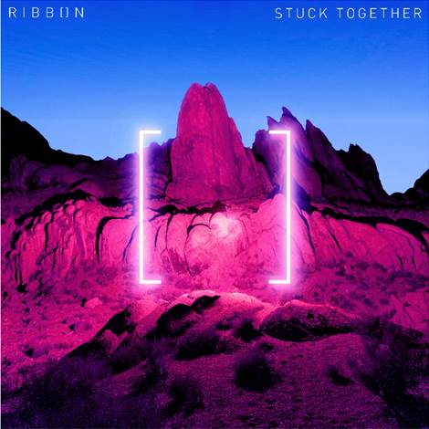

Homegrown UK producer RIBB[]N (pronounced Ribbon) delivers his debut release ‘Stuck Together’ on Big Beat Records/FFRR/Parlophone. A label founded by BBC Radio 1’s Pete Tong, FFRR has long been established as a platform for breaking and championing new acts in the electronic dance music space. Listen HERE!

Already setting the industry alight with his original production and hotly tipped to be a definitive ground-breaking electronic artist in the making, RIBB[]N now embarks on a series of huge-sounding releases.

With a sound that takes inspiration from a string of electronic music greats such as Eric Prydz and Deadmau5, in addition to the emotion and texture of Jon Hopkins, RIBB[]N has moulded his very own sound and sonic feel, paving the way to the beginning of his own promising career.

‘Stuck Together’ demonstrates RIBB[]N’s ability to construct deep electronic textures, dreamy, tension building synths, offset with thumping bass and angelic vocals. The music is also paired with highly creative illuminating artwork.

With little known about the artist at this stage, his masterfully crafted music speaks for itself.
‘Stuck Together’ is sure to be a feature in many DJs sets this summer and RIBB[]N is a name to remember.

Press site: http://press.wearebigbeat.com/singles/ribbon/
Press contact: gabrielle.reese@atlanticrecords.com

