RAVENNA GOLDEN ADDS A HYPERPOP SPIN TO
WEEZER’S CLASSIC SINGLE “BEVERLY HILLS”

OUT TODAY VIA BIG BEAT RECORDS

WATCH THE OFFICIAL MUSIC VIDEO HERE

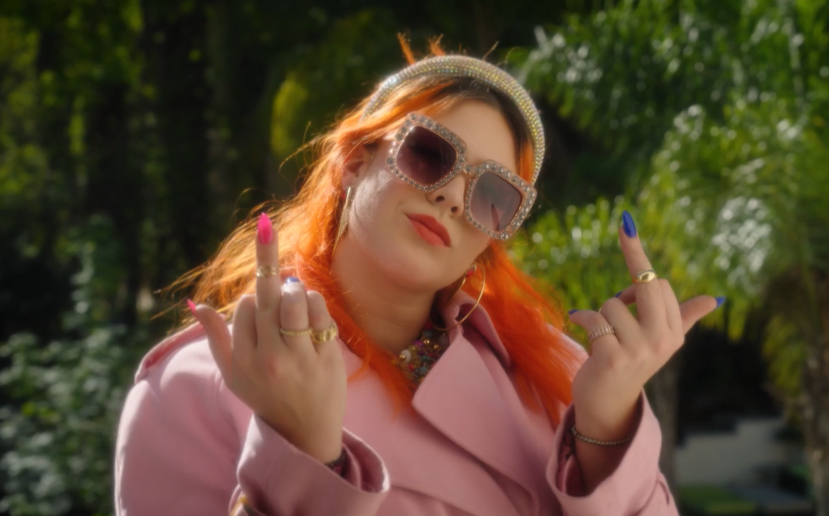

"...long a fixture of the [hyperpop] scene..." – PAPER

“Ravenna Golden is here to take over the music industry.” – FLAUNT

Founding member of the hyperpop genre, Ravenna Golden, has shared her vivacious take on Weezer’s classic “Beverly Hills” alongside the kinetic official music video via Big Beat Records. Watch/listen HERE.

“Beverly Hills” follows last year’s “Expensive City,” joined by an official music video streaming HERE. “Ravenna Golden is here to take over the music industry,” wrote FLAUNT in its exclusive video premiere, “carving her own lane in the hyperpop genre… ‘Expensive City’ was written from a vulnerable place as any young adult woman would feel in an attempt to turn her dreams into a reality.”

2021 saw Golden make her Big Beat Records debut with “R U Joking,” earning acclaim from PAPER as a “hard-as-fuck Dylan Brady collab,” adding, “Long a fixture of the scene, ‘R U Joking’ takes Golden to another level.” “R U Joking “ was followed by the punchy “Girlfriend Sucks (Ft. midwxst),” praised by Glasse Factory as “an alluring melody with a blend of electronically-rich vocals with a punchy beat and heavy rock elements laced throughout. midwxst joins in during the second verse and offers a contrast of clean vocals intermixed with Ravenna’s tuned and cool ones.”

Ravenna Golden has been a pioneer in the electronic and hyperpop space since she started creating music, pushing boundaries and creating new and unique sounds. Her story starts in the suburbs of St. Louis, soaking up the sun and diverse sounds of the late 90s, mid 2000s and 2010s, which highly influenced her sound today. After taking a poetry class in high school, she set verses to melodies and recorded a demo on a lark. Freshman year of college, Golden sent the songs to her old friend Dylan Brady who insisted she work on a full-length album. Fast forward and Ravenna is a founding member of the Hella and Cake Pop crews and a leader in crafting a unique sound and stealing center stage in the minds of kids and critics alike. Weaving fibers of pop-punk, indie rock and electronic mayhem into a vibrant fabric of original noise, she creates a blistering energy that explodes with life and sweat on stage.

In 2015, Ravenna gave birth to Girl Gone Wild, an 11-track trip through toxic relationships, party scenes, introspectiveness, existentialism, glitter, and gore. Soft ballads are sandwiched between harsh-hitting electro-pop beats and toy synths. It’s a little bit bubblegum with a whole lot of bite, and the process of its creation proved to Golden that music was her destiny - especially performing on stage. Things bubbled from there into a tight string of singles, each song exploring a different shade of personality. It boiled over with the 2018 single “7th Grade,” a guitar-driven sing-along ripped straight from the summer of 2001. Since then, Golden has collaborated with WHIPPED CREAM and Perto on “IDFC“, chillpill on his remix of “FUCK THE CLUB,” and six songs on the Cake Pop 2 album, among others.

CONNECT WITH RAVENNA GOLDEN
INSTAGRAM | SPOTIFY | TWITTER | FACEBOOK | YOUTUBE

FOR MORE INFORMATION:
Paige.Rosoff@atlanticrecords.com
Atlantic Records | Big Beat Records

