R3HAB TEAMS UP WITH CLARA MAE AND FRANK WALKER FOR HEARTFELT NEW SINGLE + VIDEO "MORE THAN OK (WITH CLARA MAE)"

ON BIG BEAT RECORDS/CYB3RPVNK

WATCH THE VIDEO HERE: https://youtu.be/-zYz0OhqzXM
LISTEN HERE: https://BigBeat.lnk.to/MoreThanOkayPR

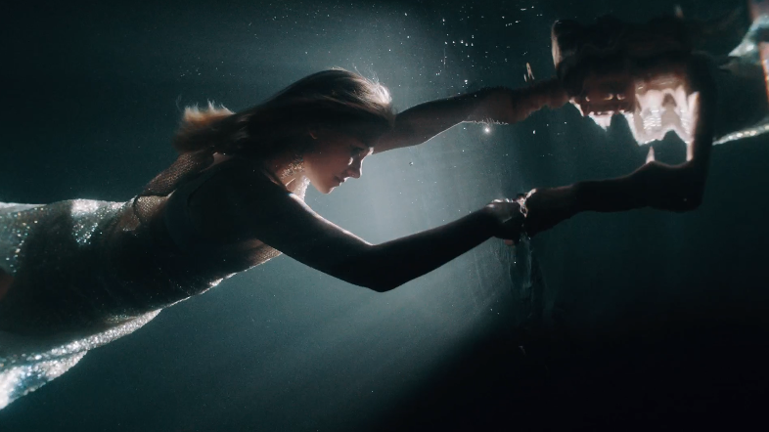

R3HAB, Clara Mae and Frank Walker kick off the new decade with "More Than OK (with Clara Mae)" - a melodic and vibey tune that's full of hope as much as heartache. The track opens with dreamy, organic instrumentals that create a sumptuous backdrop for Clara Mae's stunning vocals as she performs lyrics about a couple losing the magic in their relationship. The new single is R3HAB's first collaboration with Clara Mae, and his second with Frank Walker, who enlisted R3HAB as a remixer of his "Heartbreak Back" in 2018, which went gold in Canada. Check out what all three artists had to say about this exciting collaboration below and watch the official music video HERE!

"I've been a fan of Clara Mae's voice for quite a while, and when I got the chance to work with her, I didn't hesitate one minute. ‘More Than OK’ is a cool vibey song with great vocals, including a message everyone can relate to, and a perfect way to kick off the new decade." - R3HAB

"'More Than OK' is a reminder to never settle for less than what you want in life and in love. You want every day to feel special, and love like every day is your last. Working on this record with R3HAB and Frank Walker has been so much fun. I love the vibe they brought to the track. Shooting the video was amazing. It was a real challenge doing underwater scenes but also an incredible experience, and we had lots of fun together. So happy with how it all turned out, and Mario, the director, made the video look so beautiful!" - Clara Mae

"I've been a huge fan of R3HAB since I first started producing music and am lucky to call him a good friend as well. Around a year ago I reached out about getting him to remix my single 'Heartbreak Back,' which went gold in Canada, so I'm super fired up that we finally found the right record for us to collab on. Clara Mae is unbelievably talented, and her voice on 'More Than OK' really made this one special!" - Frank Walker
Over the last eight years, the Dutch/Moroccan artist Fadil El Ghoul - better known as R3HAB - has established himself as a leader at the forefront of modern electronic music. His talent has been called the "future of the craft" by the likes of Forbes and Billboard, and he's circuited the globe's best clubs and festivals, all without the backing of a formal record label. In 2017, R3HAB independently released his debut album "Trouble" through his imprint CYB3RPVNK, which amassed over a half-billion streams globally and officially placed R3HAB among electronic music's heavy hitters. He made number 14 on DJ Mag's Top 100 list in 2019, topping the charts with tracks like "Lullaby" and "Hold On Tight," while his sophomore album "The Wave," revealing more complex, emotional and experimental layers of himself, has amassed over 250 million streams on Spotify alone. In 2019 R3HAB's "All Around The World" with A Touch of Class quickly became his biggest ever record already topping 200M streams across platforms and achieving gold & platinum status in 8 countries, while the follow-up saw him team up with none other than ex-One Direction phenom ZAYN. Stay tuned to see where R3HAB's journey takes him in 2020!
After spending years studying jazz vocals and piano in her small town of Gävle, Sweden, Clara Mae garnered attention by co-writing with the likes of David Guetta, Tiesto and Martin Jensen. She soon after co-wrote and featured on KREAM’s “Taped Up Heart,” which boasts over 130 million streams and reached the top 25 on Billboard’s Hot Dance/Electronic Songs chart. Her debut EP Sorry For Writing All The Songs About You (available now via Big Beat Records) collectively boasts over 75 million worldwide streams to date. The 6-track collection was heralded by the release of “Rooftop,” collaborative single “Better Me Better You” with Jake Miller (which the duo performed on the Elvis Duran Show and MTV’s TRL), “I’m Not Her” (praised as “a pop anthem” by Culture Collide) and “I Forgot” (deemed “the perfect anthem” for running into an ex-flame by Refinery 29). Most recently, Clara released tracks “Lost” and “Unmiss You,” in addition to touring in support of singer-songwriter Ella Vos in North America and European tours with singer-producer Alex Aiono and singer-songwriter Carlie Hanson.
Following up on a groundbreaking 2018, Frank Walker has been taking 2019 by storm. Touted as an iHeart Radio Future Star and a Billboard Rising Artist, this Toronto-native has captivated fans across the globe, owing mainstages in Europe, Asia, and North America. Frank also supported Kygo on his “Kids In Love” worldwide tour. Backed by the industry’s best and fresh off a new record deal with Universal Music, this producer is becoming a mainstay on Spotify’s Dance & Pop playlists.
Destined for big things, Frank has had official remixes for Kygo, Marshmello, Bastille, Loud Luxury and Nick Jonas. Frank’s single ‘Heartbreak Back’ hit #1 on BPM XM and was Top 10 at Canadian radio for 10 weeks, and his latest single Only When It Rains with Astrid S is currently top 10 in Canada.
CONNECT WITH R3HAB
WEBSITE | INSTAGRAM | TWITTER | FACEBOOK

CONNECT WITH CLARA MAE
ClaraMaeMusic.com | Instagram| Twitter | Soundcloud | Facebook | Press Assets

CONNECT WITH FRANK WALKER
WEBSITE | INSTAGRAM | TWITTER | FACEBOOK

Press contact: gabrielle.reese@atlanticrecords.com

