SHLOHMO
DELIVERS NEW REMIX FOR CHART TOPPING
PNB ROCK ‘SELFISH’
OUT TODAY ON BIG BEAT WHITE LABEL!

LISTEN/POST: https://www.hive.co/l/pnbshyt
STREAM/BUY: https://BigBeat.lnk.to/pnbsPR

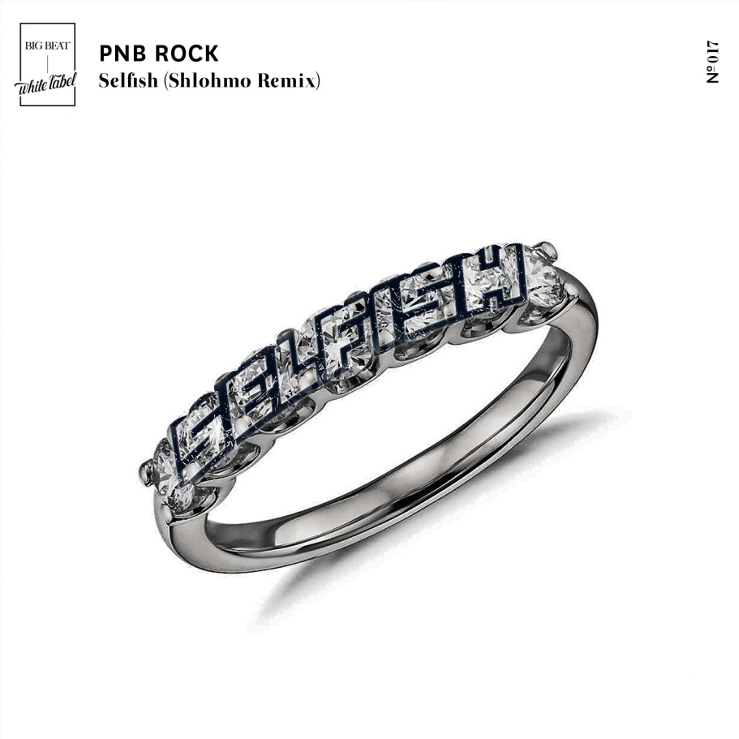

LA-based producer Shlohmo adds his chilling touch to PnB Rock’s “Selfish,” the RIAA certified Gold track which soared through the charts throughout the past year – LISTEN HERE – arriving today via Big Beat White Label. Shlohmo’s extensive back catalogue lists impressive remixes and reworks for Gucci Mane, Drake, Baby Bash, and The Weeknd, to name a few.

Named one of Rolling Stone’s “10 Artists You Need To Know,” rising Philadelphia superstar PnB Rock released GTTM in January 2017 and features an all-star roster of guest appearances including Quavo, A Boogie Wit Da Hoodie, Wiz Khalifa,Ty Dolla $ign and YFN Lucci. The project topped the iTunes “Top Hip-Hop/R&B Albums” chart upon release and spawned the now RIAA Gold-certified smash single, “Selfish.” PnB Rock has also collaborated with A Boogie Wit Da Hoodie and Kodak Black on their track “Horses,” which is featured on The Fate of the Furious: The Album, as well as Kodak Black’s gold-certified “Too Many Years.”

##

Connect with PNB ROCK:
https://twitter.com/pnbrock
https://www.facebook.com/pnbrockmusic/
https://www.instagram.com/pnbrock
https://www.youtube.com/channel/UC52OnlZcHd_ajoTiqcskrvg/featured
http://pnbrockofficial.com/

Connect with SHLOHMO:
https://twitter.com/shlohmo?lang=en
https://www.facebook.com/shlohmo/
https://www.instagram.com/shlohmo/?hl=en
https://soundcloud.com/shlohmo

Connect with BIG BEAT:
http://www.wearebigbeat.com
https://www.facebook.com/wearebigbeat
https://soundcloud.com/wearebigbeat

For more information please contact:
Jordan Frazes (Head of PR): jordan.frazes@atlanticrecords.com
Catherine Corkery (Online): catherine.corkery@atlanticrecords.com

