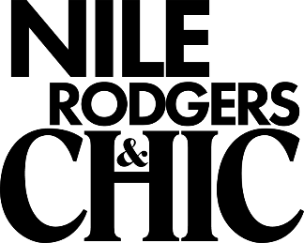

Among music legends, Nile Rodgers is truly exceptional. He amplifies his legacy as a multiple GRAMMY-winning composer, producer, arranger and guitarist by constantly traversing new musical terrain and successfully expanding the boundaries of popular music. As the co-founder of CHIC and the newly elected Chairman of the Songwriters Hall of Fame, Rodgers pioneered a musical language that generated chart-topping hits like “Le Freak,” (the biggest selling single in the history of Atlantic Records!) and sparked the advent of hip-hop with “Good Times”. Nile Rodgers transcends all styles of music across every generation with a body of work that’s garnered him inductions into the Rock & Roll Hall of Fame (2017) and the Songwriters Hall of Fame (2016.)
Most recently, he was appointed as the first ever Chief Creative Advisor for the legendary Abbey Road Studios to cap off a year that has included “festival best” performances at both Glastonbury and Coachella that resulted in the BBC nominating the band for the BBC Music Awards as “Best Live Performance Of 2017” and the LA Times stating “Nile Rodgers influence stretches all over Coachella, beaming the sound of a better future.”
His work in the CHIC Organization and his productions for artists like David Bowie, Diana Ross, and Madonna have sold over 500 million albums and 75 million singles worldwide while his innovative, trendsetting collaborations with Daft Punk, Avicii, Sigala, Disclosure, and Sam Smith reflect the vanguard of contemporary music. Nile Rodgers & CHIC recently released their first new studio album in over 26 years to critical acclaim and a Top 10 position in the UK album charts.

- ###

- Big Beat Records, 2018

