NERVO RELEASES NEW REMIX PACKAGE & BEHIND THE SCENES VIDEO FOR ‘IN YOUR ARMS’

WATCH/SHARE: https://www.youtube.com/watch?v=nbP7rySrf3c
BUY/STREAM ‘IN YOUR ARMS’ REMIXES: https://bigbeat.lnk.to/iyarmxsPR

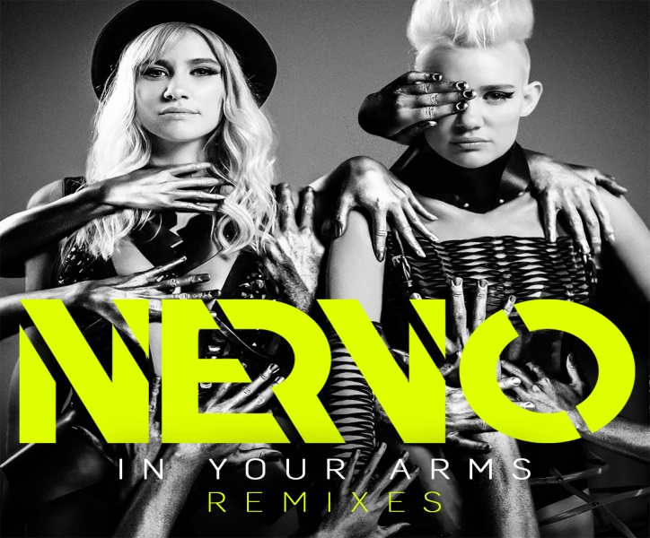

Grammy Award-winning Australian duo NERVO kicked off 2017 with their new single ‘In Your Arms,’ released on February 10th 2017 via Big Beat Records. In celebration of the record, the girls have teamed up with Big Beat again to unleash an all new remix package. The package features four versions from HugeL, Lucky Charmes, Savi, and Askery, giving every type of dance music listener something to gravitate to.

In addition to the remixes, Liv and Mim are allowing their fans to step behind the scenes into the world of their beautifully choreographed ‘In Your Arms’ music video to get a feel of what it took to come to life. From the early morning hours of hair and makeup, to a night of dance and fun, viewers can step inside the fast paced world of NERVO. Both the remix package and BTS video are out today ahead of the girls scheduled shows at Miami Music Week on March 24th.

Check out their full Miami Music Week Schedule here: https://www.miamimusicweek.com/artist/nervo

More About NERVO:

Miriam and Olivia Nervo, better known as NERVO kicked off their music career as songwriters and producers, displaying their skills on tracks for a range of artists including Kylie Minogue, Ke$ha and Steve Aoki. Additionally, the sisters earned a Grammy Award for their songwriting abilities on David Guetta & Kelly Rowland’s smash hit, ‘When Love Takes Over’ which has received an incredible 67 million Spotify streams.

The pair are now recognized for their energetic DJ sets, and play a staggering 200+ live shows worldwide per year, racking up main stage slots at Tomorrowland, Lollapalooza, EDC and Creamfields. Away from the festival circuit, NERVO have held coveted residencies at Omnia and Wet Republic in Las Vegas and Ibiza’s Ushuaia. In 2015, the duo released their debut album ‘Collateral’ to critical acclaim. Featuring a range of notable guest appearances from Kylie Minogue, Nile Rodgers and Au Revoir Simone to name a few, the record peaked #1 on the iTunes Chart. Album track ‘It Feels’ is the album’s biggest streaming track to date, amassing over 9 million Spotify streams and counting.

Connect with NERVO:
Website | Facebook | Twitter | Soundcloud
Press Assets: http://press.wearebigbeat.com/singles/nervo/

For more information please contact:
Jordan Danielle Frazes
Head of Publicity, Big Beat Records
jordan.frazes@atlanticrecords.com

Lindsay Herr
lindsay@thewanderlvst.com

