NERVO RELEASES NEW SINGLE & OFFICIAL VIDEO FOR ‘IN YOUR ARMS’ OUT NOW ON BIG BEAT RECORDS

WATCH/POST: https://www.youtube.com/watch?v=gXlblHraS1I
PURCHASE: https://BigBeat.lnk.to/armsPR

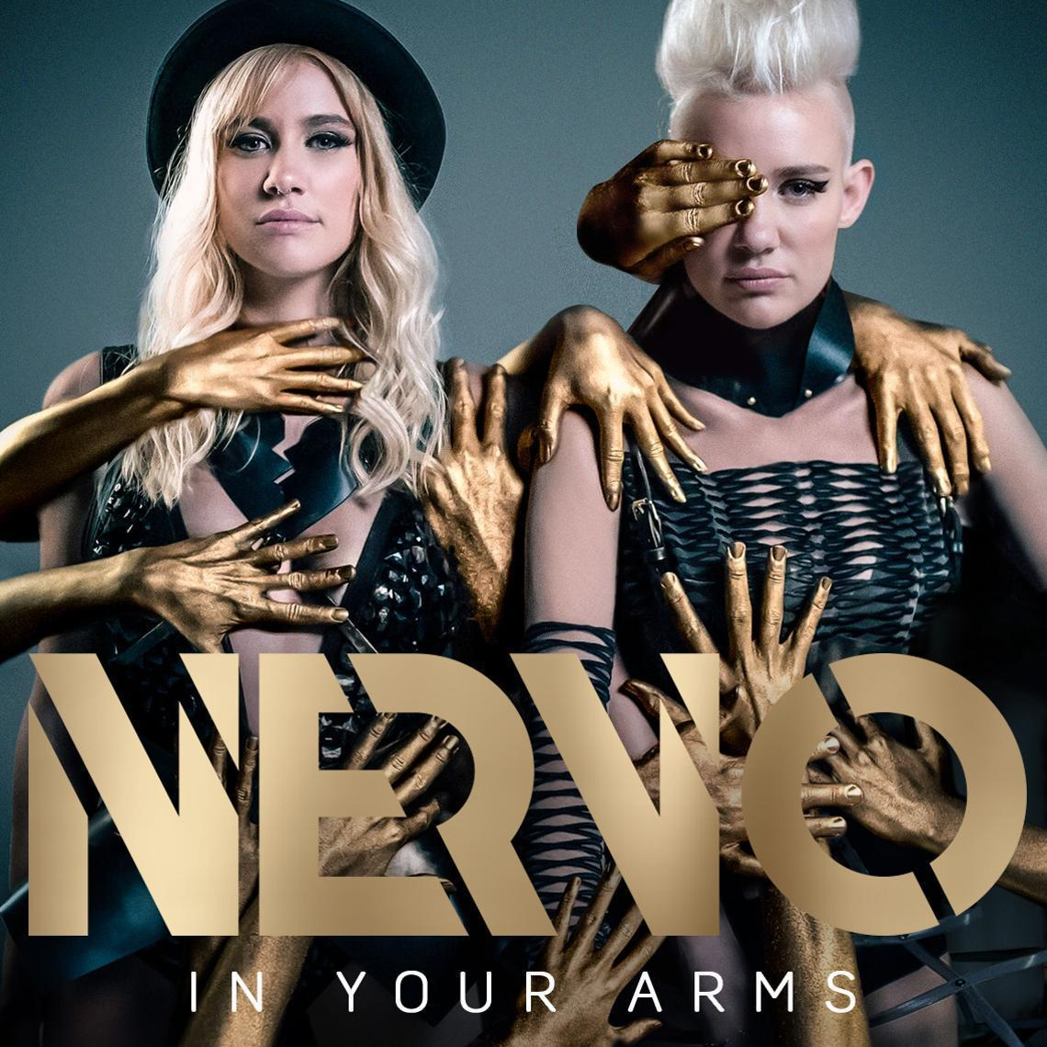
Grammy Award-winning Australian duo NERVO kick off their 2017 with new single ‘In Your Arms’, released 10th February 2017 via Big Beat Records. This is the second release to come from the duo on the label. Their last record “People Grinnin’” Featuring The Child of Lov, quickly soared to over 1.5 Million streams online and was supported by a stellar remix package which featured a slew of up-and-coming acts and veteran DJ/producer Erick Morillo.
Miriam and Olivia Nervo, better known as NERVO kicked off their music career as songwriters and producers, displaying their skills on tracks for a range of artists including Kylie Minogue, Ke$ha and Steve Aoki. Additionally, the sisters earned a Grammy Award for their songwriting abilities on David Guetta & Kelly Rowland’s smash hit, ‘When Love Takes Over’ which has received over an incredible 67 million Spotify streams.
‘In Your Arms’ begins as a stirring, piano-led record fused with throbbing club beats, whilst Miriam’s soaring vocal portrays a heartfelt love story. The track later falls into a plethora of synth hooks and percussive elements. Whilst the accompanying music video features colorful hues and bold, synchronized choreography.
The pair are now recognized for their energetic DJ sets and play over a staggering 200 live shows worldwide per year, racking up main stage slots at Tomorrowland, Lollapalooza, EDC and Creamfields. Away from the festival circuit, NERVO have held coveted residencies at Omnia and Wet Republic in Las Vegas and Ibiza’s Ushuaia. In 2015, the duo released their debut album ‘Collateral’ to critical acclaim. Featuring a range of notable guest appearances from Kylie Minogue, Nile Rodgers and Au Revoir Simone to name a few, the record peaked #1 on the iTunes Chart. Album track ‘It Feels’ is the album’s biggest streaming track to date, amassing over 9 million Spotify and counting.

Connect with NERVO:
Website | Facebook | Twitter | Soundcloud
Download assets: http://press.wearebigbeat.com/singles/nervo/

For more information please contact:
Jordan Danielle Frazes
Head of Publicity, Big Beat Records
jordan.frazes@atlanticrecords.com

Lindsay Herr
lindsay@thewanderlvst.com

