LAUNCHES NEW TRACK
‘HEART WON’T FORGET’
WITH GIA

Stream on Spotify + iTunes
Stream on Apple Music + Soundcloud

‘Party At Your Place!’ world tour including dates in San Francisco, Boston, Chicago & New York (Terminal 5)

Launches ‘Follow To Win’ competition to win a once-in-a-lifetime trip to see him play in New York City at Termianl 5

“With each track projecting enough warmth to melt the iciest cynics' hearts, he's excelled in blending dancehall and house in a pop-friendly package.” – Rolling Stone

“Matoma is becoming one of the hottest Norway exports since smoked salmon!” – DJ Mag

“Irresistible, catchy and overall mood-heightening.” – Dancing Astronaut

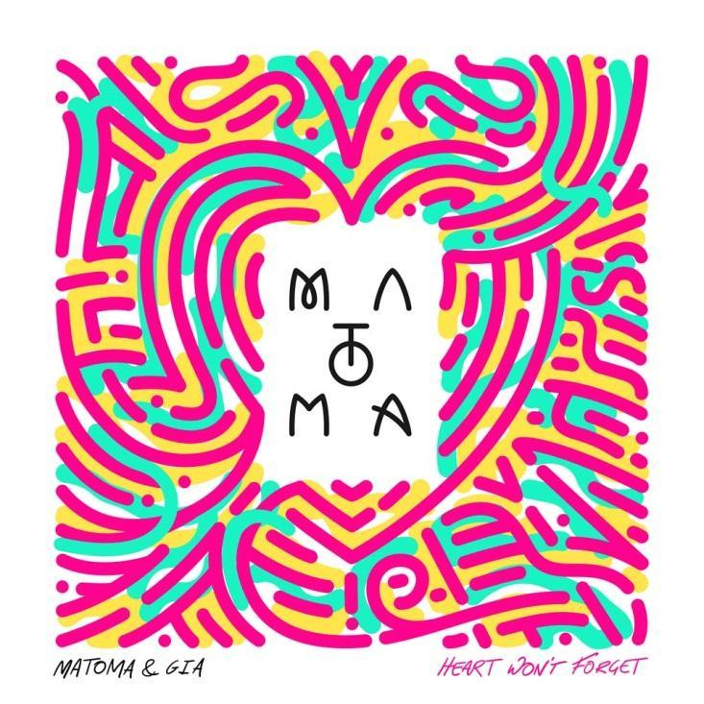

Matoma follows his collaboration with The Vamps on ‘All Night’ – which has brought in over 8M streams worldwide – with the brand new track ‘Heart Won’t Forget’ which features Gia out on Big Beat Records.

A summery antidote to the winter months, ‘Heart Won’t Forget’ finds the young Norwegian producer excelling with a shimmering rush of melody and sweltering Caribbean instrumentation. ‘Heart Won’t Forget’ is a collaboration with Gia, whose vocal rockets the track to new heights with lyrics which brim with nostalgia.

“"It's winter now and the amazing summer we had is a distant memory, and that's why I love this song so much. Gia is incredibly talented and when she played this idea to me I knew we had to work on it together. We hope it warms everyone up in the winter months!” says Matoma.
“’Heart Won’t Forget’ is a very personal song to me,” adds Gia. “When Matoma heard it and got involved he made it even more special. It feels like the perfect time for us to share it with everyone."

The track looks set to be Gia’s biggest since her debut ‘Only A Girl’ amassed almost 6 million views at YouTube alone. Since the release of ‘Only A Girl’, Gia has been in the studio crafting her sound with producers Switch (Major Lazer, MIA, Beyonce) and King Henry (Major Lazer, Justin Bieber).

‘Heart Won’t Forget’ comes as Matoma is preparing for next year’s major ‘Party At Your Place!’ world tour. Commencing in the States, in Costa Mesa, CA and wrapping in New York City at the legendary Terminal 5, before continuing across Europe.

Matoma has also today launched a very special competition at http://www.hakunamatoma.com/ for fans to win a once-in-a-lifetime trip to see his show in New York City at Terminal 5. Everyone who follows his ‘Hakuna Matoma’ album at Spotify between now and February 9th will have the chance to win a pair of tickets for the show as well as round trip flights and a night in a hotel. The Terminal 5 Flyaway Sweepstakes is open to fans aged 18+ who live in the US.

The full ‘Party At Your Place’ dates are:

2-Feb Time - Costa Mesa, CA, USA
3-Feb Omnia - San Diego, CA, USA
4-Feb Ruby Skye - San Francisco, CA, USA
9-Feb House of Blues - Boston, MA, USA
10-Feb Concord Music Hall - Chicago, IL, USA
11-Feb Terminal 5 - New York, NY, USA
14-Feb ABC2 - Glasgow, Scotland
16-Feb 02 Academy Islington - London, UK
18-Feb Le Trabendo - Paris, France
20-Feb Chango Live - Madrid, Spain
21-Feb Bikini - Barcelona, Spain
23-Feb Tunnel - Milan, Italy
24-Feb Berfi's - Verona, Italy
25-Feb Harterei Club - Zurich, Switzerland
26-Feb Technikum - Munich, Germany
27-Feb Chaya Fuera - Vienna, Austria
28-Feb Roxy - Prague, Czech Republic
2-Mar Kantine - Cologne, Germany
3-Mar Melkweg (Old Room) - Amsterdam, Netherlands
4-Mar Amager Bio - Copenhagen, Denmark
5-Mar Uebel & Gefährich - Hamburg, Germany
7-Mar Circus - Helsinki, Finland
8-Mar Debaser Strand - Stockholm, Sweden
11-Mar Sentrum Scene - Oslo, Norway (All Ages)
11-Mar Sentrum Scene - Oslo, Norway (18+)

Matoma recently refreshed the groundbreaking playlist-meets-album concept of his ‘Hakuna Matoma’ album by adapting it to become the ‘Midnight Edition’. Leading with ‘All Night’, the ‘Midnight Edition’ features collabs and remixes with artists including Coldplay, Jason Derulo, Becky Hill, Akon, Popcaan, Wale, Sean Paul, Nico & Vinz, Becky Hill and Dua Lipa.

In the past two years, Matoma has amassed well over half a billion streams. With over 8 million monthly listeners on Spotify alone, he ranks higher than long established heavyweights such as Pharrell Williams, Snoop Dogg and U2. His biggest tracks include ‘Old Thing Back’ with Notorious B.I.G. (215 million combined streams across Spotify, YouTube and SoundCloud), ‘Try Me’ (132 million streams) and ‘Running Out’ (124 million streams).

Matoma ‘Hakuna Matoma’ album playlist:

Spotify | Apple Music | iTunes | SoundCloud | YouTube

http://www.hakunamatoma.com
https://soundcloud.com/matoma-official
https://www.facebook.com/artistmatoma
https://twitter.com/MatomaOfficial

For more information please contact:
Jordan Danielle Frazes
Head of Publicity, Big Beat Records
Jordan.Frazes@atlanticrecords.com

Lindsay Herr:
lindsay@thewanderlvst.com

