NEW MUSIC VIDEO REVEALED FOR
MATOMA & BECKY HILL
‘FALSE ALARM’
http://smarturl.it/FalseAlarmVid

From the Matoma debut album ‘Hakuna Matoma’:
Spotify | Apple Music | iTunes | SoundCloud | YouTube
(Big Beat Records/Parlophone)

“For me I'm just so inspired by incredible vocals, and I think Becky has one of the most special voices I've ever heard, it's such an honour to collaborate with her on this track. When I heard her first demo vocal I got goosebumps, it was so good we ended up keeping it! I'm so excited about this song coming out and being the soundtrack to my summer.”
--Matoma

“I'm so excited by False Alarm coming out this summer! I'm really glad I got to share one of the songs I'd written and collaborate with such an exciting producer like Matoma.” --Becky Hill

***************

Norwegian electronic music star Matoma and British singer-songwriter Becky Hill unveil the brand new official video for their collaboration ‘False Alarm’ (http://smarturl.it/FalseAlarmVid) directed by Samy Mosher, following the adventures of a young couple whose shared experiences suddenly take a radical turn for the unexpected. “False Alarm” was picked as Track of the Day on BBC Radio 1 where it’s now playlisted and has shot to 20 Million plays on Spotify worldwide.

‘False Alarm’ is the latest track – and arguably the biggest – to be added to Matoma’s innovative ‘Hakuna Matoma’ album project (available via Big Beat Records/Parlophone) which continues to go from strength-to-strength as it expands and evolves over time on streaming media platforms. With 280 million streams to date and 7.5 million regular monthly listeners on Spotify, Matoma is proving that his unconventional approach is paying dividends.

The strength of Becky Hill’s impassioned vocal creates a soaring and classic topline which only furthers the track’s infectious style. The blissful ‘False Alarm’ captures the shimmering, summery side of Matoma’s sound, which presents an immediately captivating hook with his uplifting brand of dance music.
‘False Alarm’ follows Matoma’s recent track ‘Paradise’ which featured Sean Paul and KStewart and was launched during Matoma’s set at Coachella, where Sean Paul was on hand to reprise his performance on the track, and special guests Akon and Ja Rule surprised the beyond capacity tent with unannounced appearances.

‘Hakuna Matoma’ demonstrates Matoma’s ability to reach beyond the confines of house with elements of urban, dance, pop and Caribbean sounds within its palette. In addition to ‘False Alarm’ and ‘Paradise’, the album’s highlights include guest appearances from Washington D.C. rapper Wale and Jamaican dancehall artist Popcaan on the feel-good ‘Feeling Right (Everything Is Nice)’; ‘Try Me’, a collaboration with global superstars Jason Derulo and Jennifer Lopez; the jubilant ‘Wonderful Life’ as featured on the Angry Birds soundtrack; Matoma’s inspired reimagining of Coldplay’s ‘Adventure of a Lifetime’; the HypeM #1 ‘Knives’; and the gorgeous ‘Running Out’ with MTV Music Europe Award winner Astrid S.

One of Britain’s most exciting rising artists and songwriters, Becky Hill is already an established hitmaker. She scored her first UK #1 with ‘Gecko (Overdrive)’, a collaboration with Oliver Heldens – the duo subsequently joined forces again as Becky Hill co-wrote his Top 5 hit ‘Last All Night (Koala)’. Other major accomplishments include co-writing and featuring on Wilkinson’s ‘Afterglow’; writing and performing on Rudimental's platinum selling album 'Powerless'; teaming up with US house DJ/producer MK on his track ‘Piece of Me’; and hitting Radio 1’s A-list as co-writer of ‘Gone Missing’ alongside Shift K3Y.

MATOMA on Tour
15-Sep - Philadelphia, PA @ Coda**
16-Sep - Del Mar, CA @ Kaaboo***
17-Sep - Washington, DC @ A.I**
18-Sep - Richmond, VA @ Kabana**
21-Sep - Grand Rapids, MI @ The Intersection**
22-Sep - Detroit, MI @ Necto*
23-Sep - Toronto, ON @ Uniun Nightclub*
24-Sep - London, ON @ London Music Hall*
25-Sep - Rochester, NY @ Anthology*
27-Sep - Morgantown, WV @ Mainstage Morgantown*
28-Sep - Columbus, OH @ Park Street Salon*
29-Sep - Pittsburgh, PA @ Diesel Nightclub*
30-Sep - Urbana, IL @ Canopy Club*
2-Oct - Scottsdale, AZ @ W Hotel***
3-Oct - Columbia, MO @ Blue Note*
4-Oct - Madison, WI @ Majestic Theatre*
5-Oct - Minneapolis, MN @ Mill City Nights*
6-Oct - St Louis, MO @ Delmar Hall*
8-Oct - Boulder, CO @ Boulder Theatre*
9-Oct - Salt Lake City, UT @ The Complex*
12-Oct - Sacramento, CA @ District 30*
13-Oct - Santa Cruz, CA @ Catalyst*
14-Oct - San Francisco, CA @ The Regency*
15-Oct - Los Angeles, CA @ Exchange LA*
16-Oct - Santa Barbara, CA @ EOS Lounge*
20-Oct - Portland, OR @ Euphoria*
21-Oct - Seattle, WA @ Crocodile*
22-Oct - Vancouver, BC @ Celebrities*
SUPPORT: CHEAT CODES* / STEVE JAMES** / NO SUPPORTS***

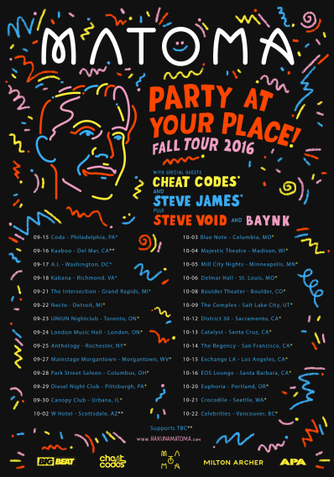

Connect with MATOMA
http://hakunamatoma.com
https://facebook.com/matomaofficial
https://instagram.com/matomaofficial
https://twitter.com/matomaofficial
http://press.wearebigbeat.com/artists/matoma/

Connect with Becky Hill
https://www.facebook.com/Beckyhillofficial/
https://www.instagram.com/beckyhill/
https://twitter.com/BeckyHill

For more information please contact:

Jordan Danielle Frazes
Head of Publicity, Big Beat Records
Jordan.Frazes@atlanticrecords.com

Lindsay Herr
Lindsay@thewaderlvst.com

