FOR IMMEDIATE RELEASE
OCTOBER 23, 2020

MATOMA IS BACK WITH “WOW”

INSPIRATIONAL DJ/PRODUCER DROPS EUPHORIC SINGLE WITH
RISING NORWEGIAN POP STAR EMMA STEINBAKKEN

LISTEN TO “WOW” HERE
WATCH THE VIDEO HERE

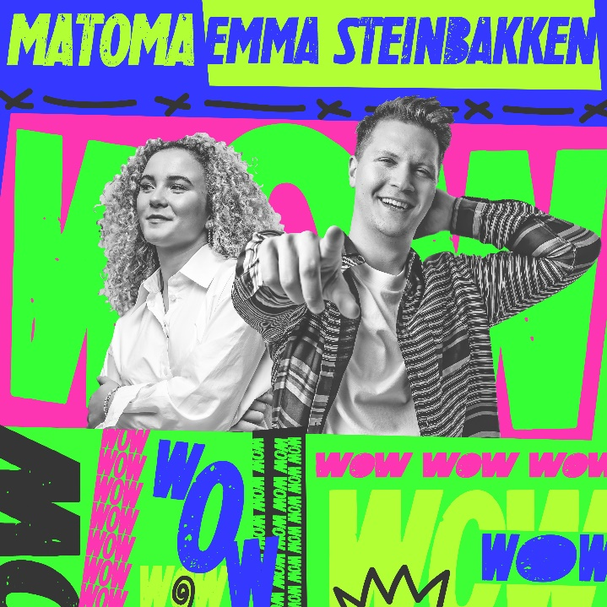
DOWNLOAD ARTWORK HERE

International feel-good producer and DJ MATOMA has released his upbeat and euphoric new single with Emma Steinbakken, “WOW” – available now via Atlantic Records/Big Beat Records HERE. The track is accompanied by a colorful companion video, streaming now via Matoma’s official YouTube channel HERE.

“WOW” features vocals from 17-year-old Norwegian pop sensation Emma Steinbakken, a talented singer-songwriter and multi-instrumentalist who has quickly racked up more than 20 million worldwide streams since making her official debut last year.

"'WOW' is the only way to really describe your feelings when you're blown away by something,” Matoma shared, “and that's how I felt when I heard the incredible voice of rising star Emma Stienbakken! This song is about that precise feeling...for some it can be a feeling you get from a person you meet, from others you can feel this impact from a beautiful sunset, a mountain view, or a song. We hope this song gives you that feeling!"

"Working on 'WOW' with Matoma has been super inspiring,” Emma said. “I love the song and the music video and it’s been an incredibly fun journey to be a part of."

DOWNLOAD PRESS PHOTO HERE

The new track arrives on the heels of Matoma’s recently released critically-acclaimed EP, RYTME. RYTME – meaning “rhythm” in Norwegian – saw the Norway-based DJ/producer teaming up with an array of top vocal talents, including acclaimed singer-songwriter Brando, Atlantic recording artist Georgia Ku, soulful British singer-songwriter Bryn Christopher, rising pop singer-guitarist-producer Griff Clawson, singer-songwriter Anna Clendening, and fellow Norwegian artist Alida. Hailed by EDM.com for showcasing “Matoma’s signature upbeat, lighthearted sound combined with a classically inspired production style,” the EP was highlighted by the irresistible lead single, “The Bender,” featuring Brando (known for such chart-topping collaborations as Loud Luxury’s worldwide blockbuster, “Body”) as well as the ebullient “Let It Go (Feat. Anna Clendening),” joined by an official lyric video streaming HERE.

Matoma recently joined forces with British singer/TV personality HRVY for the feel-good new single, “Good Vibes,” joined by an official companion video streaming now HERE. He’s also currently shooting the latest season of The Voice in Norway, where he’ll act as one of four mentors on the popular television show. Matoma continues to build on his brand of positivity in the tough times of 2020 through his hosting of the mental health-focused Alone Together Music Festival this summer as well as a yet-to-be announced project defined by his ongoing dedication to wellness both in and out of the sphere of music.

With over two billion worldwide streams, Matoma has ranked among Spotify’s top 40 most streamed artists worldwide. Since making his debut in 2015, the gifted DJ/producer has joined the ranks of EDM’s most popular and innovative new stars, prompting Rolling Stone to declare him the “leader of tropical house’s next big wave.” Born Tom Lagergren, Matoma scored a breakout success in 2015 with his RIAA gold certified single, Matoma & The Notorious B.I.G.’s “Old Thing Back (Feat. Ja Rule & Ralph Trevsant),” featured on the groundbreaking 2015 debut album, HAKUNA MATOMA. Since then, Matoma has made waves with life-affirming originals (including the smash “Running Out“) alongside cross-genre collaborations with the likes of Jason Derulo, Jennifer Lopez, Dua Lipa, and The Vamps, as well a dazzling array of remixes for artists as varied as Coldplay, One Direction, Snoop Dogg, Eminem, and Sean Paul, among others.

Matoma’s journey reached a landmark moment with the release of 2018’s acclaimed debut album, ONE IN A MILLION. Hailed by Billboard as “a fresh collection of varied dance-pop compositions…heavy with feels from start to finish… (and) poised for pop-crossover success with some stirringly emotional moments and dance floor feelings,” the album includes a quartet of worldwide hit singles, including “False Alarm (Feat. Becky Hill),” “Lonely (Feat. MAX),” “Slow (Feat. Noah Cyrus)“ and “All Night (Feat. The Vamps),” all of which have now amassed close to a billion total streams and counting.

2019 saw Matoma touring the globe while continuing to unleash new music, including the sultry
mixtape, FORCE OF NATURE: HEATWAVE , as well as stellar singles “ Bruised Not Broken (Feat. MNEK &
Kiana Ledé) ,” Ally Brooke &amp; Matoma’s “ Higher ,” Matoma &amp; Petey’s “ Keep It Simple (Feat. Wilder Woods) ,” “ All Around The World (Feat. Bryn Christopher) ,” and Matoma &amp; LATENIGHTJIGGY’s “ Peligrosa (Mimosas) .”

For more information on MATOMA, please visit: HAKUNAMATOMA.COM

# # #

CONNECT WITH MATOMA
HAKUNAMATOMA.COM | SOUNDCLOUD | FACEBOOK | TWITTER | INSTAGRAM | PRESS ASSETS

For press inquiries please contact:
Jessica Nall // Jessica.Nall@atlanticrecords.com

