Matoma reveals awesome new live video for "All Night"
…plus announces huge World Tour for Spring 2017
PARTY AT YOUR PLACE!
WATCH/SHARE: http://found.ee/allnight
“With each track projecting enough warmth to melt the iciest cynics' hearts, he's excelled in blending dancehall and house in a pop-friendly package.” – Rolling Stone
“Matoma is becoming one of the hottest Norway exports since smoked salmon!” – DJ Mag
“Irresistible, catchy and overall mood-heightening.” – Dancing Astronaut
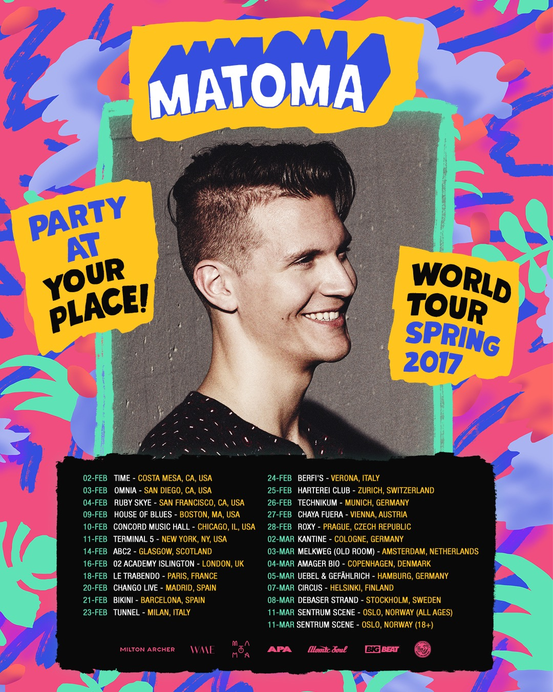
After a mammoth U.S. tour and DJ sets at key festivals such as Coachella, Tomorrowland, Lollapalooza and Electric Zoo, Matoma can now announce the biggest headline tour of his career to date. Taking in shows across both North America and Europe, Matoma’s ‘Party At Your Place! World Tour’ kicks off in Costa Mesa, California and will conclude with two homecoming shows in Oslo, Norway. To celebrate the announcement Matoma drops an awesome live video diary from his recent massive bus tour of the US, check it HERE.
Matoma recently released ‘False Alarm’ (with Becky Hill), his latest and biggest track (69 million Spotify streams) to be added to his innovative ‘Hakuna Matoma’ album project. It demonstrates Matoma’s ability to reach beyond the confines of tropical house with elements of urban, dance, pop and Caribbean sounds within its palette. ‘Hakuna Matoma’ continues to go from strength-to-strength as it expands and evolves over time on streaming media platforms.

Matoma recently refreshed the groundbreaking playlist-meets-album concept by adapting it to become the ‘Hakuna Matoma – Midnight Edition’. Leading with ‘All Night’ – a collaboration with The Vamps that has attracted over 3 million streams a week since its release – the ‘Midnight Edition’ features collabs and remixes with artists including Coldplay, Jason Derulo, Akon, Popcaan, Wale, Sean Paul, Nico & Vinz, Becky Hill and Dua Lipa.

In the past two years, Matoma has amassed well over half a billion streams. With 8 million monthly listeners on Spotify alone, he ranks higher than long established heavyweights such as Pharrell Williams, Snoop Dogg and U2. His biggest tracks include ‘Old Thing Back’ with Notorious B.I.G. (215 million combined streams across Spotify, YouTube and SoundCloud), ‘Try Me’ (126 million streams) and ‘Running Out’ (124 million streams).

US TOUR DATES:
2-Feb Time - Costa Mesa, CA, USA
3-Feb Omnia - San Diego, CA, USA
4-Feb Ruby Skye - San Francisco, CA, USA
9-Feb House of Blues - Boston, MA, USA
10-Feb Concord Music Hall - Chicago, IL, USA
11-Feb Terminal 5 - New York, NY, USA

Matoma ‘Hakuna Matoma’ Album playlist:
Spotify | Apple Music | iTunes | SoundCloud | YouTube
(Big Beat Records/Parlophone)

Connect with MATOMA
http://hakunamatoma.com
https://facebook.com/matomaofficial
https://instagram.com/matomaofficial
https://twitter.com/matomaofficial
http://press.wearebigbeat.com/artists/matoma/

For more information please contact:
Jordan Danielle Frazes
Head of Publicity, Big Beat Records
Jordan.Frazes@atlanticrecords.com

Lindsay Herr
Lindsay@thewaderlvst.com

