Matoma continues to surprise with revolutionary album format – adding new tracks to "Hakuna Matoma" LP—
including huge Akon collaboration and new single “Running Out” with Astrid S!

Subscribe to hear the track + the album ‘Hakuna Matoma’:
Spotify | Apple Music | iTunes | SoundCloud | YouTube

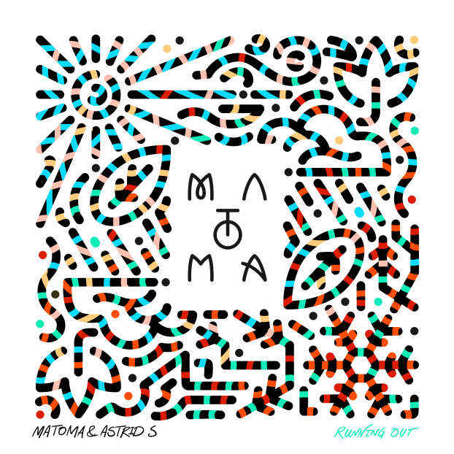
​
Norwegian tropical house wunderkind Matoma continues to surprise and delight his fast-growing audience with new single “Running Out” with Astrid S out today on FFRR / Big Beat Records, alongside another smash "Stick Around", a brand new collaboration with the legendary Akon.

Tom Lagergren aka Matoma recently revealed "Hakuna Matoma", a new kind of album that expands and evolves over time by using the playlist format on streaming media platforms. The new tracks join that living, breathing album, which already includes smash hits like "Try Me", Matoma's collaboration with international superstars Jason Derulo and Jennifer Lopez, and "Feeling Right (Everything Is Nice)”, (LINK) a new track featuring dancehall star Popcaan and D.C.-based rapper Wale that has already garnered over 4 million plays on Spotify, along with #1 Hype Machine charting “Knives” featuring Friendship (LINK).

Check out Matoma & Astrid S “Running Out” (LINK) plus Akon & Matoma's "Stick Around" here (LINK) and below by logging on to your preferred streaming service to listen to "Hakuna Matoma” as a whole.

Subscribe to Hakuna Matoma here:
Spotify | Apple Music | iTunes | SoundCloud | YouTube
For more information:
http://matomamusic.com/
https://soundcloud.com/matoma-official
https://www.facebook.com/artistmatoma
https://twitter.com/MatomaOfficial

To download press tools: http://press.wearebigbeat.com/artists/matoma

National requests: Jordan Danielle Frazes @ Jordan.Frazes@atlanticrecords.com
Tour/Regional requests: Lindsay Herr @ Lindsay@thewanderlvst.com

