FOR IMMEDIETE RELEASE
APRIL 10, 2020

MATOMA & LATENIGHTJIGGY KICK OFF THE WEEKEND WITH
SUNNY NEW TRACK “PELIGROSA (MIMOSAS)”

LISTEN TO “PELIGROSA (MIMOSAS)” HERE
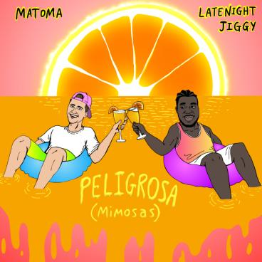
DOWNLOAD ARTWORK HERE

Global superstar producer/DJ Matoma has teamed up with rising vocalist/songwriter LATENIGHTJIGGY for the new Latin-influenced track, “Peligrosa (Mimosas)”; listen HERE. The sun-soaked collab features Matoma’s signature uplifting production alongside LATENIGHTJIGGY’s feel-good, multi-lingual lyrics. “Peligrosa (Mimosas)” arrives today alongside an animated visualizer – now streaming HERE.

Matoma is fresh off his North American co-headline ‘CAMP SUPERDOPE!’ tour with dance-pop duo Two Friends, selling out 11 shows and playing to crowds up to 5,000 in major markets. The extensive and high-energy trek kicked off in January and included impressive stops in major markets including New York, Nashville, Los Angeles, and more.

For more information on MATOMA, please visit: https://www.hakunamatoma.com/

ABOUT MATOMA:
Since making his debut in 2015, Matoma has joined the ranks of electronic’s most popular and innovative new stars, prompting Rolling Stone to declare him the “leader of tropical house’s next big wave.” Born Tom Lagergren, Matoma scored a breakout success in 2015 with his RIAA gold-certified single, Matoma & The Notorious B.I.G.’s “Old Thing Back (Feat. Ja Rule & Ralph Trevsant),” featured on the groundbreaking 2015 debut album project, “HAKUNA MATOMA.” Since then, Matoma has made waves with life-affirming originals (including the smash “Running Out”) alongside cross-genre collaborations with the likes of Jason Derulo, Jennifer Lopez, Dua Lipa and The Vamps as well a dazzling array of remixes for artists as varied as Coldplay, One Direction, Snoop Dogg, Eminem, and Sean Paul, among others.

Matoma’s journey reached a landmark moment with the release of last year’s acclaimed debut album, ONE IN A MILLION, which has garnered over 1 billion streams worldwide. Hailed by Billboard as “a fresh collection of varied dance-pop compositions…heavy with feels from start to finish… (and) poised for pop-crossover success with some stirringly emotional moments and dance floor feelings,” the album includes a quartet of worldwide hit singles, including “False Alarm (Feat. Becky Hill),” “Lonely (Feat. MAX),” “Slow (Feat. Noah Cyrus)” and “All Night (Feat. The Vamps),” all of which have now amassed over a billion total streams and counting.

ABOUT LATENIGHTJIGGY:
When it comes to creating music that can shift your mood, vocalist, producer and songwriter, LATENIGHTJIGGY, has figured out the perfect formula. At the age of 12, he began playing instruments like the clarinet, saxophone and percussion. Naturally, writing and producing would shortly follow. Growing up in the DMV area in a predominantly latin community, the Trinidadian born talent taught himself to speak Spanish and would later infuse this into his music.

In 2015, he started self-producing records and the artist known as LATENIGHTJIGGY was born. JIGGY has since released his debut project Flavors, amassing millions of streams collectively. The impressive debut has been championed and shared by some of the biggest artists in the Latin and World music space including: J. Balvin, Eladio, AnuelAA, Sech and Mega Producer Rvssian. JIGGY's sound touches on a wide range of musical influences including R&B, hip-hop, dancehall, reggaeton, and AfroBeat. With a knack for producing a global sound that is eerily familiar, yet obviously unique, you can be sure to see LATENIGHTJIGGY as an influential addition to the next wave of culture shifters.

DOWNLOAD PRESS PHOTO

# # #

CONNECT WITH MATOMA:
Official Website | Facebook | Twitter | YouTube | Instagram | Spotify | Apple Music | SoundCloud |
Press Assets

CONNECT WITH LATENIGHTJIGGY:
Instagram | Spotify | Twitter | YouTube | Apple Music | Soundcloud

FOR PRESS INQUIRIES, PLEASE CONTACT:
Jessica Nall – Jessica.nall@atlanticrecords.com

