UNVEILS NEW TRACK ‘PARADISE’ WITH SEAN PAUL FT. KSTEWART
PERFORMED LIVE FOR THE FIRST TIME THIS WEEKEND AT COACHELLA

https://youtu.be/OdQ2n5UmGZc

From the album ‘Hakuna Matoma’:
Spotify | Apple Music | iTunes | SoundCloud | YouTube

“a bop built for warmer temperatures.” – FADER

“When Matoma comes on our iTunes, it's like we're living in a world where ISIS, Ebola, and slow Internet no longer exist.” – THUMP

After Matoma delivered his sun-kissed sound to Coachella at the weekend, the Norwegian electronic music star can now unveil his brand new track ‘Paradise’. The track has also been added to his innovative ‘Hakuna Matoma’ album project which expands and evolves over time as new tracks are added to the playlist on streaming media platforms. The format has been lapped up by fans with over 7 million monthly listeners at Spotify alone.

‘Paradise’ finds Matoma’s scorching summer sonic cocktail freshly infused with a Caribbean edge that is heightened by Sean Paul’s distinctive dancehall vocals. Hotly-tipped British newcomer KStewart provides the song’s infectious hook with her soaring and sweet vocal gift.

"Sean and I met in L.A. a couple months ago and wrote this together with Bonnie McKee,” says Matoma. “I've always been a huge fan of his and to see him in the booth recording these vocals that were just so sick, it was amazing. I think the combination of our vibes is perfect for summer!"

After 62 million Spotify plays of his previous single ‘Running Out’, Matoma launched ‘Paradise’ this weekend during his set at Coachella, with Sean Paul on hand to reprise his performance on the track. Matoma recently played two of the biggest shows of his career with sold-out dates at the Opera House in his home city of Oslo.

‘Hakuna Matoma’ demonstrates Matoma’s ability to reach beyond the confines of tropical house with elements of urban, dance, pop and Caribbean sounds within its palette.

In addition to ‘Paradise’ and ‘Running Out’ (which features MTV Music Europe Award winner Astrid S), the album’s highlights include guest appearances from Washington D.C. rapper Wale and Jamaican dancehall artist Popcaan on the feel-good ‘Feeling Right (Everything Is Nice)’; ‘Try Me’, a collaboration with global superstars Jason Derulo and Jennifer Lopez; Matoma’s inspired reimagining of Coldplay’s ‘Adventure of a Lifetime’; and the HypeM #1 ‘Knives’.

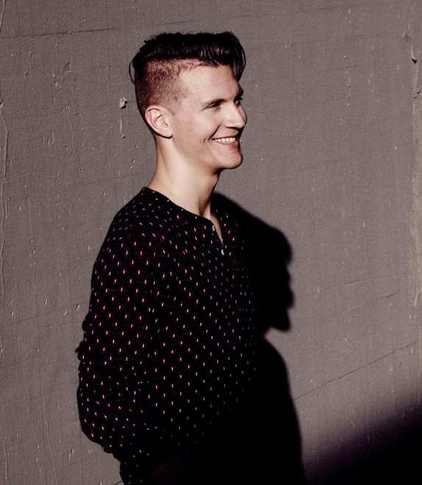

For more information:
http://matomamusic.com/
https://soundcloud.com/matoma-official
https://www.facebook.com/artistmatoma
https://twitter.com/MatomaOfficial

To download press tools: http://press.wearebigbeat.com/artists/matoma

National requests: Jordan Danielle Frazes @ Jordan.Frazes@atlanticrecords.com
Tour/Regional requests: Lindsay Herr @ Lindsay@thewanderlvst.com

