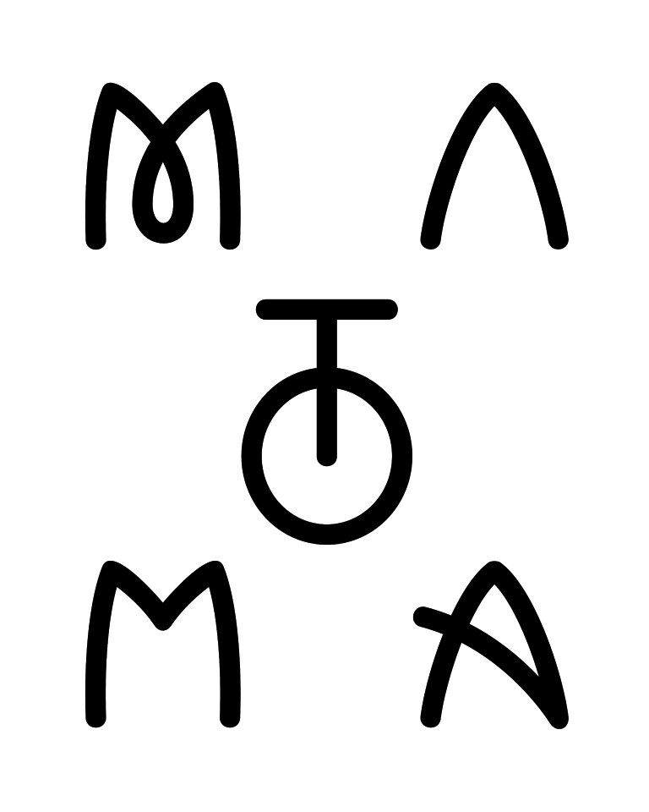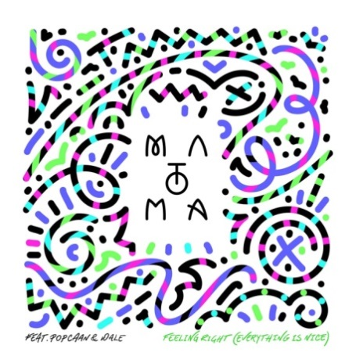

**Tropical House producer Matoma returns with**

**new single "Feeling Right (Everything Is Nice)”**

***Feat. Popcaan and Wale, released today via Big Beat Records***

Post: <https://soundcloud.com/matoma-official/feeling-right-everything-is-nice-feat-popcaan-wale>

Stream: <http://smarturl.it/S_MEverythingIsNice>

Purchase: <http://smarturl.it/MEverythingisNice>

While the longer nights of fall are officially upon us, the breezy sound of those warm, sunlit summer days remains with **"Feeling Right (Everything Is Nice)”**, the latest release from breakout Norwegian artist **Matoma** available today (October 16th) on Big Beat Records. Featuring vocals from Jamaican dancehall singer **Popcaan** and a slick verse from Washington D.C.-born rapper **Wale**, the track is a feel-good jam that works as well in your headphones as it does on the dancefloor.

With this latest single, **Matoma**, the 24-year-old year old producer born **Tom Lagergren**, continues to stake his unique claim over the more urban side of tropical house, fusing a classic hip hop vibe with the burgeoning electronic genre and creating a combined sound that is sophisticated, unabashedly upbeat and irresistibly danceable.

The track follows Matoma’s massive 2015 single **“Old Thing Back,”** which features **The Notorious B.I.G., Ja Rule** and **Ralph Tresvant** and currently has more than **90 million plays on Spotify**. Matoma also recently collaborated with **Jason Derulo** and **Jennifer Lopez** on this past May‘s “Try Me,” a track *SPIN* called the best of Lopez’s career, and has also amassed nearly 50 million plays so far.

Meanwhile, **Matoma** is currently on the road for his ***Living the Dream*** tour, which finds him playing key clubs and festivals throughout the United States and Canada. As temperatures continue dropping as summer turns to fall and fall to winter, the Matoma sound will keep the vibe warm.

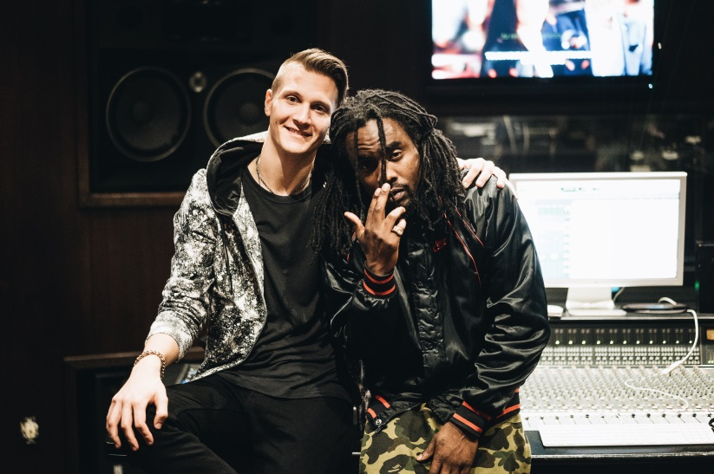

*Matoma & Wale*

*Photo credit: @orli_1st*

*The Boom Boom Room, Los Angeles*

*October 13, 2015*

Matoma on tour:

Fri 16 Oct 2015 The Showbox Seattle, WA, US

Sat 17 Oct 2015 Trees Dallas, TX, US

Wed 21 Oct 2015 9:30 Club Washington, DC, US

Thu 22 Oct 2015 Public Works San Francisco, CA, US

Fri 23 Oct 2015 Avalon Hollywood, CA, US

Sat 24 Oct 2015 The Parish Austin, TX, US

Wed 28 Oct 2015 Terminal West at King Plow Atlanta, GA, US

Thu 29 Oct 2015 Union Transfer Philadelphia, PA, US

Fri 30 Oct 2015 Webster Hall New York, NY, US

Sat 31 Oct 2015 Ascend Amphitheater Nashville, TN, US

Tue 03 Nov 2015 Calvin Theatre & Performing Arts Center Northampton, MA, US

Wed 04 Nov 2015 Toyota Presents the Oakdale Theatre Wallingford, CT, US

Fri 06 Nov 2015 New City Gas Montreal, QC, Canada

Sat 07 Nov 2015 Sound Academy Toronto, ON, Canada

Sun 08 Nov 2015 London Music Hall London, ON, Canada

Tue 10 Nov 2015 Stage AE Pittsburgh, PA, US

Wed 11 Nov 2015 Bluestone Columbus, OH, US

Thu 12 Nov 2015 Royal Oak Music Theatre Royal Oak, MI, US

Fri 13 Nov 2015 Aragon Ballroom Chicago, IL, US

Sat 14 Nov 2015 Skyway Theatre Minneapolis, MN, US

Sun 15 Nov 2015 Segredo Madison, WI, US

Tue 17 Nov 2015 Canopy Club Urbana, IL, US

Wed 18 Nov 2015 Egyptian Room, Old National Centre Indianapolis, IN, US

Thu 19 Nov 2015 The Pageant St Louis, MO, US

Fri 20 Nov 2015 Liberty Hall Lawrence, KS, US

For more information:

<http://matomamusic.com/>

<https://soundcloud.com/matoma-official>

<https://www.facebook.com/artistmatoma>

<https://twitter.com/MatomaOfficial>

To download press tools: <http://press.wearebigbeat.com/artists/matoma>

Press requests: **Jordan Danielle Frazes** @[Jordan.Frazes@atlanticrecords.com](mailto:Jordan.Frazes@atlanticrecords.com)

Tour requests: **Lindsay Herr** @[Lindsay@thewanderlvst.com](mailto:Lindsay@thewanderlvst.com)