MANILA KILLA & AOBEATS
“I’M OK (FEAT. SHAYLEN)” REMIXES
OUT NOW ON BIG BEAT WHITE LABEL
AND MOVING CASTLE!

WATCH/POST: https://www.hive.co/l/okrmxspl
BUY/STREAM: https://BigBeat.lnk.to/mkabPR

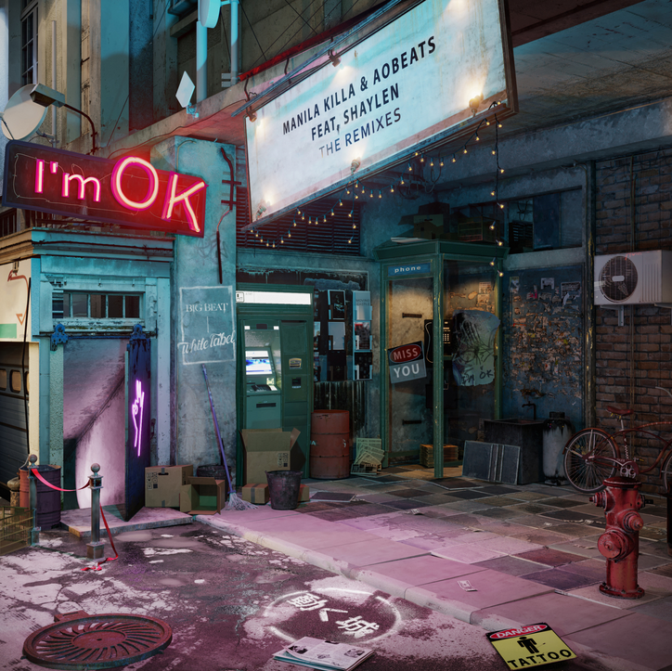

“….combines the sonic strengths of not one, not two, not three, but FOUR talented artists…. a healthy dose of summertime sunshine delivered in the form of a bass-heavy foundation by Manila Kills & AObeats, uplifting lyrics courtesy of Shaylen, and last but not least, a vibrant nu-disco touch by Kid Froopy” – ONE’S TO WATCH
Last month Manila Killa & AObeats debuted their new single “I’m OK” featuring vocals from Shaylen on Big Beat White Label. The Moving Castle collective members delighted listeners with a feel good future bass heavy anthem, building slowly into Shaylen’s heart exposing lyrics. They return today with an impressive “I’m OK” remix package – LISTEN HERE – featuring an epic spread of emerging producers including SMLE, Kid Froopy, JUDGE, and Kwon.

Manila Killa, comprised of duo Hotel Garuda, has had official remixes for the likes of The Knocks, Jack Garratt, Dawn Golden, Tegan & Sara, and more. His debut single, “All That’s Left” was released on Ultra Music last year and since then has racked in 30 million global Spotify streams. LA-based producer AObeats has produced for everyone from Felix Snow to gnash and has had official remixes for Annabel Jones, ZZ Ward, and more.

SMLE; Miami-based electronic duo from composed of childhood friends producing original tracks and an array of official remixes all with the intent to make you smile, Kid Froopy; singer, songwriter & producer who came onto the scene in 2015 with early support from Beats 1 radio host Anna Lunoe and Skrillex’s music blog NestHQ, JUDGE; LA-based producer, most known for producing for Hoodie Allen, Mark Johns and most recently, Young Thug & KWON; DMV-based artist began producing in 2012 after spending his early musical years playing the piano and violin, inspired by his father who played bass and drums for a well-known band in Korea.

"We've always loved Kid Froopy's "future disco" style which is why we asked him to do a remix, and he definitely did not disappoint. He brought new life to the song and prepared it for this very hot summer we're about to endure. We hope you like it as much as we do!" – AOBeats & Manila Killa

"We've always loved AO Beats & Manila Killa's music therefore we had a blast flipping on of their songs into one of our own!" – SMLE

"this remix was fun. i was listening to a lot of kaytranada and paramore when i was making it. guitars and big drums with a summer type vibe for sure. big thanks to manila, ao and shaylen!" – Kid Froopy

"AOBeats and Manila Killa are two of my favorite producers, so when I got the chance to remix "I'm OK" I knew I had to snap - wanted to bring my JUDGEness to it and make it a crazy banger but still build it around Shaylen's beautiful vocal and just flip the feel of the original." – JUDGE

"This track initially was a demo I had already created but one day I was having trouble coming up with ideas, so I asked Chris for the vocals to his single with AO and pulled up my most recent track (which was the demo) and it somehow made sense. Worked on it for the rest of the day and sent it over and the rest is history." – KWON

##

Connect with Manila Killa :
Soundcloud |Facebook |Twitter |Instagram

Connect with AOBeats:
Soundcloud |Facebook |Twitter |Instagram

Connect with Shaylen:
Soundcloud |Facebook |Twitter |Instagram

Press Tools:
http://press.wearebigbeat.com/singles/im-ok/

For more information please contact:

Jordan Danielle Frazes
Head of Publicity, Big Beat Records
Jordan.Frazes@atlanticrecords.com

Catherine Corkery
Publicity, Big Beat Records
Catherine.Corkery@atlanticrecords.com

