MANILA KILLA & AOBEATS TEAM UP ON “I’M OK (FEAT. SHAYLEN)” OUT NOW ON BIG BEAT WHITE LABEL AND MOVING CASTLE!

WATCH/POST: https://youtu.be/nkFjeeB0TT0
BUY/STREAM: https://lnk.to/imokPR

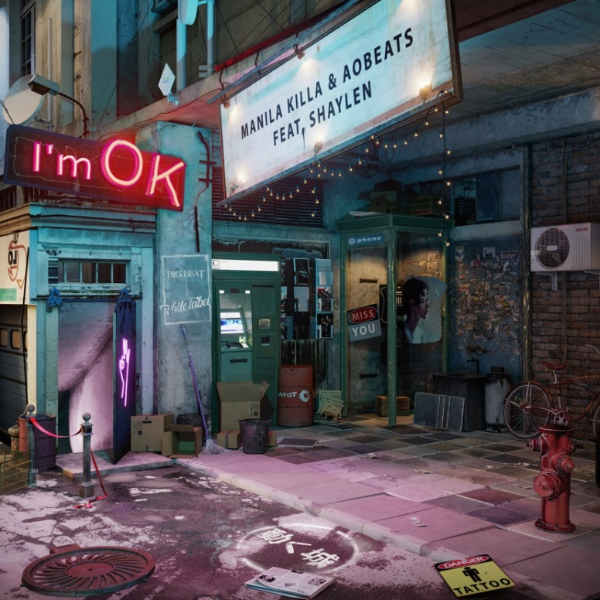
Out today on Big Beat White Label, Manila Killa & AObeats debut their new single “I’m OK” featuring vocals from Shaylen. The Moving Castle Collective members delight listeners with a feel good future bass heavy anthem. Building slowly into Shaylen’s heart exposing lyrics, the producers take us into a crescendo of a funky and bubbling bassline, which makes the lyrics calling out to lost love a little easier to get through.

The pair remark, "This is such a special song because it's the first time we've officially collaborated since 2015 for Helix 2.0. We've always been able to lock in together creatively and this one felt especially memorable since we were able to release the single on our label Moving Castle. Plus Shaylen is very talented and we're so stoked she could be a part of this song!"

Manila Killa, one half of duo Hotel Garuda, has had official remixes for the likes of The Knocks, Jack Garratt, Dawn Golden, Tegan & Sara, and more. His debut single, “All That’s Left” was released on Ultra Music last year and since then has racked in 30 million global streams on Spotify. LA-based producer AObeats has produced for everyone from Felix Snow to gnash and has had official remixes for Annabel Jones, ZZ Ward, and more.

The pair is off to set summer on fire with this new electronic/pop record “I’m OK” available today!

Connect with Manila Killa
https://soundcloud.com/manilakilla
https://www.facebook.com/manilakilla
https://twitter.com/ManilaKilla

Connect with AOBeats
https://soundcloud.com/aokamura
https://www.facebook.com/aobeats
https://twitter.com/aobeats

For more information please contact:

Catherine Corkery
Publicity, Big Beat Records
Catherine.Corkery@atlanticrecords.com

Jordan Danielle Frazes
Head of Publicity, Big Beat Records
Jordan.Frazes@atlanticrecords.com

Lindsay Herr
Lindsay@thewanderlvst.com

