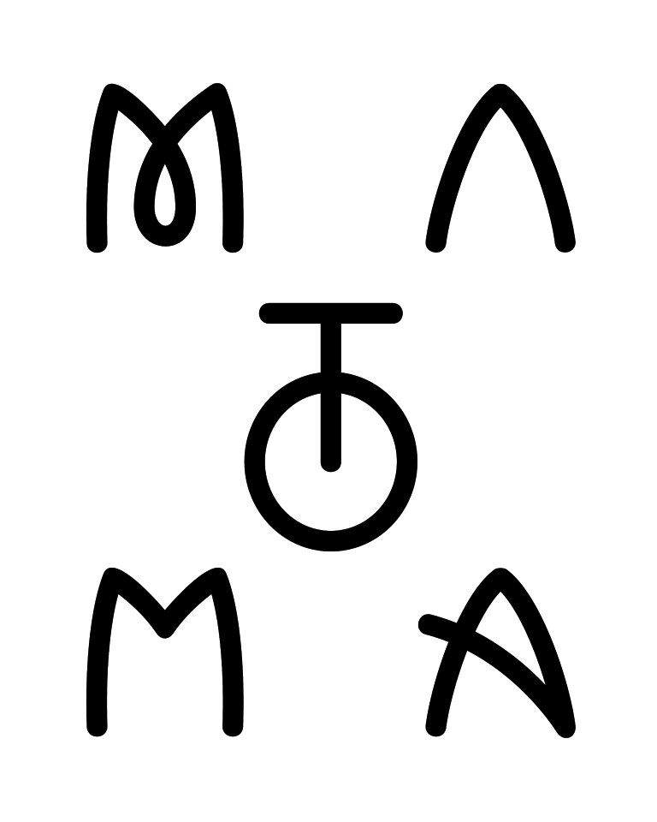

Norwegian artist Matoma has certainly done big things in a short amount of time. He’s equally adept at creating life-affirming originals as he is with cross-genres collabs with the likes of Jason Derulo, Jennifer Lopez and The Vamps – not to mention dazzling remixes for artists including Coldplay, One Direction and Eminem.

The result is that Matoma is huge on Spotify: 161 million streams of ‘Old Thing Back’; 118 million plays of ‘Running Out’; and another 113 million for ‘All Night’, his recent collaboration with The Vamps.

All three tracks feature on ‘Hakuna Matoma’, his pioneering reinvention of the album concept. Blurring the boundaries between the playlist and the artist album, ‘Hakuna Matoma’ continues to evolve with the addition of brand new tracks across all key streaming platforms.

Having performed at major festivals including Bonnaroo, Electric Zoo, Lollapalooza, Tomorrowland, and Coachella, Matoma’s ‘Party At Your Place’ world tour is now underway.

###

1633 Broadway - New York, NY 10104
Tel: 212.707.2000 Fax: 212.405.5477
3400 W. Olive Ave. Burbank, CA 91505
Tel: 818.238 6800 Fax: 818.562.9211
www.wearebigbeat.com

