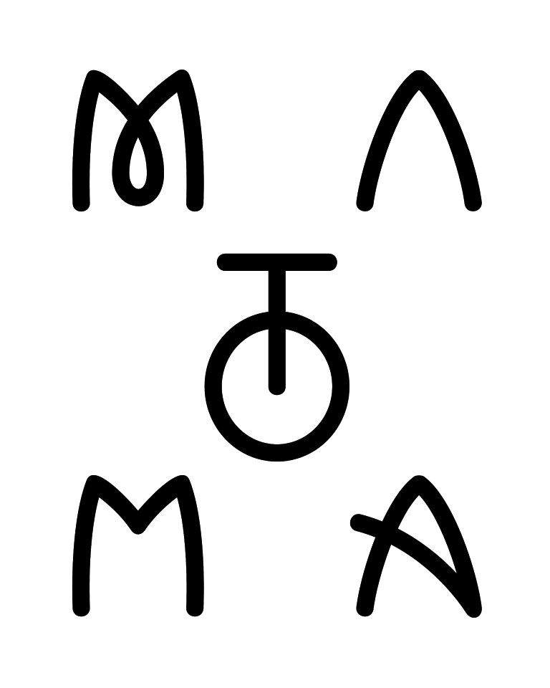

We exist in an era of music in which success is easily quantified—an artist becomes a sensation on an ever-higher number of views, followers, plays and likes.

By this standard, Norwegian artist Matoma – the 25-year-old artist born Tom Lagergren – has certainly done big things in a short amount of time. He’s an artist who is equally adept at creating life-affirming originals as he is with cross-genres collabs with the likes of Jason Derulo, Jennifer Lopez and The Vamps – not to mention a dazzling array of remixes for artists as varied as Coldplay, One Direction, Snoop Dogg, Eminem and Axwell.

The result is that Matoma commands a following of over 17 million monthly listeners at Spotify. Individual tracks are even bigger still: 161 million streams of his breakthrough track ‘Old Thing Back’; 118 million plays of his anthem ‘Running Out’; and another 113 million for ‘All Night’, his recent collaboration with The Vamps.

True achievement, however, is about more than a numbers; it’s about depth, feeling and that magical symbiotic relationship between the performer and the crowd. In this sense, Matoma has accomplished something special.

His signature sound is a summer-ready mix of uplifting house, breezy funk and classic hip-hop, with influences including Ice Cube, Xzibit and The Notorious B.I.G. While these styles may seem disparate, Matoma has fused his influences into an infectiously feel good and completely danceable sound. Stepping outside of obvious genre labels, Matoma prefers to call his output the future of pop music.

What’s more, Matoma has pioneered a bold reinvention of the album concept with his ‘Hakuna Matoma’ collection. Blurring the boundaries between the contemporary playlist and the old school artist album, ‘Hakuna Matoma’ is a collection that continues to evolve with the continued addition of brand new tracks across all key streaming platforms.

Matoma started out as music-oriented kid learning to play classical piano. When he tired of the instrument, he began producing music on a laptop in his bedroom. After a stint in the military, he went to University in Norway where he became a resident DJ, earned his bachelor’s degree in music production, and assumed he’d become a music teacher. As it turned out, however, life went in another direction after Matoma started putting his remixes on Soundcloud. He was surprised, and thrilled, to find his music celebrated by listeners around the world.

“Remixing was a really good opportunity to show people my skills,” he says. “I did that for fun, and my Soundcloud profile started growing. I got really inspired and kept going.” It’s something that he’s now paying forward, as evidenced by the new talent that he’s helped to provide a platform for with his remix packages for his hits ‘False Alarm’ (a Radio 1 Track of the Day and his first UK Top 30 single) and ‘Heart Won’t Forget’.

His 2015 ‘Midnight Sun’ tour of the United States was largely sold-out and met with a rapturous reception which prompted Matoma to realise, “Shit, this is my dream.” It was a moment which inspired his subsequent two-month ‘Living The Dream’ tour towards the year’s end, which was followed by regular North American and international touring throughout much of 2016. Already his roll call of major festivals and events includes Bonnaroo, Electric Zoo, Lollapalooza, Tomorrowland, Coachella and many more.

His current ‘Party At Your Place’ tour is now underway. Calling at fifteen countries, it concludes with two homecoming shows at Sentrum Scene in Oslo.

Matoma is soaking up the opportunity to play for crowds around the world, to flex his diverse musical knowledge, and to make ever-larger audiences feel the same infectious vibrancy instilled in his music. “There’s too much shit going on in the world,” Matoma says. “I just want people to listen to my music, be happy and feel my love through the music.”

Matoma’s success thus far proves that audiences are indeed feeling that love, and loving him right back.

###

1633 Broadway - New York, NY 10104
Tel: 212.707.2000 Fax: 212.405.5477
3400 W. Olive Ave. Burbank, CA 91505
Tel: 818.238 6800 Fax: 818.562.9211
www.wearebigbeat.com

